Wednesday 18th October 2023
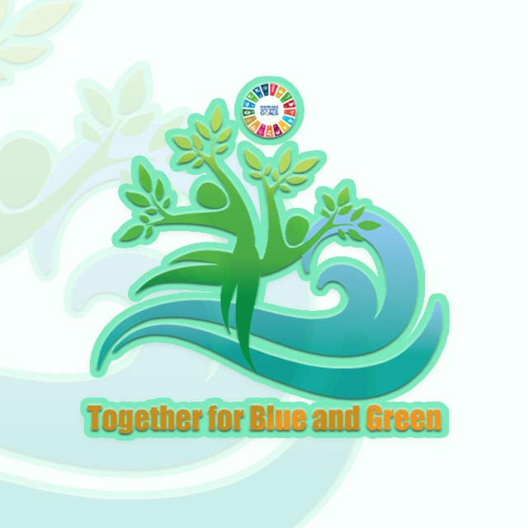
LCOY ALGERIA First edition 2023
Together for Blue and Green

Workshop report

Theme : "Unlocking Climate Finance for Youth-Led Initiatives in Algeria"
Duration : 1 h 30 min
Participants : 18 participants
Facilitators : AIT YAHIATENE Amina , sami ali kacem, Belkhir Hani
Mission of the workshop :
- Inform participants about the role of climate finance in addressing environmental challenges.
- Facilitate dialogue on the creation of youth-led climate finance initiatives.
- Promote youth engagement in climate finance to drive SDGs related to climate action.
The workshop activities :
- Icebreaker (Q/A card activity) ,20 min, delivered by Belkhir Hani
Activity Description:
the attendance are given cards and are asked to write down a field of their choice. Then the facilitator asks several questions and they step up if the answer is YES and they step down if the answer is NO relating to the field written. The aim of this activity is to kick-start the workshop by creating a comfortable atmosphere.

Questions asked :
-Is the field YOU CHOSE highly considered in Algeria?
-Is the field YOU CHOSE highly considered outside Algeria?
-Is a large budget allocated to projects related to the field YOU CHOSE in Algeria?
-Do you think the new generation youth Stand Out for Climate Change Activism more than the old generation?
-Are there significant government initiatives or policies in order to promote the field YOU CHOSE?
-Do you believe that there are a good number of startups in the field YOU CHOSE in Algeria?

- Presentation and debate, 40min, delivered by amina ait yahiatene and sami ali kacem
The facilitators prepared a powerpoint presentation, the sub titles presented were as follows :
- What is climate finance
- Climate finance & SDGs
- Climate finance &COP Meetings
- Climate finance in Algeria
- Climate finance tools
- Public vs private funding
- International & national climate finance institutions
- Green startup in Algeria
Following the presentation, a debate and a question-and-answer session were initiated. The primary objective of this part was to open-eye and provide a comprehensive understanding of the issues at hand, enabling participants to recognize their significance and relevance.

- Suggestions and recommendations, 30min :
After the presentation and the recognition of the challenges at hand, the participants were given the opportunity to speak and put forth their recommendations.

