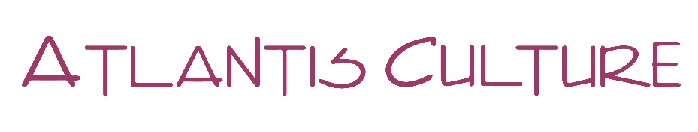
11 September 2019

Worldwide Reading for Freedom of Expression

The event in Cyprus, organised by Atlantis Culture, took place at PROZAK Café, a literary Café in the heart of Nicosia, capital of the island. It was part of the global event organised by the International Literature Festival Berlin.

The event hosted 20 poets and authors, all based in Cyprus:
Manuella Mavromichalis & Kathleen Ruddy, Annetta Benzar, Konstantinos Kokologiannis, Chandni Chopra, Maria Kouvarou, Antonis Georgiou, Chrystalla Soteriou, Irene Papakyriakou, Argyris Loizou, Michael-Angelos Englezos, Halil Karapaşaoğlu, Omar Al-Sheik , Zoe Piponides, Alexia Victoros, Chrystalla Kaiafa, Demetra Englezou, Pavlos Andreou, Gaia Zaccagni, Nora Nadjarian

And a young musician Tassos on ruvdrum.

