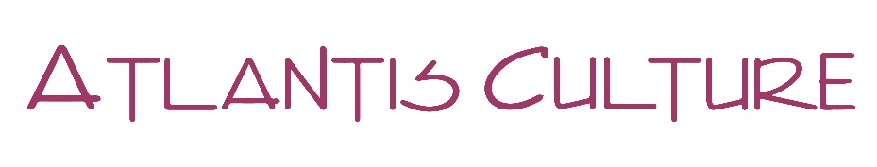
29 January 2020

Worldwide Reading screening of the documentary ‘Shoah,

by Claude Lanzaman,

Sunday, 26 January 2020 at 15.00 – Monday, 27 January 2020, 01.30

The event in Cyprus, was organised by Atlantis Culture, together with the embassies of Israel, France and Germany and the French Institure and the Goethe-Institut in Cyprus.

It took place at the ARTos Foundation.

The screening event started at 14.30, with short speeches by the three ambassadors and a short introduction by Atlantis Culture.

The screening started at 15.00on Sunday afternoon, included 3 breaks of about 15 mins each, and finished at 01.25 on Monday morning

There were 35 persons at the start, with another 10 arriving at 20.00. At the finish there were 7!

