Palestine Vanguard Organization's Profile
https://www.facebook.com/tala3palestien/
About Us (establishment and management structure)
Palestine Vanguards Association, an independent non-profit CBO, was founded in January 2000 in Khan Younis. and has registration No. 7454. It aims to build a conscious generation with a future vision and active civic participation by upgrading the level of Palestinian vanguards in the educational, school teaching and moral aspects, relying on providing many services and multiple and varied programs, such as establishing the Vanguard Parliament, Radio, and Vanguard Website, which seeks to achieve sustainable development for the target groups and commitment to the values, principles, and culture of human rights. The Palestine Vanguards Association was founded in response to support vanguard, youth, and women categories to advance the vanguards generation (12-18) by developing their abilities, enhancing their school teaching, values, and educational aspects, discovering and developing their talent, finding places to play and entertainment, enhancing their civic participation of them by refining their personality and improving their psychological and social status due to they are the primary target groups and their families and their mothers as secondary target groups, vanguard mothers are considered breakable, marginalized and fragile in society.in addition to promoting and supporting the youth target group, empowering them, improving their social and living conditions, and providing them with job opportunities. The Vanguards website and radio station are considered the superior achievements of the association, as it is developed periodically to ensure the continuity of achieving the goals for which it was established, where it works on implementing radio episodes and digital community accountability sessions, during which it discusses vanguard issues, their reality, rights, and needs. The association is a member and an active partner in many institutional and cluster gatherings and the institutions of the Palestinian National Authority. It is a member of the Childhood Protection Network in partnership with the Ministry of Social Development and UNRWA. It has several partnerships and cooperations with several international institutions and civil society institutions in the Gaza Strip.
The administrative structure of the association
The administrative structure of the association includes an executive director, an administrative assistant, a secretariat, a program manager, and a director of activities, through which the various programs of the association aiming to support, develop and support the youth are directly and implemented as the direct target group of the association, youth and women as a secondary target group. The association consists of a board of directors elected by the general assembly every three years. The number of members of the board of directors is (7), and the General body consists of (23) members.
Position | Major | Name | No.
President of the board | BA in sociology/ Birzeit University | Nabil Khaleel Shanna | 1.
vice President | MA in human development | Madiha Najeeb Shahwan | 2.
Secretary | BA in media and public relations | Amal Awad Shehada | 3.
Treasurer | BA in social work | Mansour Hasan Zanoun | 4.
member | BA in psychological counselling | Salama Mohammed Abu Aker | 5.
member | MA in Islamic studies | Alaa Waleed Alghalban | 6.
member | BA in social work | Mahmoud Salman Abu Mostafa | 7.

Target Groups
Children- Vanguards- Youths- Women.
Our vision
To build an informed generation with a future vision within the approach based on sustainable development to ensure effective civic participation.
Our mission
We seek to raise and enhance the vanguards' participation in the societal fields, develop the educational, school teaching and moral aspects, and enhance their civic participation by providing distinguished and diverse services in the educational, cultural, and development aspects for them and their families in Khan Yunis Governorate.
Association Philosophy and Values
The Association philosophy focuses on interventions through which sustainable development can be achieved for the target groups through adherence to the developed positive values prevailing in the Palestinian society, represented by the following:
- Professional values: credibility, quality, the privacy of target groups, non-discrimination, and justice in providing services, equal opportunities, professionalism, discipline, and commitment.
- Moral values: impartiality, observance of society's values and customs, social responsibility, and cooperation.
Association Approach
Palestine Vanguards Association works on the participation of stakeholders from the target groups (vanguards - youth - women) in the stages of planning and implementing programs and projects to ensure that the services provided to them are delivered to their needs appropriately, in addition to consultation the government agencies, municipalities and community institutions in the programs offered by the association during meetings, workshops, field visits and statistics to ensure that the appropriate needs of the target groups are identified. In addition, the change and development required for them are achieved.

THE Strategic Goals of the Association:

Partnership and Membership:
The association is an active member and partner in many institutional groupings, which include, for example, the following partnerships:
- The association is a member of the Child Protection Network in partnership with the Ministry of Social Affairs and UNICEF.
- An active member of the Palestinian Educational Coalition, which is based on developing the education sector for children and youth.
- A Member of the General Union of Cultural Centers concerned with developing culture and art for the community in the Gaza Strip.
- A Member of the Refugee Protection Network.
Geographical Scope
The association works mainly in Khan Yunis governorate in the southern Gaza Strip, with the possibility of targeting other areas in cooperation with many NGOs in the targeted area.

Khan Yunis City
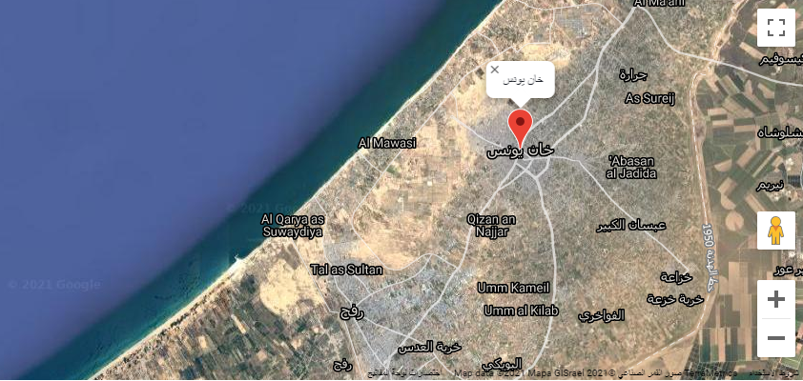
Khan Yunis is a Palestinian city, and the center of the Khan Yunis Governorate. It is in the southern part of the Gaza Strip, 100 km to the southwest from Jerusalem. It is bordered on the south by Rafah city and on the north by Deir al-Balah city. It is the center of a coastal governorate overlooking the Mediterranean Sea from the west and the occupied territories from the east. Khan Yunis is the second largest city in the Gaza Strip in terms of population and area after Gaza City. It has an area of ​​54 square kilometers, making it one of the most densely populated Palestinian cities. Khan Yunis is considered the first governorate in the governorates of the Gaza Strip in terms of area, and it is considered the second governorate in terms of population after Gaza Governorate, where the population of Khan Yunis is about 420 thousand people. Khan Yunis governorate includes 11 localities belonging to 7 local municipalities. It is one of the most densely populated Palestinian cities.

Appendix1: Major projects and initiatives
Year | Partner | Project's Name | No.
2021 | United cultural and social society | AVP
2021 | Women's Affairs Center | Free Voice makers
2021 | Women's Affairs Center | Your vote is homeland
2020 | BADIl center | Palestinian Stories (Film)
2020 | Palestine Save the Children foundation | My learning is my future
2020/2021 | Women's Affairs Center | Life project
2019 | Teacher Creativity Center | Activating Parents' role of in the field of public administration in education
2019 | HADAF Center for human rights | Voices for Change
2019 | Yaboos Charity Society | Learn project
2019 | Unlimited friends association | Sacrificial Meat
2018/2019 | Save Youth future Society | Vanguards' voice is getting Louder
2018/2019 | GUCC | Civic participation for youth
2017 | Save Youth future Society | Youths' initiatives ''10''.
2017 | Islamic Relief/ Catholic Relief | Employment of graduates
2017 | Save Youth future Society | Gazan Vanguards are drawing the future
2015 | Save Youth future Society | Vanguards' initiatives ''3''.
2015 | Save Youth future Society | Gazan Vanguards are making differences
2011 | Women's Affairs Center | Social Gender project
2010 | Al- fukhary Rural Development association | Supportive education project
2010 | AFESD | Youth Participation Enhancement
2010 | PCDCR | Reducing the risk of illiteracy
2010 | IRD | Job creation
2010 | Tamer Institute | We learn in Gaza
2010 | International Save the children foundation | Small Business Development and Financial Literacy
2008 | UNICEF | Biking race
2008 | CRS | Youths' voice is getting Louder
2008 | UNRWA | Summer Games project
2008 | Tamer Institute | Creative Writing and Dramatic Art project
2007 | PCDCR | Child Protection Initiative
2006 | The culture and free thought association | Floating Cultural boat project
2006 | UNICEF | Safe play areas for children project
2006 | Nashed | The Vanguard Cultural and Entertainment Forum

Outreach workshops
Year | Sponsor | Project's name | Activity's Name | Organization's Name | No.
2021 | NPA | Cultural incubators in the Gaza Strip | (We are with you) within the initiative to prevent gender-based violence. | Basma Society for culture and art
2021 | UNWOMEN | Life Project | Outreach workshops and community meetings (Gender-Based Violence) | Women's Affairs Center
2021 | Christian Aid | Promoting women's political participation | Free Voice Maker initiative | Women's Affairs Center
2021 | Oxfam | Enhancing women's political participation in elections | Your vote is homeland initiative | Women's Affairs Center
2020 | KTK | Empowering and advocating for women to achieve justice and equality | Outreach workshops on promoting women's political participation | Women's Affairs Center
2019 | UNDEF | Inclusion of men and boys in promoting gender justice in Palestine | Outreach workshops on responsible parenting and positive parenting for children | Women's Programs Center Rafah
2019 | KTK | Engaging men and boys in the fight against gender-based violence | Outreach workshops within the “My Legacy is My Right” initiative | Aisha Association for Woman and Child Protection

