Description of Upcoming Projects 2022-23

The Alexander project

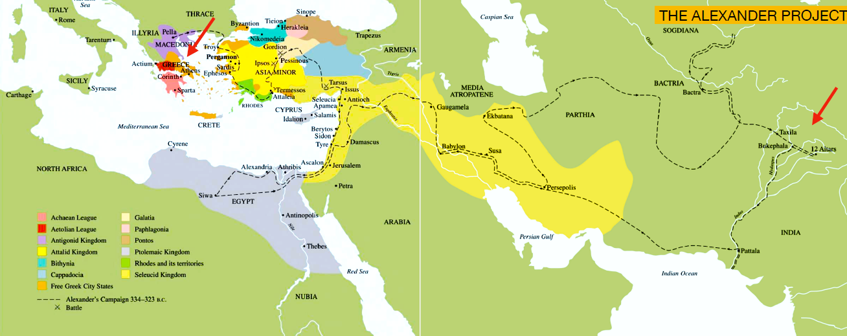

Route of the Journey to Empire

Artist: Award-winning filmmaker and artist Sarah Singh
Location: N/A
Summary: GREECE IN USA has partnered with Ms. Singh for the first part of the long form film project to explore the history of India and Greece, which focuses on Alexander the Great. The project will incorporate theatre, photography, and installation in both staged and verite styles.

The plan is to work over a period of 5 years creating vignettes that are individually released as standalone works. When all parts are completed, the vignettes will be edited into one continuous work, which is expected to have a running time of approximately 5 hours. For this initial part of project, Sarah will collaborate with Greek actors and writers to create a new theatrical work based on an ancient theatrical work created during the lifetime of Alexander the Great and performed for his troops in Punjab. It would become a contemporary, stylized presentation that is set both in north India in one of the oldest Forts of the entire Subcontinent, as well as in Greece. The location in India is directly related to the footsteps of Alexander the Great.

Ms. Singh has shown her film works all over the world in Museums, think tanks, universities, Biennales, etc such as London’s Victoria and Albert Museum; and has had working relationships with UNESCO, Embassies, Swiss Arts Council, and various governments as the Founder/Director of Panorama Editions. Panorama Editions has had 3 iterations and was set in 3 different historical forts in India. It is a unique platform for both the audience and the performers, which emerges from a conceptual idea and is customized to the setting and location.

The Crack

The Crack, cover picture

Artists: Artistic Director Anna Furse, along with Wendy Houstoun, Nicole Dimitrakopoyloy, Graeme Miller, Thanos Vovolis
Location: The R&D will take place in the ACE-funded Chats Palace, Hackney, London, UK and the final product will tour in the UK and Greece.
Summary: GREECE IN USA has partnered with Anna Furse in the production of The Crack; a new experimental Anglo-Greek dance theatre work that explores how we struggle to articulate, embody and act as artists on the critical issues of today.

The Crack is an urgent, innovative and provocative physical theatre project - online and live - that explores how we confront, embody and speak about specific and unprecedented traumas we are living through today. It develops online, culminating in live performance, for eventual touring production. It is a co-creation between three older women artists plus creative and technical team. It stretches between Greece and the UK. It starts from two words of vital meaning today: insularity (from ‘island’) and mobility (the pandemic, migration and what leaving Europe means). It is a creative dialogue between Europeans and post-Europeans, refusing to be divided by politics, each living in countries comprising many islands (the UK a staggering 6289, Greece 6000). It is conceived in crisis to create from crisis. It employs online tools to create a draft performance text whilst geographically-dispersed, followed by, Covid-permitting, rehearsals towards a live try-out performance for a focus group. Our research includes asking what it means to be a European immigrant in post-Europe UK, conducted with London’s Greek community of third-age women.
The Crack is co-created with and performed by two women dance theatre artists, who each inhabit different and new worlds: they are three decades apart in age; they live in urban and rural environments; have different domestic arrangements; they are from an EU and Brexit country respectively. Working from such difference, they collaborate on what connects at this time, resist boundaries. It is an impassioned duet, a ritual dialogue of flesh and word, a dialectical sharing of anxiety, despair and hope.

VITAL, Innovative sustainable artworks in public space

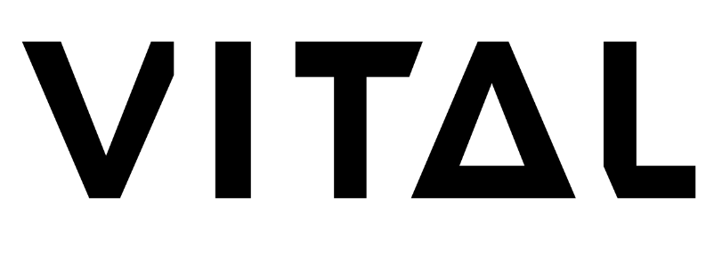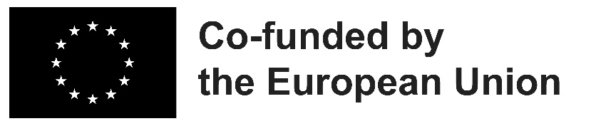
Artists: Marco Barotti, Klitsa Antoniou, Thibault Honoré, Irena Pivka and Brane Zorman
Location: Strasbourg
Summary: GREECE IN USA has partnered with VITAL to connect artistic production to public through technical innovation and living plants in its effort to create an innovative artistic ecosystem that respects the environment and contributes in its own way to the fight against global warming and atmospheric pollution. Strasbourg will be offered four artworks integrating living plants and technologies, using renewable energies, designed for public space, with active participation of citizens. In addition to raising awareness among artists and the targeted and wide public, VITAL aims to ultimately create a European dynamic and a network for production and promotion of environmentally friendly works in public space, with the involvement of local authorities and the support of industries.

VITAL is designed on three pillars; objective – Innovation, priority; Sustainability, and sector; Visual Arts. VITAL particularly stresses the innovation topic as it is centred on production of innovative artistic works through the combination of living plants as an active element, interactivity provided by new technologies working with renewable energies, citizen participation in all stages of the project, and their installation in the public space for the widest possible visibility. While the project naturally and substantially contributes to the European Green Deal and the New European Bauhaus, VITAL brings support to the emerging European artists raising attention to the ecology topics in innovative, playful and accessible way.

The partners decided to innovate with a specific category of artworks respecting the environment and physically produce four important samples in order to create a good-practice dynamic in Europe and abroad. Marco Barotti captures the fluctuations of atmospheric CO2 thanks to the living plant moss that covers his sound installation, while Klitsa Antoniou dreams of a garden, created from the burnt elements of the great fire in Cyprus and animated by the public. Thibault Honoré invents a sculpture whose palms are activated by wind energy, which in turn allows a series of activities and functions such as lighting and watering. Finally, the artists Irena Pivka and Brane Zorman are inventing a sound application linked to the biodiversity of a public space.

- Amusementorium, Karagiozis in Asia Minor
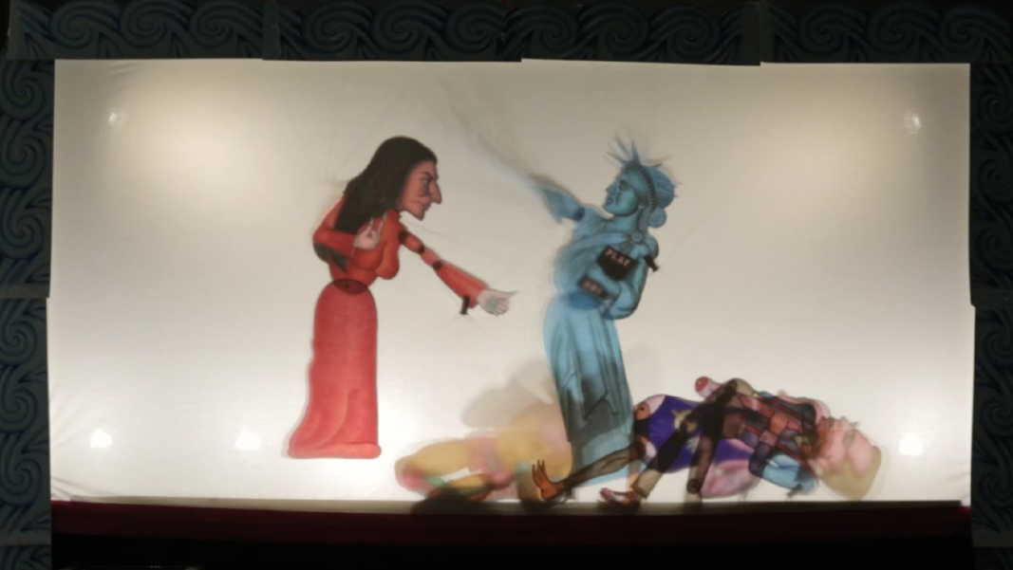
Amusementorium

Artist: Spyros Aggelopoulos
Location: Whitebox NYC and NYC University
Summary: GREECE IN USA has partnered with Spyros Aggelopoulos in a project that explores the traditional shadow theater in the modern context with the aim to define the dark spots of our national historiography.

This series of collaborative history and writing workshops aims to direct a new play starring Karagiozis as the leader of a cohort advocating for the "big idea" in Asia Minor, in an effort to challenge the established narratives about the war in Greece and Turkey. Since 2013, the core of Aggelopoulos’ artistic search and work is the world of Karagiozis and consequently the art of shadow theater. His work explores how the popular-national hero can exist in today's world and take on the role of storyteller in the present, while abandoning the nostalgic and subjective imprint of the past. His work is guided by its communication with the world of pop culture, psychology, archetypes, history and humor.

In collaboration with the anthropologists and historians of Columbia (mainly those who specialize in Greek and Ottoman history), data will be collected on this blurred historical condition and period, as well as on the two civilizations. Meanwhile the Writing, Visual Arts departments will contribute in the creation of the theatrical text, and the creation of original shadow theater figures, sets and special effects respectively. Columbia musicians in collaboration with my team of collaborators (traditional Greek musicians and composers) co-create the musical investment of the project.
- ΕΛΕVΣIS
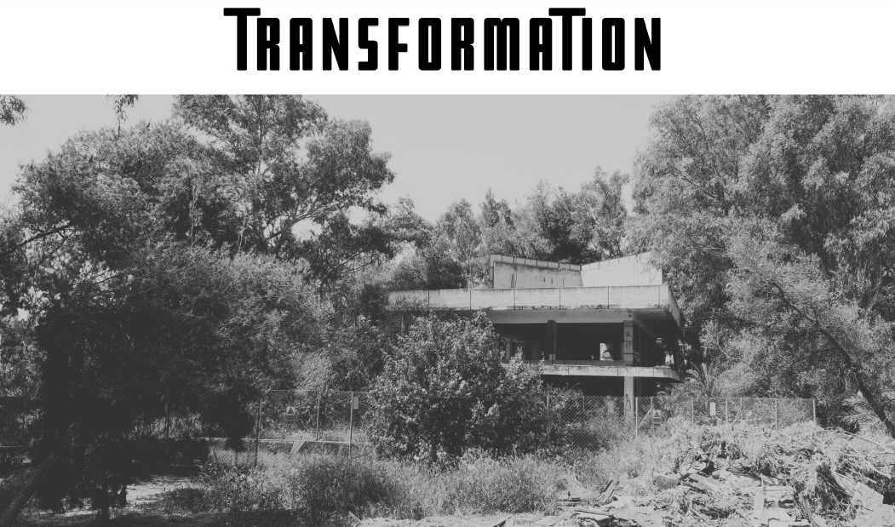
Artists: Professor Brian Michaels, Peter Pretscher, Dr. Jacek Luminski, Roger Kleiber, Yiannis Kotsonis, Dr. Sophia Antoniadou, Aggeliki Konstantinidi and Tina Zoubou, Catherine Peila
Location: Elefsina, Greece
Summary: GREECE IN USA has partnered with Kronology to transform an abandoned landscape into a flourishing world of the Goddess Demeter's magical gardens--augmented by video art, soundscapes and performance. An eco-cultural vision rebirthing the earth, manifesting bodies and art in space to recreate and interpret both the ancient ecstatic and modern industrial worlds. The EΛΕVΣIS project will re-connect the recent and contemporary history of Eleusis and its people.

One of the five most important sacred cities of antiquity, the center of the Eleusinian Mysteries and the birthplace of Aeschylus, Elefsina is a natural port in a strategic position, in the Thriassian Plain, just 21 km west of Athens. From the 19th century it was transformed into one of the largest industrial centers in Greece and a place of internal migration, offering fertile ground for the development of labor movements and the evolution of industrial architecture. In its post-industrial period, it is re-established through the title of European Capital of Culture for 2023, revealing the invisible side of a mysterious place. Marking a new era for the city and its evolution, through a new model of cultural development. Eleusis 2023 proposes the Mysteries of Transition, a series of multifaceted cultural activities – modern mysteries. A great European celebration of Culture focusing on Human, Society, the Environment and Labour.

- LUCAS SAMARAS, A Life
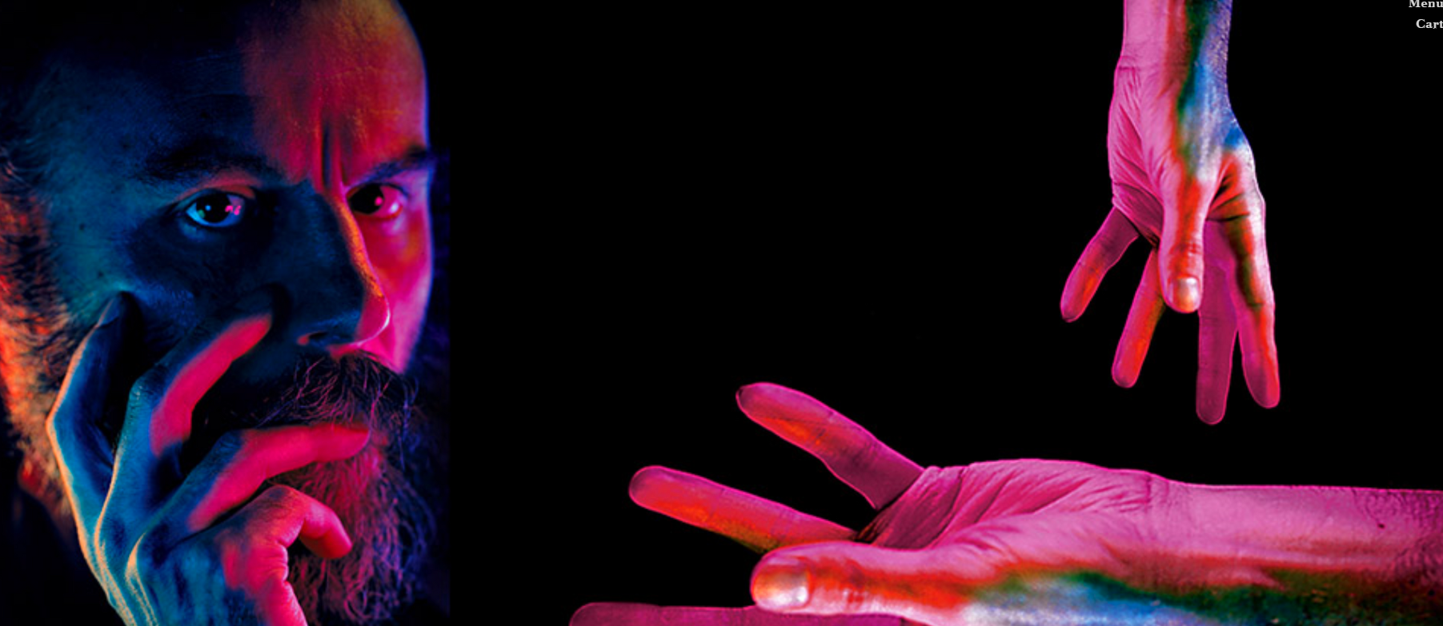Lucas Samaras
Artist: Michael Skafidas
Location: N/A
Summary: GREECE IN USA under the auspices of the Greek Ministry of Culture co-publishes the work Michael Skafidas. From his sensitive evocation of Samaras’ childhood in wartime Greece through to his perceptive interpretation of the artist’s career in the United States, Michael Skafidas has produced an outstanding account of his subject’s life and work. It is also an intriguing record of his own relationship with Samaras, and a powerful mediation on the art of life-writing.

Lucas Samaras is one of the great avant-garde artists of our time. Renowned both for his innovative use of fabrics and for his skilful deployment of everyday objects in his installations, he is perhaps best known for his work in photography, where he often takes himself as a subject. This lavishly illustrated volume is the authoritative biography of a consummate self-portraitist and a riveting depiction of a paradoxical personality: of an artist whose work in the 1960s and ’70s “prefigured the vindicated narcissism of the selfie era”, but who also shows every sign of being “a quiet and agoraphobic maverick at war with the mindset of calculated sociability.”

GALAN TRIO in the US

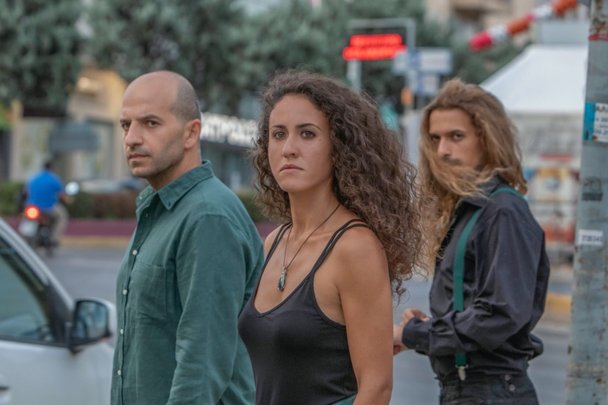
Galan Trio http://www.galantrio.com in New York

Artists: Petros Bouras, Babis Karasavvidis, Marina Kolovou
Location: Gorell Recital Hall, IUP, Indiana, PA
Gore Recital Hall, UD, Newark, DE
Rock Hall Aud, Temple University, Philadelphia, PA
Solmssen Court, UArts, Philadelphia, PA
Millard Auditorium, University of Hartford, CO
Summary: The GALAN TRIO project is part of GREECE IN USA’s new program GREECE NOW under the auspices of the Ministry of Culture focusing on Greek artists who experiment with “nowness” and reflect upon the ubiquity and social ramifications of “nowness” in their work.

GREECE IN USA presents Galan Trio’s “Kinesis,” a survey on the music of contemporary American composers in an original, multifaceted concert program. The project draws from a collaboration between Galan Trio and professors of composition from selected US Universities, and from the notion of “Kinesis.” Kinesis is an undirected movement of a cell, organism, or part, in response to an external stimulus. In Greek, Kinesis means movement, motion. Motion is a fundamental characteristic of all living beings; motion is what all musicians worldwide have desired during the last couple of years; motion alludes to continuity and it’s a promise for the future of “Kinesis” itself.

Greek Music Ensemble “Galan Trio” performs in five distinguished universities in Pennsylvania, Delaware and Connecticut presenting new commissions in collaboration with prominent composition professors. The first edition of the project featured the work of composers Nikitas Demos, Martin Gendelman, Paul Richards, Scott Robbins and Yiorgos Vassilandonakis who contributed one original work for piano trio reflecting on the period of the pandemic. The April 2022 edition features the work of Matthew Greenbaum, Todd Groves, John Levey, David Martynuik, Ken Steen and David Thomas.

3 movies with background of the “road map” in the area – History and stories

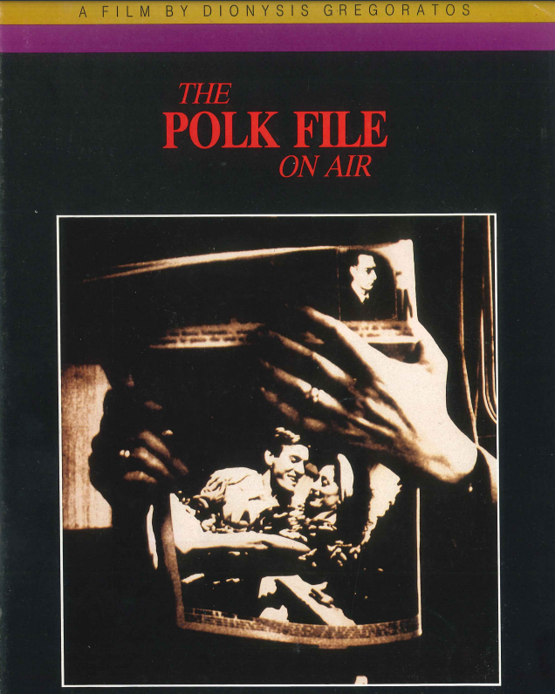

The Polk File On Air, cover
Artist: Dionysis Gregoratos
Location: N/A
Summary: GREECE IN USA partners with Dionysis Gregoratos to support his film project in gaining international recognition after the success of his film The Polk File on Air and the increased interest in the world of literature in the US on the case of George Polk’ murder.

Part of the project, therefore, is the critically acclaimed film The Polk File on Air which unfolds the story of the murder of American journalist George Polk. Considering that the murder triggered a climate of hysteria and terrorism in Greece, and the “contemporary” climate of hysteria due to current terrorisms on Greek soil, Gregoratos unfolds a story between a young couple, within the framework of a radio program, who look for the root cause as well as the analogies and differences between past and present. The fear, action and suspense which are prevalent even today, in the yet unsolved Polk case, enter their lives as well, with unforeseen consequences.

The film was acclaimed by the Thessaloniki Festival the Best Male Supporting Actor Award, Best Costume Design, Award for Best Editing and Special Award for Cinematography. Meanwhile it was nationally acclaimed with the Award for Best Original Screenplay, Costume Design, Editing, and acquired the State’s Award for Quality.

Space Oddity

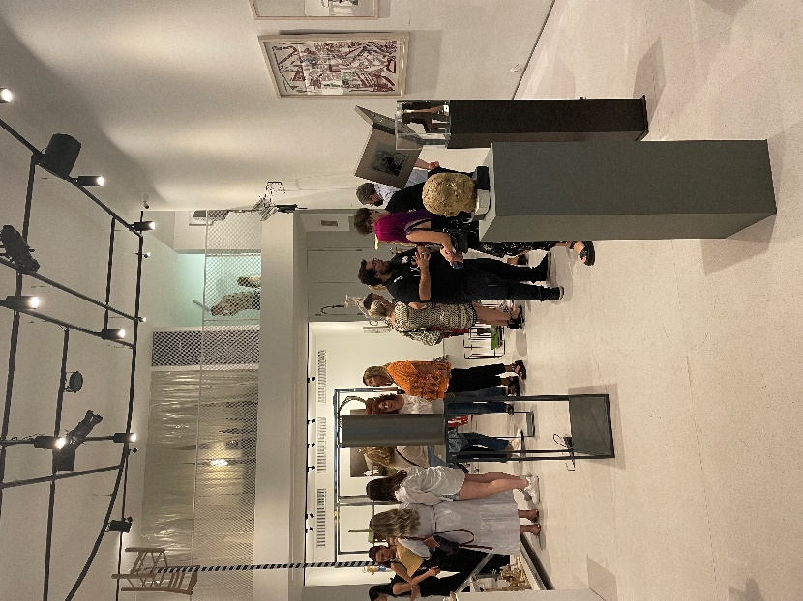

Opening event at Metaphor, Athens

Artists: Nikos Charalabidis, Robin Cofer, Santiago Sierra, Umut Ballikaya, Sarah Singh, Panorama editions, George Lappas, Juan Munoz, Savvas Christodoulidis, Antonis Michailidis, Panamarenko, Mounir Fatmi, Leda Papakonstantinou, George Kazazos, Aliki Palaska, Orlando Britto Jinorio, Charalabos Theodorou, Aggelos Papadimitriou, Charalambos Dermatis, Yiannis Gaitis, Andreas Liberatos, Panagiotis Siagris, Christos Katsinis, Michailangelos Vlassis-Ziakas, Txuspo Poyo, Vasiliki Sofra, Persefoni Zigomala, George Triadafilopoulos, Fotini Mastori, Zaharias Agiovlaitis, Pulvis Umbra, Marios Antoniadis, Costas Ziridis, Stergios Samsakis, Costas Filippou, Haris Kontosfyris, Kosmas Dendrinos, Panos Tsoukanas, Athanasia Tsatsou, Danai Gougia, George Choundas, Athanasia Kati, Giouli Chalari, Eliza Kalogianni, Anastasia Alexandri, Panos De Pinto, Antonis Petrakis, Konstantina Pontiki, Anna Papadopoulou, Pavlos Theodorou, Nikos Larios, Eleni Zervou, Kyriakos Mitropoulos, Vassilis Hantzis, Athanasios Triantos, Vassilis Loules, Stathis Fotis, Katerina Keramida, Charis Baskozos, Ismini Georgiadou, Eleni Voulala, Dimosthenis Chadoulis, Elisabet Papadimitriou, Giouli Chalari.
Date: 14 June – 2 July 2022, and Fall 2022
Location: Metaphor Athens, Athens, and New York
Summary: GREECE IN USA and Metaphor are co-organizing the Space Oddity project. The project takes place in multiple stages in Athens and New York, and includes the group exhibitions of renowned artists, lectures, performances, and workshops as part of the educational research programme Art Space Oddity (A.S.O.).

The modern society of satellite technologies and space excursions is rapidly reverting to darkness. Phenomena that have been placed in the human history are coming to front in a more urgent appeal due to the emergence of new generation diseases, resulting from toxic living conditions and environmental pollution. In this context the research project A.S.O focuses both on the anthropological type of life in the post human era of space, and on the transformational experiences of the humanitarian and energy crisis of our time, and conducts workshops with students to reflect on their own iconographic mythologies for the planetary epic of tomorrow.

The first part of the project takes place in Athens and unfolds as a conversation between the students’ works from the workshops organized by A.S.O., and the works of renowned artists. The second part includes big scale events in Athens and New York taking place in fall 2023. The closing of Space Oddity is a solo exhibition of Nikos Charalabidis organized by GREECE IN USA in partnership with the Ministry of Education and Sports Cyprus.

The Poetic Interstitial as Mediterranean Historiography: Konstantinos Kavafis

Portrait of Konstantinos Kavafis

Artists:
Location: N/A
Summary: GREECE IN USA supports “Hidden Things”; a panel discussion in which echoing Pamuk, it will be examined how Kavafis’s poetry calls for Mediterranean historiographies that challenge notions of “Greek origins” and that focus on the contributions of the African and Near Eastern populations to what Eurocentric approaches will later mark as “Greek antiquity.” By combining performative readings of excerpts from Kavafis’s poems “Ithaca,” “Thermopiles,” “Hidden Things,” “The Barbarians” and “The City” with presentations of scholarly work and discussion, this round table talk/ panel will explore the interstitiality of Kavafis’s work as poetic calls for Mediterranean historiographies that create alliances in ways that embrace pluralism without organizing it hierarchically.

In “Hidden Things” Konstantinos Kavafis invites us to sense freedom by embracing the interstitial that lies in-between cultures, religions, genders, languages, and fabricated-yet-real boundaries and binaries.The queer, ethnically Greek artist, was born in Alexandria, Egypt and lived as an eternal immigrant, in-between Egypt, Turkey, Greece and England. In his article “Other Countries, Other Shores” published by New York Times Orhan Pamuk writes that Kavafis’s poetry is inseparable from “the texture of Mediterranean Life.” For Kavafis that “texture” involves an experience of longing that, far from seeking for resolution, embraces the lived practice of waiting on its own terms liberated from any teleological orientations.

- The Fall of the House of Commons
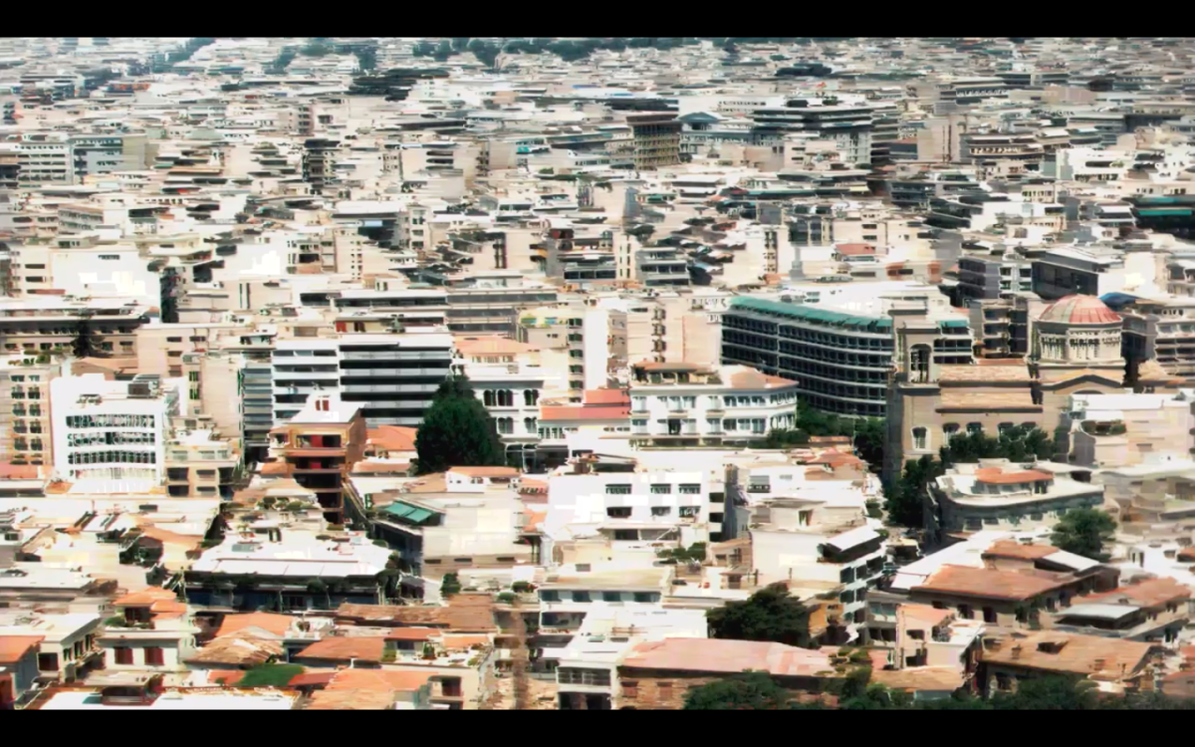
The Fall of the House of Commons, background picture

Artists: Orestis Papaioannou, Alekos Lountzis, Orfeas Apergis (co-author in the English version)
Location:
Summary: GREECE IN USA partners with Papaioannou and Loutzis to support the Sci-Fi opera based on material from an ever-closer reality. The Fall of the House of Usher is an exhaustively studied, continually “metastasising” work, minutely mapped to its last crack and fissure, including the one which proves to be the House’s undoing. The current emanating from “… the capital and capitalised FEAR, which builds up, is reviled, is revived and finally laid bare”[6] in the Ushers, has been conducted, in time, through the circuits of all the arts, from opera to the cinema, and has helped create webs of interpretation that its original creator would have found impossible to believe.

The plot unfolds over five scenes/episodes, centring on a broken couple (He and She) instead of Poe’s twins, a visitor (Danae or Her) who is the “double” of the lady of the house (She), and above all on an omnipresent and omni-presiding robotic personal assistant, who keeps a record of the House’s memories, the conflicts of its occupants, and the whole symbiotic crossword. this opera attempts to transfuse, not just to communicate, the sense of asphyxia felt in Poe’s iconic gothic House, into our homogenised present—no matter how we may subvert or underestimate it at times—in all its universal, price-tagged terror, its uniform tastes, its prefabricated fantasies. Further, the present work tries to turn to fruitful advantage its particular premise by projecting the atmosphere and feeling of Poe’s original story onto the only material nowadays found in abundance as this is methodically woven by the coming world of claustrophobia (or is it claustrophilia?) inside our very House.

- WOMANIFESTO: The first film-manifesto of the female artistic voice
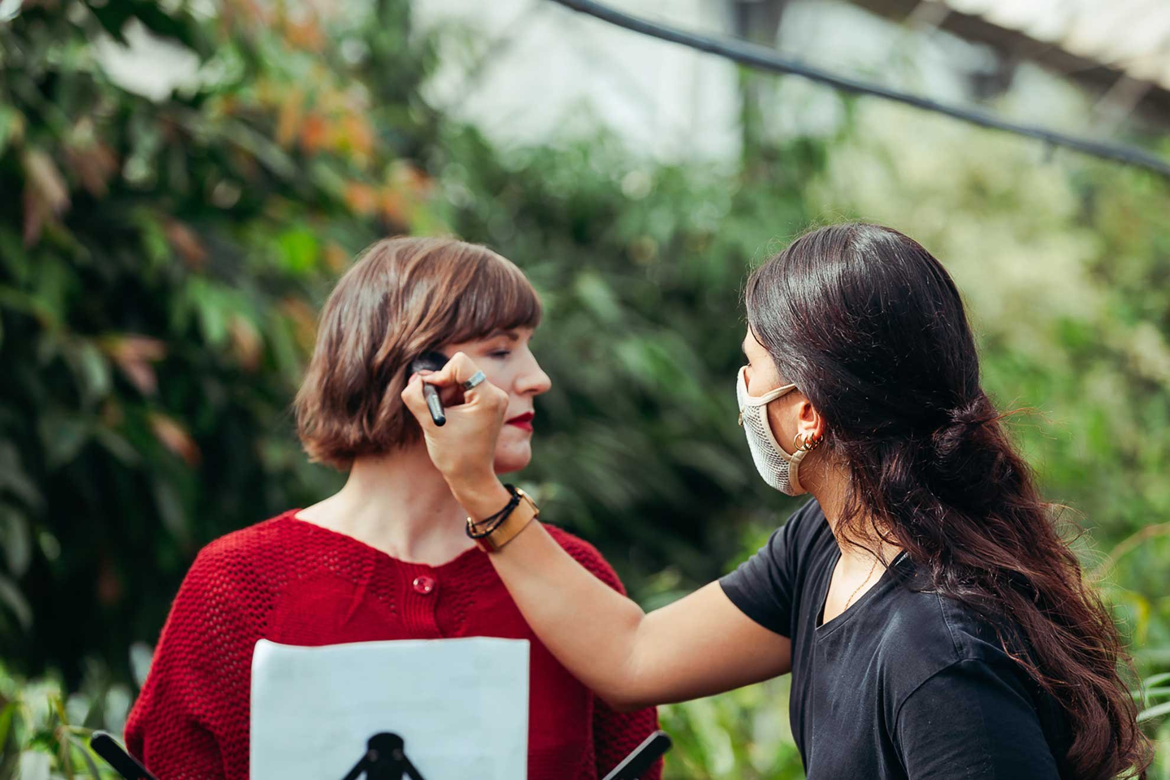
WOMANIFESTO (behind the scenes)

Artists: Efi Spyrou
Date: Summer 2022-2023
Location: Athens, New York
Summary: GREECE IN USA partners with WOMANIFESTO to create a 360-minute film embracing the female artistic voice. WOMANIFESTO invites women creators to write and present their own manifesto and own a minute of expression to disclose their own response to today’s challenges. Women of a wide age range and different nationalities are guided by their own artistic voice to create the first ever film manifesto; a film where the passion of expression and discussion between women and the arts flourish.

The long-term goal of the initiative is to act as an invitation to artists from all over the world, and eventually cross the borders of the initial dialogue to create a 360-minute film by 360 artistic manifestos by female artists. The filming of WOMANIFESTO II will take place in the middle of 2022 and will be presented with WOMANIFESTO I as a single screening in Athens in 2022-23.

- Shadows in Hades
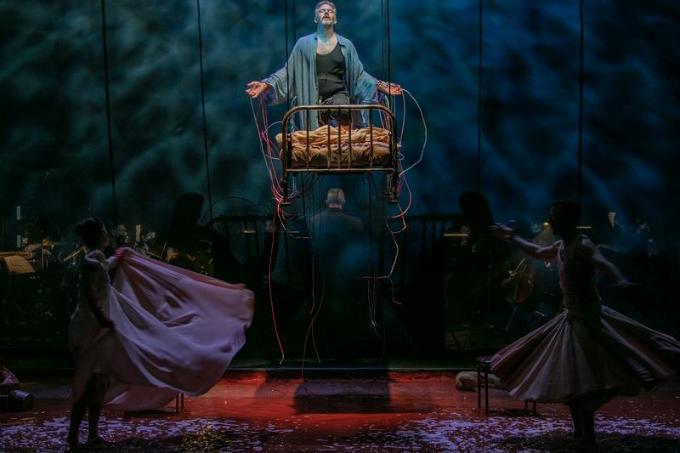
Shadows in Hades, Alexander Mouzas
Artists: Alexander Mouzas
Date:
Location: Athens, New York
Summary: GREECE IN USA supports the musical theater project Shadows in Hades which describes Byron's descent, in the form of the archetypal "fallen angel", into the wet and dystopian environment of Messolongion, into a Hades that traps in its Shadows, in a completely "Greek Gothic" environment. The work was supported by Stavros Niarchos Foundation in the context of the celebration of 200 years since the start of the Greek Revolution, and was presented for two performances in November 2021.

The work uses original texts of Lord Byron selected from his last letters from Greece, his travel work Child Harold , his play Cain , as well as his poems. In an evocative, soggy setting that vividly conveys the feeling of a fantasy Hades full of shadows, premonitions and memories, the atmospheric music of Alexandros Mouza flirts with cinematic aesthetics, framing in a unique way the demanding interpretation of the actor Christos Loulis. The latter in turn provides an ideal reading of a playful and poetic Lord Byron, obsessive and captive to his passions but also the glorious creator of his fate.

- ART SESSIONS 22
Artists: 14 select internationally renowned artists including Marcel Dzama, Penny Siopis, Andres Serrano, Laura Lima et al
Date:
Location: Greece, New York
Summary: ART SESSIONS 22 aims to establish a virtual interactive educational pilot program underwritten by Out Of The Box (GR Non-Profit), Design Farm (GR), Greece in USA (US Non-Profit), University of Ioannina (GR), School of Architecture, University of Patras (US), University of Nafplion, Art Department (GR), Arthur Ross Architecture Gallery, Columbia University (US), that will explore methods of disseminating artistic research in the (post) Pandemic Era and the ways cultural experimentation and remote learning can define the future of the public humanities in Greece. The program envisages the creation of a virtual platform through which the above organizations will provide a virtual communications hub where audiences in Greece will interact with Internationally acclaimed artists.
Art Sessions 22 aims initially to kickstart a public discourse through the hub about the effects, challenges, limits, freedoms and opportunities of emerging virtual interfaces increasingly adopted by the arts and public humanities. The impact of an exponentially accelerated adaptation of virtual over physical interfacing during the pandemic, due to necessity, has been introduced unfiltered due to circumstance. The research of this ongoing transformation is the underlying Topos and the Logos of the platform where critical issues will be addressed and debated, ranging from virtual everyday emotions, to virtual ethics, virtual market/ museums/ collectors, art currency nfts, virtual workspace incubators and virtual audiovisual productions. Marking the start of the project, Art Sessions After Covid-19 (A.C.19) is a virtual audiovisual production by Design Farm curated by Sozita Goudouna/ Greece in USA filmed during the peak of the pandemic. Currently in the final production stage (on location shooting in Greece and final editing) it will open the discussion on Virtual Audiovisual Production. The objective will be for participants, particularly students, to actively engage in the final phase of editing.

- Drama International Short Film Festival (DISFF)
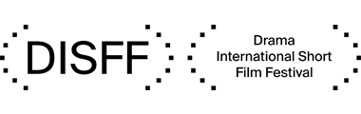
Artists:
Location: Drama
Summary: GREECE IN USA is strategic partner with DISFF. The Festival was established in 1978 and, since 1996, it is a Municipal Enterprise, whose purpose is: to promote and disseminate the art of cinema, and especially of the short film, in Greece and abroad, to develop a spirit of friendship and cooperation between filmmakers from all over the world, to organize screenings of Greek and foreign short films; film tributes; seminars, conferences, lectures and fora; art exhibitions; musical concerts; and theatrical performances, throughout the year, in the city of Drama, in Greece and abroad and to collaborate with similar institutions, both in Greece and abroad, towards the fostering and development of short film.

- The AfroGreeks
Artists: collective community project
Date: N/A
Location:
Summary: GREECE IN USA supports the AfroGreeks. The AfroGreeks is a collective community project in progress that will be presented as a video installation, accompanied by live events, workshops, open discussions, film screenings, co-operations with the communities and other actions, with the aim to give a voice and a means of expression to the “invisible” ones of Athens who stand up for being Greeks of African origin.

The project “the AfroGreeks” by Døcumatism, coordinated by filmmaker Menelaos Karamaghiolis, started in 2015 with actions that led to a public discussion in Kypseli, in 2019, about the African community in Athens, a first installation in the library for immigrants “We Need Books” and in the Catholic Church along with parallel events by the African community. The term was made openly known mainly through Instagram by the project and was adopted by young people of African descent who approached the project curious to learn what it was about. 200 AfroGreeks, the protagonists (up until now) of the project’s video installation, live and work in Greece, are proud of their origin, claim their right to be artists and strive to express themselves in every possible way. Their creative participation in the collective project “the AfroGreeks” offers them a chance to express themselves in order to become visible, to declare spyrothrough a work of art they take part in creatively in any possible way.

The aim of the project is to create an archive and a first record of the history of the African community in Greece in the 20th and 21th centuries, as an integral part of the national narrative and Greek history.The project is of particular importance both for its heroes and the artists that create it, as the AfroGreeks are “recognized” as Greeks through artistic procedures and as artists, they create their work and take part in a workshop that puts them in contact with their history and their past. A “task force” operates as part of the project, and in co-operation with communities and organizations, it intervenes in crucial questions of its heroes.

- The Callas
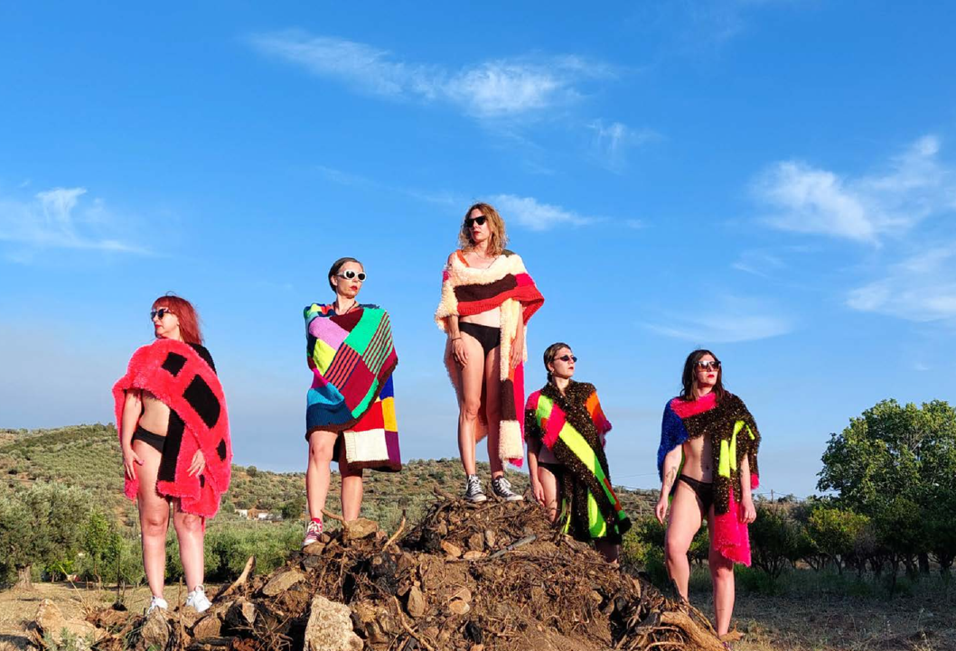
The Callas featuring The Callasettes

Artists: Lakis & Aris Ionas
Date: April 2023
Location: New York
Summary: GREECE IN USA supports “The Callas”. In essence a group of (primarily) friends and (secondarily) collaborators “The Callas” choreograph projects with DIY culture and aesthetics, with a blink to the weird Greek wave, but also with a completely uncomplicated voyeuristic look that in this certain of their films follow their sweet "nothings" and a vague family secret that hovers in the atmosphere and under the hot summer sun.

