Wednesday 18th October 2023
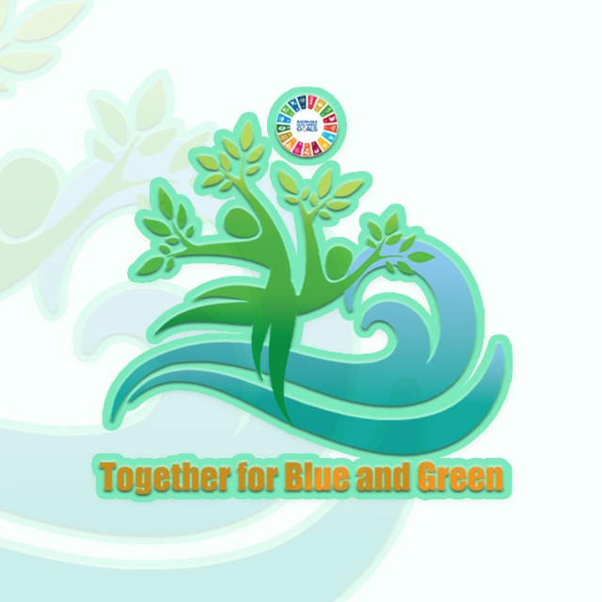
LCOY ALGERIA First edition 2023
Together for Blue and Green

FINAL REPORT

- Workshop Title: Addressing Loss and Damage due to Climate Change in Algeria and north Africa
- Duration: 1 hour 30 minutes
- Participants: 9 participants, All Students .
- Organization: -icebreaking (Q/A) 20minutes.
-Interactive Session (video projection and debate) 30 minutes .
- Advocacy training (presentation and debate) 30 minutes.
- Suggestions and recommendations .15min
Icebreaking session (starts 11:40)
The icebreaking session served to dissolve the initial formality among participants. The primary objective of this session was to kick-start the workshop and create a comfortable atmosphere.
It began with participants introducing themselves and subsequently responding orally to questions (in any language) posed by the facilitators. The questions were structured as follows: 'What is climate change?' and 'Do you believe climate change has had repercussions and consequences on Algeria? Please provide an explanation.'"
Participants were supplied with Post-it notes with the aim of encouraging written expression. This allowed participants to convey their comprehensive ideas and perspectives on climate change in Algeria. The collected insights served as valuable input for the facilitators, enabling them to tailor the workshop content, approach, and explanations accordingly.
Here were some answers:
Q1 – What is climate change ?
- Environmental degradation /Seasonal shift / Ozone hole / Imbalance in wildlife and flora and fauna .
Q2- 'Do you believe climate change has had repercussions and consequences on Algeria? Please provide an explanation
All answers were positive “YES”
-Emergence of diseases and allergies
-Decrease in precipitation (Answered by the majority of participants)

Interactive session
After the icebreaking session, a video illustrating the effects of climate change in Algeria was projected. The primary objective of this projection was to capture the participants' attention and underscore the assertion that climate change indeed has consequences on Algeria and the North African region. Following the screening, a debate was initiated to explore the ideas and perceptions held by the participants and to assess whether they were already aware of the consequences, even if they did not initially recognize them as effects of climate change. Simultaneously, this discussion directly initiated the core topic, which is was loss and damages due to climate change.
The debate revealed that the majority of participants were not well-informed about the various consequences of climate change on Algeria. However, they unanimously acknowledged the agricultural impacts and the ongoing water drought affecting the country.
Advocacy training
During this part of the workshop, the facilitators prepared a PowerPoint presentation. The subjects and titles presented were as follows:
-Introduction to Climate Change
-Assessing Loss and Damage
-Statistics on Loss and Damage from Climate Change
-Direct Impacts of Climate Change on Algeria and North Africa
-Mitigation Measures and Adaptation Measures
-Policy and Funding Gaps
Following the presentation, a debate and a question-and-answer session were initiated. The primary objective of this part was to open-eye and provide a comprehensive understanding of the issues at hand, enabling participants to recognize their significance and relevance.
Furthermore, it aimed to encourage and initiate participants to share their ideas and recommendations, making them aware of the challenges faced by the Conference of Youth (LCOY) and future Conference of the Parties (COP) meetings. This allowed them to understand that the youth's ideas hold significance, and they play a pivotal role in effecting change.
Suggestions and recommendations

After the debate and the recognition of the challenges at hand, the participants were given the opportunity to speak and put forth their recommendations. They were also provided with Post-it notes to ensure that even those who preferred expressing their ideas in writing had a chance to do so. The recommendations gathered by the facilitators were as follows:
- Develop technologies capable of replacing seawater desalination, which is already polluting, while addressing pollution as the primary reason for the need for drinkable water, creating a cyclical issue.
- Monitor agriculture practices, including water use, and reduce overall resource wastage.
- Enforce environmental control measures on individual citizens engaging in pollution through simple actions, as well as on industries causing ecological disasters.
- Introduce environmental education from a young age in educational institutions.
-Foster political will .
- Implement waste sorting and proper recycling.
- incorporate good habits into the daily lives of adults, and then extend them to children and students.
-Mandate training for startups.
-Initiate legal proceedings against individuals who litter in the streets.
CLOSURE (ends at 13:20)

