Curriculum Vitae 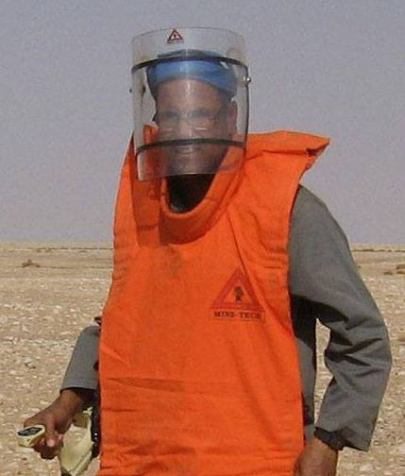

Personal data

Name and surname: Ahmed Amer Khalifa Gibril
Address: M.Matruh, Egypt
Telephone: 002-01094803307 -01224720816
E-mail: Ahmed_amer_3000@yahoo.com
Nationality: Egyptian
Birth Date: Jun. 12, 1968 Matruh ,Egypt
Driving License : license is available
Military Service: Completed
Experience Years : Over 17 years

Academic qualifications
- studying a doctorate in mine action for humanity, Ain Shams University EGYPT
- Master for Mine action management to reduce environmental damage & Environmental impact assessment in contaminated areas in Institute for Environmental Studies and Research, Ain Shams University. EGYPT
- Good experience in demining, victim assistance,& preparation, planning, implementation, monitoring and evaluation of mine risk education activities in war-contaminated areas

LANGUAGES
- Arabic – Mother Tongue
- English - Fluent (Speaking and Writing)

Professional skills
- MRE &VA Consultant for Egypt Mine Action Project
- Consultant and Lecturer at Mine Tech Egypt centre for Mine Action services
- Development Advisor for the Survivors land mines Association for Sustainable

Experience
- Technical and non-technical survey in contaminated areas ROW
- Management, Planning, supervising and Controlling the MRE Teams
- UXO Clearance using the Visual Search Method IMAS
- Management Health, safety and environmental in contaminated areas
- Management of sites in contaminated areas from ROW
- Management, Planning MRE activities in contaminated areas
- Reporting to the client about the UXO Finding Daily

Summary of field experiences and skills
The skills include
1- Consultant of Mine Tech Egypt company for Mine Action Services in Egypt Provide environmental services and consultation on the impact of mines and war remnants on the environment for the companies of excellence Khaleda, Apache, Shell, Bapetco , the EDC ,and the service companies and industrial and tourism investment projects through;
- Identification of areas contaminated with mines and remnants of war in Western Desert
- Presenting lectures and training courses on MRE mine risk education
2- Advisor to the Landmine Survivors' Organization for Sustainable Development and Humanitarian Action;
- Physical rehabilitation services and the installation of prosthetic devices prostheses
- Social and economic rehabilitation services for survivors and families of victims
- Community culture on mine and war debris education
- Promoting the rights of persons with disabilities and human rights
3- Quality Control and Quality Assurance for Mine Action Mine Action with UNDP and the Ministry of International Cooperation through ;
- Quality Assurance Monitor on Landmine Clearance Activities in Cooperation with the Ministry of Investment International Cooperation and the Egypt Landmine Control Project with the United Nations Development Program, the European Union and the Armed Forces in Clear Areas for the Ministry of Agriculture
- management, planning and supervision of mine, unexploded ordnance disposal, ammo and demining teams through manual detection
- Removal of unexploded ordnance using optical scanning
- MRE and unexploded ordnance on ROW
- Prepare daily and monthly reports at the end of the project
- Good instructor in high skills in the management of the transfer, storage and use of explosives and radioactive materials for the benefit of petroleum services companies and awareness of the dangers of explosives and radioactive materials from 2000 to 2003
- Good training in mine and ERW skills in civilian communities and ERW areas. Security, safety and environmental protection in ERW areas, community outreach with grassroots and executive leaders, police and army in contaminated areas, minimizing the psychological impact of civilians and helping mine victims
Studies and reports
- A study on mines as obstacles for sustainable development in the Western desert.
- Preparation and dissemination of MRE Book to the Ministry of Education
- The environmental implications of the existence of military waste of World War II in the western desert in EGYPT
- Social problems resulting from World War II in Egypt
- Monitoring and monitoring activities related to mines and unexploded ordnance in Egypt
- Monthly and annual reports to monitor mine action in the Western Sahara
- Prepare documentaries, articles and news releases on mine action in Egypt
Cooperation partners
- United Nations Development Programmers
- League of Arab States
- Institute of Environmental Studies and Research
- Desert Research Center Ministry of Agriculture
- Center for Science and Strategic Studies
- Nasser Academy for Military Sciences
- Mine Action Project in Egypt
- Ministry of Investment and International Cooperation
- Hans-Seidel Foundation
- Ministry of Education and Scientific Research
- General Petroleum Corporation
- Information Center of the Council of Ministers

Please find the attached letters of some recommendations and Appreciation Letters from different Clients.

