THE HISTORY OF HOLY WATER

(AND THE DISCOVERY OF MOUNT ZION FOUNTAIN)

A Unifying Spring for People of All Faiths

by

Brandon WinsGaris

Brandon WinsGaris
15717 Gypsy St
Corpus Christi, TX 78418
Brandonwgaris@gmail.com
www.BrandonWinsGaris.com
361.500.1814

Contents

Overview Page 3
Ritual Purification Overview Page 4
Fountain of Life Page 11
Molten Sea Page 15
Zamzam Well Page 17
Old Jerusalem’s Living Waters Page 19
The Lower Aqueduct of Jerusalem Page 26
Mount Zion Fountain Page 39
Conclusion Page 51

Overview

Water is one of humanity's most important resources—physically and spiritually. This cross-cultural book, though non-proselytizing, explores the history of Holy Water. In other words, it illustrates the various ways water has been used throughout the ages for spiritual purposes in three well-known religions: Judaism, Christianity, and Islam. Followers of different faiths are often divided, but the singular, most common characteristic shared amongst world religions is the ritual use of Holy Water and its association to the divine. In that sense, this book is meant to serve as a bridge across the often-raging river of disagreement between those who value both spirituality and unity.

This book also documents the landmark discovery of the Mount Zion Fountain and Jerusalem Aqueduct System that extends from the Solomon’s Pools in Bethlehem to the fountain and beyond—a find comparable to the Dead Sea Scrolls. The Dead Sea Scrolls were first discovered by a group of three Bedouin shepherds in 1946 from the Qumran Caves. It's been reported that a Bedouin shepherd had been looking for a lost goat when he came across the cave. He assumed his goat had gotten stuck inside and he tossed a rock in the cave’s narrow opening to see if the goat would respond. To his surprise, the sound of pottery shattering echoed out instead.

I, too, am a “Bedouin shepherd,” casting my discovery of the Mount Zion Fountain out into the world. The discovery took place during an extended trip to the Holy Land in 2003. I was a college student at the time, and, like most college students, I was poor and wondering what I was going to do for my summer break. I did what most millennial college kids do and started Googling. Besides visiting the beach and nature walks, there weren't many free activities, but I came across Birthright Israel, a program advertising a free trip to Israel. There was a requirement that you be of Jewish descent, and I'm not, but I wrote a letter to the director explaining my appreciation for the teachings of Judah and I was accepted!

The Hebrew University where I stayed is situated on the top of the Mount of Olives, overlooking the Old City of Jerusalem to the West. I studied Biblical Hebrew for a few hours every day in class and spent the rest of the time following where the Spirit led me on foot all around Old Jerusalem. I became good friends with a prominent Palestinian family, who has lived above and around the Gihon Spring area since Biblical times, or so it seems. In addition to this Palestinian family, I also became very good friends with a lady that owned an Armenian food restaurant by Jaffa Gate called Queenies, where I ate a meal almost every day while out on my excursions.

My priceless experiences with those families helped me discover the Mount Zion Fountain. The story of Holy Water and the fountain are the story of humanity, a shared ancestry from Adam and Eve to the seed of Abraham to today. Mount Zion Fountain is a revelation of the Holy Land and is as true as water flowing naturally downhill from the highest point, which will, in turn, open the curtain to the house of God. Exploring the lost orthodoxy of the Well Spring of Life and the blessing of the renewal of life from the Mount Zion Fountain is healing and unifying—and perhaps a divine solution to peace in the Holy Land rooted in spiritual cleansing.
In a world divided, water can unite us.
Ritual Purification Overview

As a sacred element of life, water is considered a purifier in most religions, however in general people are unaware of the rituals of Holy Water in differing religions and cultures from one another. For example, Judaism uses the Mikveh, a holy bath of water, which offers the individual, the community, and the nation of Israel the remarkable gift of purity and holiness. The role of immersion in the Mikveh has offered a gateway to purity ever since the creation of man. In Islam, the five daily prayers can be done in most cases (Tayammum) after completing washing certain parts of the body using clean water (wudu). One of the most prominent features of the Islamic faith is the practice of Taharah, meaning purification, through purity, cleanliness of body, clothes, place, and all aspects of Muslim’s life. Taharah (Purification) is a prerequisite for all Islamic ‘Ibadah (Worship). In, Christianity, the baptism in water of Jesus Christ is an important moment in Christian theology, and is the third most important feast of the Church called Theophany or Epiphany, following Easter and Pentecost. For roles of consecration, Christian’s use Holy Water for the sacrament of baptism to cleanse away the original sin, blessings of persons, places, and objects, or as a means of repelling evil.
Through God’s design the King of King’s has created this sacrament of divine grace through Holy Water that can cleanse away the profane, creating purification and spiritual rebirth. Be holy as God is holy, be cleansed by the washing of water through the Word!

2 Peter 3:5
⁵ But they deliberately forget that long ago by God’s word the heavens came into being and the earth was formed out of water and by water.
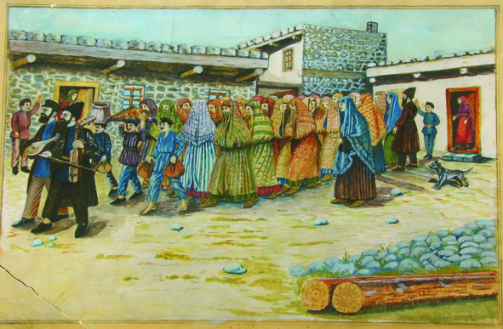
Taking the bride to the bath house (Mikveh), Shalom Koboshvili, 1939.
Ritual purification is a feature of many religions, not only to include Judaism, Islam and Christianity, but also Hinduism, Buddhism, Sikhism, the Bahá'í Faith, Shinto, Taoism, and the Rastafari movement. The aim of these rituals is to remove specifically defined uncleanliness prior to a particular type of activity, and especially prior to the worship of a deity. This ritual uncleanliness is not identical with ordinary physical impurity, such as dirt stains; nevertheless, body fluids are generally considered ritually unclean. The purpose of ritual purification is to cleanse the inner soul, from the sinful material world, to have a purer divine connection to the almighty allowing the purest spirit of light to shine from your soul creating a higher state of wellbeing of the divine self to be amongst the presence of the Lord God Almighty! This purified more divine self then serves the greater truth in life by creating and surviving in a better and more divine Earthly world as it is in heaven.
Through the comparative study of the major monotheistic Abrahamic religions, this book will help yield a deeper understanding of the fundamental philosophical concerns of ritual purification through use of water as the medium to wash away the sins of the world in the following religions: Judaism, Islam and Christianity.

Proverbs 18:4
The words of the mouth are deep waters, but the fountain of wisdom is a rushing stream.

Judaism

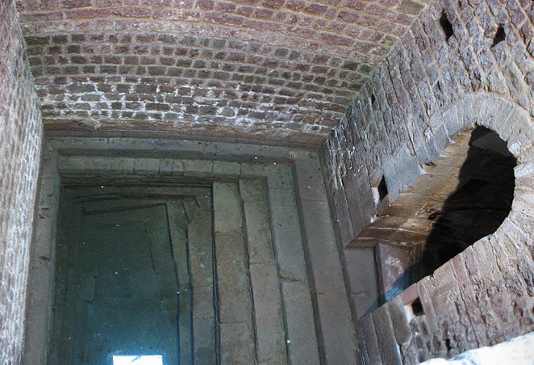
Pool of a medieval mikvah in Speyer, dating back to 1128.

The Hebrew Bible has many rituals of purification relating to menstruation, childbirth, sexual relations, nocturnal emission, unusual bodily fluids, skin disease, death, and animal sacrifices. Modern mainstream Judaism is based on a combination of the Hebrew Bible and Jewish oral law, which includes the Mishnah and Gemarrah (together comprising the Talmud) in addition to other rabbinic commentaries; this oral law further specifies regulations for ritual purity, including obligations relating to excretory functions, meals, and waking. The regulations of biblical and oral law generally prescribe a form of water-based ritual washing in Judaism for removal of any ritual impurity, sometimes requiring just washing of the hands, and at other times
requiring full immersion; the oral law requires the use of un-drawn water for any ritual full
immersion - either a natural river/stream/spring, or a special bath (a Mikvah), which contains rain-water.
These regulations were variously observed by the ancient Israelites; contemporary Orthodox Jews and (with some modifications and additional leniencies) some Conservative Jews continue to observe the regulations, except for those tied to sacrifice in the Temple in Jerusalem, as the Temple no longer fully exists. These groups continue to observe many of the hand washing rituals. Of those connected with full ritual immersion, perhaps the quintessential immersion rituals still carried out are those related to nidda, according to which a menstruating woman must avoid contact with her husband, especially avoiding sexual contact, and may only resume contact after she has first immersed herself fully in a mikvah of living water seven days after her menstruation has ceased.
In December 2006, the Committee on Jewish Law and Standards of Conservative Judaism re-affirmed the traditional requirement that Conservative women ritually immerse following menstruation. In doing so, it adopted multiple opinions regarding details, including an opinion reaffirming traditional (Orthodox) practices and concepts, an opinion adapting certain leniencies, including counting seven days from start of menstruation rather than its end, and an opinion reformulating the theological basis of the practice, basing it on concepts other than ritual purity. Classical ritual immersion and associated requirements are generally not observed by Reform Judaism or Reconstructionist Judaism, with the exception that both generally include immersion as part of the ritual for Conversion to Judaism, although Reform Judaism does not require it.

Ezekiel 36:25
I will sprinkle clean water on you, and you will be clean
Islam

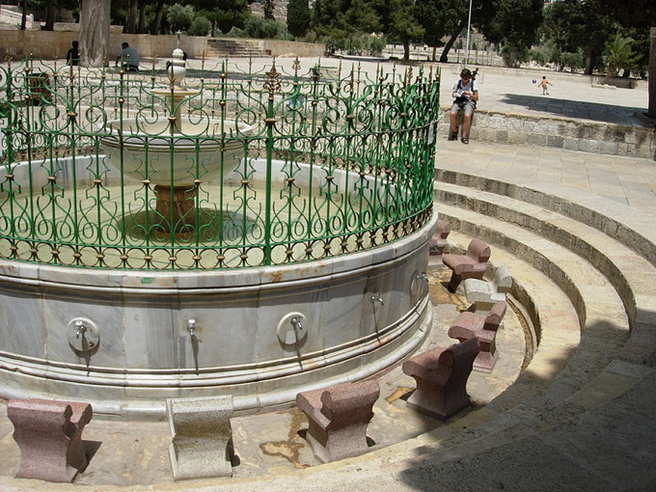The al-Kas ablution fountain, washing station in the Al-Aqsa Mosque on the Temple Mount, Jerusalem, Israel.

Islamic ritual purification is particularly centered on the preparation for ritual prayer; theoretically ritual purification would remain valid throughout the day, but is treated as invalid on the occurrence of certain acts: flatulence, sleep, contact with the opposite gender (depending on which school of thought), unconsciousness, and the emission of blood, semen, or vomit. Some schools of thought mandate that ritual purity is necessary for holding the Qur’an.
Ritual purification takes the form of ablution, in a lesser form (wudu), and greater form (ghusl), depending on the circumstance; the greater form is obligatory by a woman after she ceases menstruation, on a corpse that didn’t die during battle and after sexual activity, and is optionally used on other occasions, for example just prior to Friday prayers or entering ihram.
An alternative “dry ablution” (tayammum), involving clean sand or earth, is used if clean water is not available or if suffering from an illness which would be worsened by the use of water; this form is invalidated in the same circumstances as the other forms, and also whenever water becomes available and safe to use. And is also necessary to be repeated (renewed) before every obligatory prayer.
The obligatory activities of the lesser form include beginning with the intention to purify oneself, washing of the face, arms, head, and feet. While some optional acts also exist such as recitation of the Bismillah, Oral hygiene / the brushing of the teeth, the washing of the mouth, nose at the beginning, washing of arms to the elbows and washing of the ears at the end; additionally, recitation of the Shahadah. The greater form (ghusl) is completed by first performing wudu and then ensuring the entire body is washed. Some minor details of Islamic ritual purification may vary between different schools of thought as well as scholarly opinions and between the different sects of Islam.

The Noble Quran, Surah Al-Anfal [8:11]
[Remember] when He overwhelmed you with drowsiness [giving] security from Him and sent down upon you from the sky, rain by which to purify you and remove from you the evil [suggestions] of Satan and to make steadfast your hearts and plant firmly thereby your feet.

Christianity

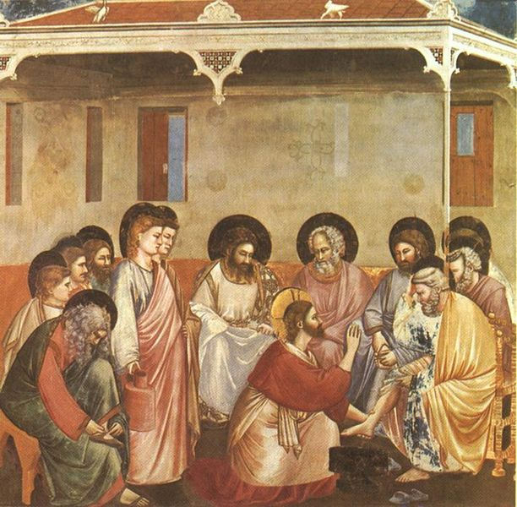
Giotto di Bondone (1267-1337), Cappella Scrovegni a Padova, Life of Christ, Washing of Feet.

Baptism, as a form of ritual purification, occurs in several religions related to Judaism, and most prominently in Christianity; Christianity also has other forms of ritual purification. In older churches, and modern Roman Catholic churches, there are a number of lavers around the building for the laity to use as ritual symbolism of cleansing themselves, usually by dipping the fingertips in the holy water, and then making the sign of the cross. In traditional liturgical churches a laver, often embedded in the wall, exists for the priest and deacon to wash their hands before celebrating the Eucharist.
Many ancient churches were built with a large fountain in the courtyard. It was the tradition for Christians to wash before entering the church for worship. This usage is also legislated in the Rule of St. Benedict, as a result of which, many medieval monasteries were built with communal lavers for the monks or nuns to wash up before the Daily Office.
Traditionally, Christianity adhered to the biblical regulation requiring the purification of women after childbirth; this practice was adapted into a special ritual known as the churching of women, for which there exists liturgy in the Church of England’s Book of Common Prayer, but its use is now rare in Western Christianity. The churching of women is still performed in a number of Eastern Orthodox, Oriental Orthodox and Eastern Catholic churches.
Roman Catholics, Eastern Orthodox and High church Anglicans are also traditionally required to regularly attend confession, as a form of ritual purification from sin, especially as preparation before receiving the Eucharist. For Catholics, this is required at least once a year and required for those who are guilty of unconfessed mortal sins.
In Reformed Christianity, ritual purity is achieved through the Confession of Sins, and Assurance of Forgiveness, and Sanctification. Through the power of the Holy Spirit, believers offer their whole being and labor as a ‘living sacrifice’; and cleanliness becomes a way of life;

Romans 12:1-2

A Living Sacrifice
12 Therefore, I urge you, brothers and sisters, in view of God’s mercy, to offer your bodies as a living sacrifice, holy and pleasing to God—this is your true and proper worship. ² Do not conform to the pattern of this world, but be transformed by the renewing of your mind. Then you will be able to test and approve what God’s will is—his good, pleasing and perfect will.

John 13:1-17

Jesus Washes His Disciples’ Feet
13 It was just before the Passover Festival. Jesus knew that the hour had come for him to leave this world and go to the Father. Having loved his own who were in the world, he loved them to the end.
² The evening meal was in progress, and the devil had already prompted Judas, the son of Simon Iscariot, to betray Jesus. ³ Jesus knew that the Father had put all things under his power, and that he had come from God and was returning to God; ⁴ so he got up from the meal, took off his outer clothing, and wrapped a towel around his waist. ⁵ After that, he poured water into a basin and began to wash his disciples’ feet, drying them with the towel that was wrapped around him.
⁶ He came to Simon Peter, who said to him, “Lord, are you going to wash my feet?”
⁷ Jesus replied, “You do not realize now what I am doing, but later you will understand.”
⁸ “No,” said Peter, “you shall never wash my feet.”
Jesus answered, “Unless I wash you, you have no part with me.”
⁹ “Then, Lord,” Simon Peter replied, “not just my feet but my hands and my head as well!”
¹⁰ Jesus answered, “Those who have had a bath need only to wash their feet; their whole body is clean. And you are clean, though not every one of you.” ¹¹ For he knew who was going to betray him and that was why he said not every one was clean.
¹² When he had finished washing their feet, he put on his clothes and returned to his place. “Do you understand what I have done for you?” he asked them. ¹³ “You call me ‘Teacher’ and ‘Lord,’ and rightly so, for that is what I am. ¹⁴ Now that I, your Lord and Teacher, have washed your feet, you also should wash one another’s feet. ¹⁵ I have set you an example that you should do as I have done for you. ¹⁶ Very truly I tell you, no servant is greater than his master, nor is a messenger greater than the one who sent him. ¹⁷ Now that you know these things, you will be blessed if you do them.

Fountain of Life

The Fountain of Life, or in its earlier form the Fountain of Living Waters, is a Christian iconography symbol associated with baptism, first appearing in the 5th century in illuminated manuscripts and later in other art forms such as panel paintings.
The symbol is usually shown as a fountain enclosed in a hexagonal structure capped by a rounded dome and supported by eight columns. The fountain of living waters, fons vivus is a baptismal font (a water fountain in which one is baptized, and thus reborn with Christ), and is often surrounded by animals associated with Baptism such as deer. The font probably represents the octagonal Lateran Baptistery in Rome, consecrated by Pope Sixtus III (432-440), which was iconographically associated with the fountain of the water of life mentioned in;

Revelation 21:6
⁶ He said to me: “It is done. I am the Alpha and the Omega, the Beginning and the End. To the thirsty I will give water without cost from the spring of the water of life.

Revelation 7:17
17 For the Lamb at the center of the throne
will be their shepherd;
‘he will lead them to springs of living water.’
‘And God will wipe away every tear from their eyes.’”

The best examples date from the Carolingian period: the Godescalc Evangelistary made to commemorate the Baptism of the son of Charlemagne in 781, and in the Soissons Gospels.

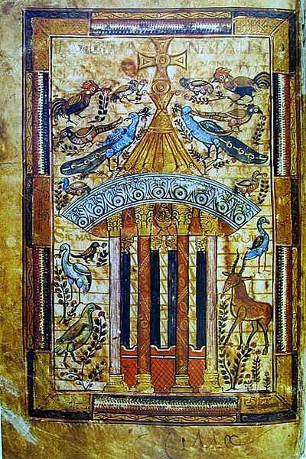
Godescalc Evangelistary, commemorating the Baptism of Charlemagne’s son in Rome in 781 with an image of the Fountain of Life.
Proverbs 10:11
The mouth of the righteous is a Fountain of Life!
Proverbs 13:14
The teaching of the wise is a Fountain of Life, turning a person from the snares of death!
Proverbs 14:27
The fear of the Lord is a Fountain of Life, turning a person from the snares of death!

In the Ghent Altarpiece: The Adoration of the Lamb by Jan Van Eyck (1438), the Lamb of God stands upon an altar dressed as for the Mass of the Precious Blood, with a blood-red frontal: the Lamb’s blood is caught in a chalice, and its Eucharistic intention is signaled by the dove of the Holy Spirit above. In the foreground, offering the other means of grace is the Fountain of the Living Water surrounded by the faithful.

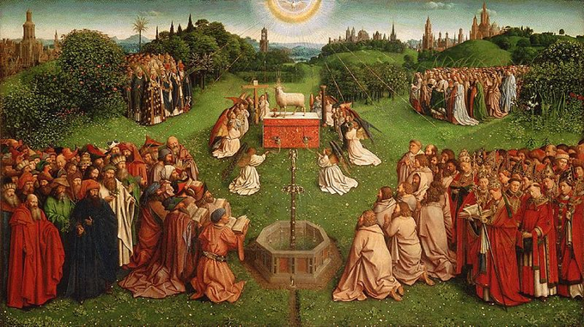
The central “Adoration of the Mystic Lamb” panel. The groupings of figures are, from top left anti-clockwise: the male martyrs, the pagan writers and Jewish prophets, the Male saints, and the female martyrs.

In Flanders at the close of the Middle Ages an intense devotion to the Precious Blood of Christ gave rise to an iconographic tradition of the 15th and 16th centuries, which rendered the theological concept of Grace, expressing Roman Catholic dogma allegorically as a fountain of blood. This transformation was first addressed in Evelyn Underhill in 1910, taking her point of departure an Assembly of Saints and the Fountain of Life of 1596 in Ghent, in which blood from the five Holy Wounds of Christ into the upper basin of a “Fountain of Life” and streams out through openings in the lower “Fountain of Mercy”. Saints and martyrs, patriarchs and prophets hold golden chalices of blood, which some empty into the fountain and the faithful hold out their hearts to receive droplets of blood.
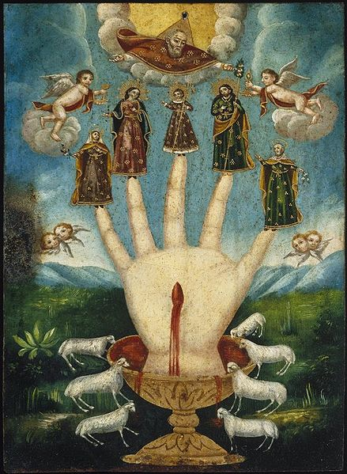
The fountain of blood icon in a Mexican painting, 18th century (Brooklyn Museum).

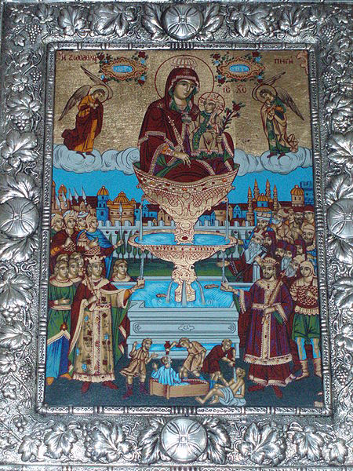
Greek icon of the Theotokos, Life-giving Spring.

The Mother of God of the Life-giving Spring or Life-giving Font is an epithet of the Holy Theotokos that originated with her revelation of a sacred spring in Valoukli, Constantinople, to a soldier named Leo Marcellus, who later became Byzantine Emperor Leo I (457-474). Leo built the historic Church of St. Mary of the Spring over this site, which witnessed numerous miraculous healings over the centuries, through her intercessions, becoming one of the most important pilgrimage sites in Greek Orthodoxy. Thus, the term “Life-giving Font” became an epithet of the Holy Theotokos and she was represented as such in iconography.
The feast day of the Life-giving Spring is celebrated on Bright Friday in the Orthodox Church, and in those Eastern Catholic Churches following the Byzantine Rite. Additionally, the icon of the Theotokos the “Life-giving Spring” is commemorated on April 4/17 in Slavic Orthodox churches.

Isaiah 41:18
¹⁸I will make rivers flow on barren heights,
And springs within the valleys.
I will turn the desert into pools of water,
And the parched ground into springs.

Isaiah 49:10
¹⁰They will neither hunger nor thirst,
nor will the desert heat or the sun beat down on them.
He who has compassion on them will guide them
and lead them beside springs of water.

Numbers 21:16-17
“Gather the people together and I will give them water.”
¹⁷Then Israel sang this song:
“Spring up, O well! Sing about it”

Job 29:23
They waited for me as for showers
And drank in my words as the Spring rain.

Psalms 114:8
Who turned the rock into a pool, The hard rock into springs of water.

Molten Sea

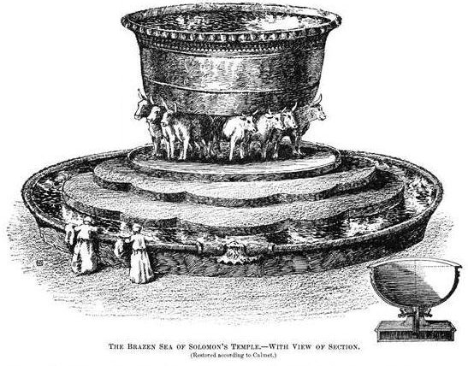
An artist's rendition of the Brazen Sea (or Molten Sea) of Solomon,
published in the 1906 Jewish Encyclopedia.

The Molten Sea or Brazen Sea (ים מוצק "cast metal sea") was a large basin in the Temple in Jerusalem made by Solomon for ablution of the priests. It is described in 1 Kings 7 and 2 Chronicles 4.
The Molten Sea stood in the southeastern corner of the inner court. The fact that it was a washbasin that was too large to enter from above lends to the idea that water would likely have flowed from it down into a sub-container beneath. The water was supplied by a conduit from Solomon's Pools. The Molten Sea was made of brass or bronze, which Solomon had taken from the captured cities of Hadarezer, the king of Zobah, 1 Chronicles 18:7-8. Ahaz later removed this laver from the oxen, and placed it on a stone pavement, 2 Kings 16:17-18. Then the Babylonians destroyed the Molten Sea, 2 Kings 25:1-16.

In Rabbinical Literature
The basin contained water sufficient for 150 ritual baths (mikvah). The symbolism of the brazen sea is described in detail in the Midrash Tadshe. The sea represented the world; the ten
cubits of diameter corresponded to the ten Sefirot; and it was round at the top as the heavens are
round. The depth of the sea was five cubits, corresponding to the distance of five hundred years' journey between heaven and earth (compare Chagigah 13a). The band of thirty cubits around it corresponded to the Ten Commandments, to the ten words of God at the creation of the world, and to the ten Sefirot: for the world can exist only when the Ten Commandments are observed; and the ten Sefirot as well as the ten words of God were the instruments of the Creation. The two rows of colocynths (knops) below the rim were symbolic of the sun and the moon, while the twelve oxen on which the sea rested represented the zodiac ("mazzalot"). It contained 2,000 baths (cubic measures), for the world will sustain him who keeps the Torah, which was created 2,000 years before the world (Midrash Tadshe ii., Epstein, in "Mi-Ḳadmoniyot ha-Yehudim," xvi., xvii.; Yalḳuṭ, Kings, 185)

2 Chronicles 4
The Temple’s Furnishings
¹He made a bronze altar twenty cubits long, twenty cubits wide and ten cubits high. ²He made the Sea of cast metal, circular in shape, measuring ten cubits from rim to rim and five cubits high. It took a line of thirty cubits to measure around it. ³Below the rim, figures of bulls encircled it—ten to a cubit. The bulls were cast in two rows in one piece with the Sea.
⁴The Sea stood on twelve bulls, three facing north, three facing west, three facing south and three facing east. The Sea rested on top of them, and their hindquarters were toward the center. ⁵It was a handbreadth in thickness, and its rim was like the rim of a cup, like a lily blossom. It held three thousand baths.
⁶He then made ten basins for washing and placed five on the south side and five on the
north. In them the things to be used for the burnt offerings were rinsed, but the Sea was to be
used by the priests for washing.

Zamzam Well

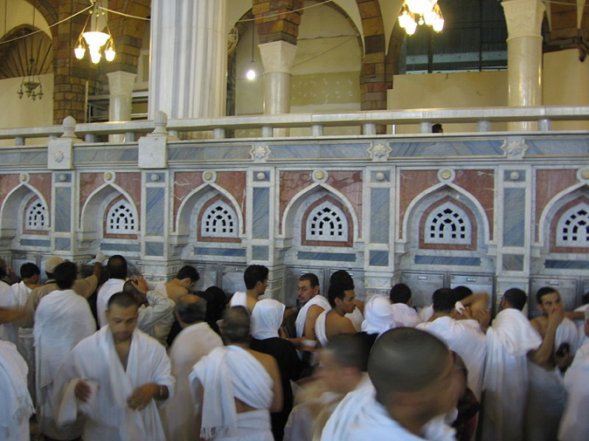
Pilgrims visiting Zamzam Well in Mecca, Saudi Arabia.

The Well of Zamzam (or the Zamzam Well, or just Zamzam; Arabic: زمزم‎) is a well located within the Masjid al-Haram in Mecca, Saudi Arabia, 20 m (66 ft) east of the Kaaba, the holiest place in Islam. According to Islamic belief, it is a miraculously-generated source of water from God, which began thousands of years ago when Abraham’s (Ibrāhīm) infant son Ishmael (ʼIsmāʻīl) was thirsty and kept crying for water. Millions of pilgrims visit the well each year while performing the Hajj or Umrah pilgrimages, in order to drink its water.
Muslims believe that the Zamzam well is a contemporary miracle, never having gone dry despite the millions of liters of water attributed to the well consumed every year. It had been deepened several times in history during periods of severe droughts.

Traditional Origin of the Zamzam Well:

Islamic history states that the Zamzam Well was revealed to Hagar, the second wife of Abraham and mother of Ismail. According to Islamic tradition, she was desperately seeking water for her infant son, but she could not find any, as Mecca is located in a hot dry valley with few sources of water. Muslim traditions say that Hagar ran seven times back and forth in the scorching heat between the two hills of Safa and Marwah, looking for water. Getting thirstier by the second, Ishmael scraped the land with his feet, where suddenly water sprang out. There are other versions of the story involving God sending his angel, Gabriel, who kicked the ground with his heel and the water rose.
The name of the well traditionally comes from the phrase Zomë Zomë, meaning ‘stop’, which, according to legend, was a command repeated by Hagar during her attempt to contain the spring water.
According to Islamic tradition, Abraham rebuilt the Bait-ul-Allah (“House of God”, cognate of the Hebrew-derived place name Bethel) near the site of the well, a building which had been originally constructed by Adam, and today is called the Kaaba, a building toward which all Muslims around the world face in prayer, five times each day. The Zamzam Well is located approximately 20 m (66 ft) east of the Kaaba.
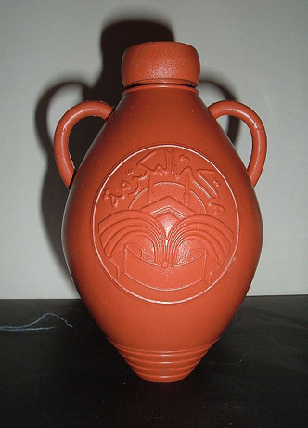
Bottle of Zamzam water as sold in the local mosque.

According to Islam Online, the well originally had two cisterns in the first era, one for drinking and one for ablution. At that time, it was a simple well surrounded by a fence of stones. Then in the era of the Abbasid caliph Al-Mansur 771 AD (149 AH) a dome was built above the well, and it was tiled with marble. In 775 AD (153 AH), Al-Mahdi rebuilt the well during his caliphate, and built a dome of teak which was covered with mosaic. One small dome covered the well, and a larger dome covered the room for the pilgrims. In 835 AD (213 AH) there was further restoration, and the dome was covered with marble during the caliphate of Al-Mu’tasim.
In 1417 (795 AH), during the time of the Mamluks, the mosque was damaged by fire, and required restoration. Further restoration occurred in 1430 (808 AH), and again in 1499 (877 AH) during the time of Sultan Qaitbay, when the marble was replaced.
In modern times, the most extensive restoration took place to the dome during the era of the Ottoman Sultan Abdul Hamid II in 1915 (1333 AH). To facilitate crowd control, the building housing the Zamzam was moved away from its original location, to get it out of the way of the Tawaf, when millions of pilgrims would circumambulate the Kaaba. The water of the well is now pumped to the eastern part of the mosque, where it was made available in separate locations for men and women.
Old Jerusalem’s Living Waters

Gihon Spring
The Gihon Spring was the main source of water for the City of David, the traditional original site of Jerusalem. One of the world's major intermittent springs - and a reliable water source that made human settlement possible in ancient Jerusalem - the spring was not only used for drinking water, but also initially for irrigation of gardens in the adjacent Kidron Valley which provided a food source for the ancient settlement. The spring, being intermittent, required the excavation of the Pool of Siloam which stored the large amount of water needed for the town when the spring was not flowing. Currently it is sometimes used by Jewish men as a sort of mikveh.

Three main water systems allowed water to be brought from the spring to the city under cover:

- The Middle Bronze Age channel - a fairly straight channel dating from the Middle Bronze Age, cut 20 feet into the ground, and then covered with slabs (which were then hidden by foliage). This led from the spring to the Pool of Siloam and was an aqueduct.

- Warren's Shaft - a steep tunnel, dating from slightly later than the Middle Bronze Age channel, leading from the Well Gate at the top of Ophel above Gihon, down to the spring. This passage was for people to collect water from the spring.

- Hezekiah's tunnel - a winding tunnel carved into the rock, leading from the spring to the Pool of Siloam. Dating from the time of Hezekiah, and seemingly built in response to the threat of siege by Sennacherib, it was an aqueduct that effectively replaced the Middle Bronze Age channel.

In 1997, while a visitor center was being constructed, the spring was discovered to have been heavily fortified since the Middle Bronze Age, when archaeologists unexpectedly uncovered two monumental towers - one protecting the base of Warren's Shaft, and the other protecting the spring itself. Due to the area around the site still being inhabited, and hence not excavated, it is unknown whether any further fortifications exist (though a further tower to the south of that protecting Warren's Shaft is thought likely).
During an archaeological dig in 2009, a fragment of a monumental stone inscription securely dated to the eighth century BC was discovered. Although only fragments of Hebrew lettering survive, the fragment proves that the city had monumental public inscriptions and the corresponding large public buildings in the eighth century.

Pool of Siloam
The Pool of Siloam (Hebrew: בריכת השילוח‎) (Breikhat Hashiloah) is a rock-cut pool on the southern slope of the City of David, the original site of Jerusalem, located outside the walls of the Old City to the southeast. The pool was fed by the waters of the Gihon Spring, carried there by two aqueducts.

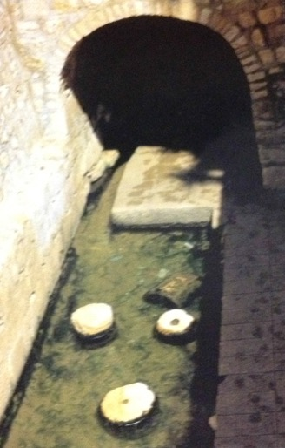
Pool of Siloam.

History
The Pool of Siloam is mentioned several times in the Bible. Isaiah 8:6 mentions the pool's waters, while Isaiah 22:9 refers to the construction of Hezekiah's tunnel.

Isaiah 8:6
⁶“Because this people has rejected
the gently flowing waters of Shiloah
and rejoices over Rezin
and the son of Remaliah,
Isaiah 22:9
⁹You saw that the walls of the City of David
were broken through in many places;
you stored up water
in the Lower Pool.

For Christians, the Pool of Siloam has additional special significance: it is mentioned in the Gospel of John as the location to which Jesus sent "a man blind from birth" in order to complete the healing of the man.

John 9:1-7
Jesus Heals a Man Born Blind
⁹As he went along, he saw a man blind from birth. ²His disciples asked him, “Rabbi,
who sinned, this man or his parents, that he was born blind?”
³“Neither this man nor his parents sinned,” said Jesus, “but this happened so that the works of God might be displayed in him. ⁴As long as it is day, we must do the works of him who sent me. Night is coming, when no one can work. ⁵While I am in the world, I am the light of the world.”
⁶After saying this, he spit on the ground, made some mud with the saliva, and put it on the man’s eyes. ⁷“Go,” he told him, “wash in the Pool of Siloam” (this word means “Sent”). So the man went and washed, and came home seeing.

A substantial remodeling of a nearby pool, thought to be the Pool of Siloam, was constructed in the 5th century under Byzantine direction and is said to have been built at the behest of Empress Aelia Eudocia. This pool, having been somewhat abandoned and left to ruin, partly survives to the present day, surrounded by a high wall of stones on all sides (except for an arched entrance to Hezekiah's tunnel – which was only rediscovered in the 19th century).

Lower Pool
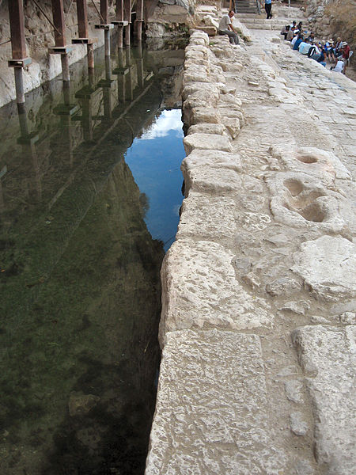
City of David, Lower Pool; Shiloach Pool.
Ancient records report that during the Second Temple period, there was a lower pool. In the autumn of 2004, Ir David Foundation workers excavating for a sewer near the present-day pool uncovered stone steps, and Ronny Reich and Eli Shukron (prominent archaeologists) were called in; it became obvious to them that these steps were likely to have been part of the Second Temple period pool. Excavations commenced and confirmed the initial supposition; the find was formally announced on August 9, 2005, and received substantial international media attention. The pool is less than 70 yards from the edge of the Byzantine reconstruction of a pool previously thought to be the Pool of Siloam. This small pool collected some of the water as it emptied there at the southern end of Hezekiah's tunnel. The water continued on through a channel into the recently discovered Pool of Siloam. The source of the water is from the Gihon Spring, located at the northern end of Hezekiah's tunnel on the eastern side of the City of David. An ancient pool (Upper Pool) existed near the Gihon Spring but was no longer used after King Hezekiah redirected the waters to the western side of the city.
The lower pool is not perfectly rectangular, but a soft trapezoid. There are three sets of five steps, two leading to a platform, before the bottom is reached, and it has been suggested that the steps were designed to accommodate various water levels. The pool is stone-lined, but underneath, there is evidence of an earlier version that was merely plastered (to help it retain water). Coins found within this plaster date from the time of Alexander Jannaeus (104–76 BC), while a separate collection of coins, dating from the time of the First Jewish–Roman War (AD 66–70), were also found.
How much of the pool and its surrounding structures were a result of monumental construction by Herod the Great is not yet understood (as of September 2006); nor is the
relationship of this pool to the earlier one (i.e., why it was built when the earlier pool already
existed). A portion of this pool remains unexcavated, as the land above it is owned by a nearby Greek Orthodox church and is occupied by an orchard known as the King's Garden.

Nehemiah 3:15
15 The Fountain Gate was repaired by Shallun son of Kol-Hozeh, ruler of the district of Mizpah. He rebuilt it, roofing it over and putting its doors and bolts and bars in place. He also repaired the wall of the Pool of Siloam, by the King’s Garden, as far as the steps going down from the City of David.

As a freshwater reservoir, it would have been a major gathering place for ancient Jews making religious pilgrimages to the city. The Gospel of John suggests that it was probably used as a mikvah (ritual bath), although mikvahs are usually much smaller in size; if the pool were a mikvah, it would be the largest ever found by a substantial margin. Yoel Elitzur has proposed that the pool was used for swimming rather than ritual immersion. It is thought that the current structure was originally the Shrine of the Four Nymphs (Tetranymphon), a nymphaeum built by Hadrian during the construction of Aelia Capitolina in 135 and mentioned in Byzantine works such as the 7th-century Chronicon Paschale; other nymphaeum built by Hadrian, such as that at Sagalassos, are very similar.

Sultan's Pool

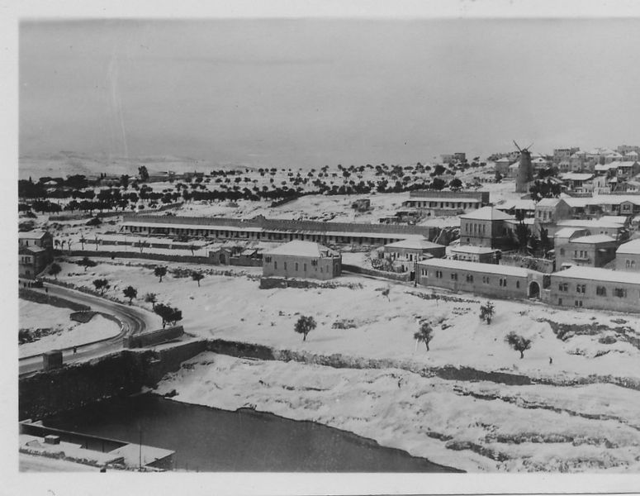
Yemin Moshe in snow, with Birket es-Sultan in foreground. 1920s.

The Sultan's Pool (Hebrew: בריכת הסולטאן‎ Birket es-Sultan) is an ancient water basin by the west side of Mount Zion. Its origins likely date to the time of Herod and some think it is the Snake pool mentioned by Josephus. In Hasmonean times, water was fed into it via the lower aqueduct. The Ottoman sultans (for whom the pool is named) enlarged it into a reservoir measuring 67 m × 169 m × 12 m. It was part of the water supply network for Jerusalem from antiquity to late Ottoman Empire times. During the Crusaders times, it was known as Lacus Germani.

Al-Kas Ablution Fountain

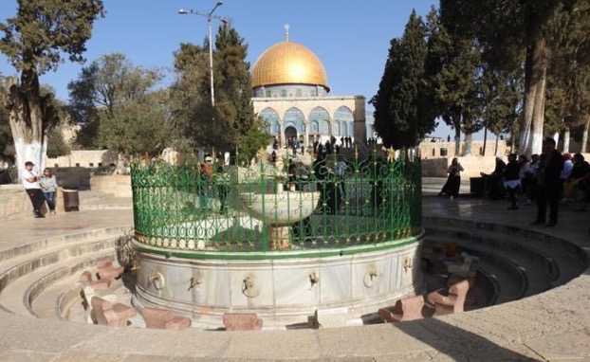
The mosque's "Al-Kas" ablution fountain.

The Al-Aqsa Mosque main ablution fountain, known as al-Kas ("the Cup"), is located north of the mosque between it and the Dome of the Rock. It is used by worshipers to perform wudu, a ritual washing of the hands, arms, legs, feet, and face before entry into the mosque. It was first built in 709 by the Umayyads, but in 1327–28 Governor Tankiz enlarged it to accommodate more worshipers. Although originally supplied with water from Solomon’s Pools near Bethlehem, it currently receives water from pipes connected to Jerusalem's water supply. In the 20th-century, al-Kas was provided taps and stone seating.

Proverbs 18:4
The words of the mouth are deep waters, but the Fountain of Wisdom is a rushing stream.
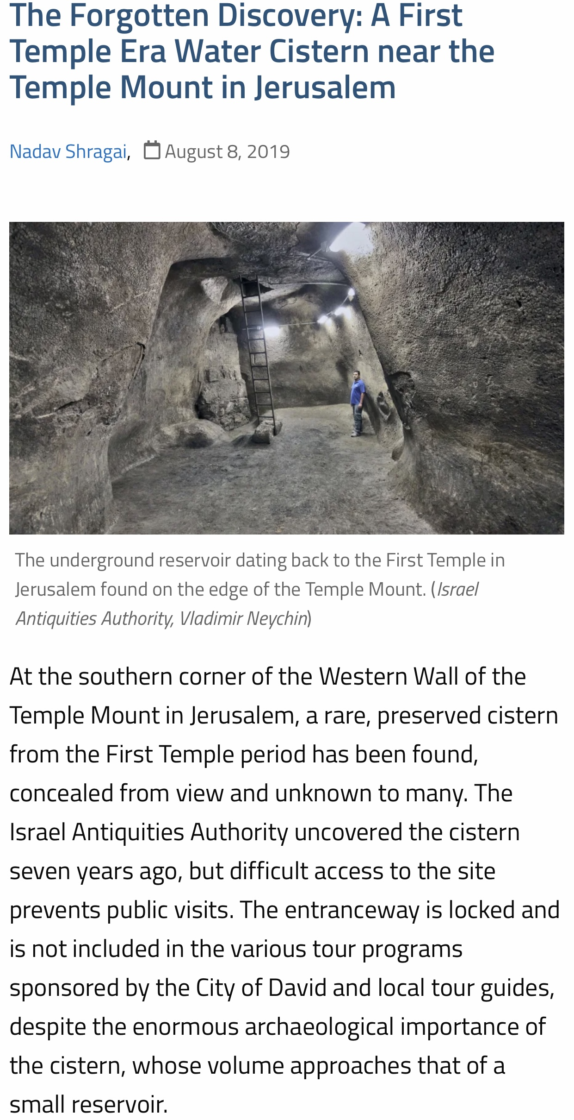
The Lower Aqueduct of Jerusalem

Location of the Lower Aqueduct of Jerusalem: The west bank of the Hinnom Valley, above the Sultan’s Pool and near the entrance to Mishkenot Sha’ananim. The aqueduct structure can be viewed both from the stepped path which runs below it and from the paved overlook above.
The aqueduct represents a true link between antiquity and modern times: From its original construction in the Hasmonean period (142-63 BCE), it continued to deliver water to Jerusalem (off and on, through various alterations) until the turn of the 20th Century! (Other parts of the system were actually supplying water to the Old City until 1967.)
The segment of several meters that has been restored and left exposed here is a small part of a system that stretches over 60km from its furthest sources to its destination. It is vast and ingenious, representing the finest of ancient engineering, and is easily the longest and most complex aqueduct system in the Land of Israel, including even Caesarea.
What we see in the following picture is quite simple: The constructed water channel is elevated atop a buttressed stonewall, in order to maintain the required gradient; it is plastered
inside to prevent leakage and capped with stone slabs in order to minimize evaporation and
contamination of the water. (What we actually see is the aqueduct as rebuilt and repaired in the late Ottoman period, but at its core it is Hasmonean.) It can only be properly understood in relation to the larger system of which it is one part.

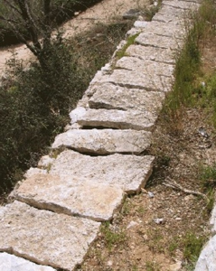
Aqueduct channel with plastered inside to prevent leakage and capped with stone slabs in order to minimize evaporation and contamination of the water.
An overview of Jerusalem’s aqueduct system:

The system, which reached its height in the late Second Temple period (200 BCE-70 CE), consists of several independent but interconnected elements, which were built/re-built at different times. It was explored & mapped by the 19th century explorers Charles Wilson and Conrad Schick and again in recent times by Amihai Mazar and others. Think of the aqueduct system in terms of the human circulatory system: a heart, veins, and arteries.

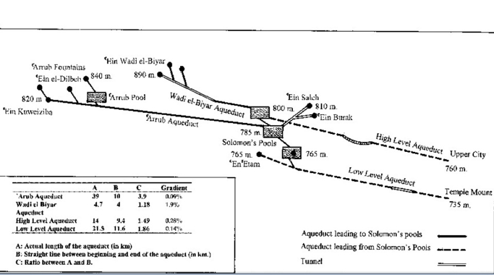Map of collecting pools and aqueduct channels creating the headwaters for the Jerusalem Aqueduct System.

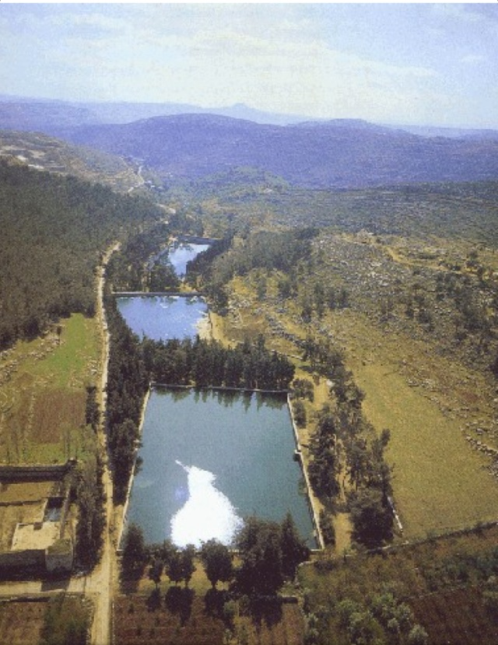
The “heart” of the system is Solomon’s Pools, three reservoirs which descend in stair-step fashion down the Artas Valley just southwest of Bethlehem [aerial view looking east].
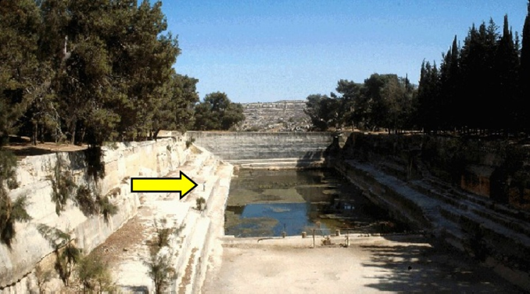
They are monumental and quite astounding, with a combined surface area equal to more than 4 football fields and a capacity of over a quarter million cubic meters lower pool; human figure (arrow) shows scale.

The pools serve as a kind of junction or interchange for the system: Besides collecting rainwater from the plains to the west and the output of 2 local springs, the pools receive the water of the two major “veins” and then send it all out through 3 “arteries” (all discussed below). Solomon’s Pools were completely refurbished by the British in 1924, when a pumping station was also installed, to send the water through iron pipes to the Old City.
One of the two “veins” feeding Solomon’s Pools from the south is the Biyar Aqueduct. It is 4.7km long and descends at a gradient of 1.9% (1:53). Compared to the other aqueducts in the system, it is the shortest, straightest and steepest. It runs roughly parallel to today’s Road 60,
about 1 km to the east of the road. It actually collected water in three ways: (1) It conducted
water from three springs in Wadi Biyar; (2) it collected rainwater from the valley via a series of
dams and shafts; and (3) along much of its length it was constructed as a trench/tunnel hewn down through an aquifer layer into an aquiclude. Thus, along the seam between these two strata the aqueduct itself is draining the aquifer—like a long, continuous layer spring—with water flowing in through the tunnel walls! This technique, which the Romans borrowed from the Persian’s Qanat underground water transportation system originating in the 1st millennium BCE, is seen nowhere else in Israel-Palestine. Built probably in the time of Herod the Great, the Biyar Aqueduct remained in service for much of the next 2000 years. It was refurbished by the British (along with Solomon’s Pools) in 1924 and provided water for Jerusalem’s Old City until 1967.
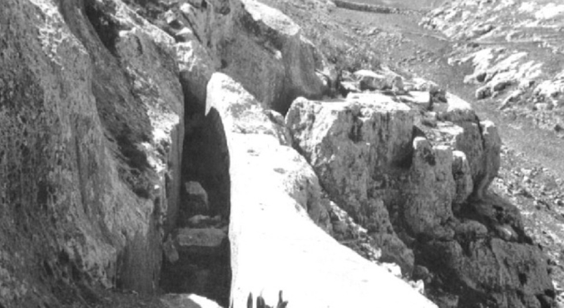
The “Arrub aqueduct crossing a cliff South of Solomon’s Pools.

The other “vein” feeding Solomon’s Pools is the Arrub Aqueduct. It gathered the waters of a group of springs lying between Bethlehem and Hebron and then, following the contours of the ridges and wadis, wound through the Judean hills for an astounding 40 km (a straight-line
distance of 10 km), at an equally amazing gradient of only 0.09% (1:1100+)! For much of its
length it was a simple channel hewn into the bedrock slopes, plastered and capped with stone
slabs. Obstacles were overcome via two methods: (1) tunneling through some ridges and (2) elevating the channel on a stone wall/dam in order to cross wadis. The dating of the Arrub Aqueduct is not certain, but it is a good candidate for the aqueduct mentioned by Josephus for which Pontius Pilate appropriated Temple funds, thereby sparking riots in Jerusalem (Antiquities 18). It seemingly was re-built in the Mamluk period and finally went out of service in Ottoman times. (Its great length made it especially susceptible to damage or clogging, unauthorized tapping of the water, and the pilfering of cap-stones.)

One “artery” (unrelated to Jerusalem’s water supply, and thus only mentioned here) is the Herodion Aqueduct, descending eastward from Solomon’s Pools, through the Artas Valley, and ending at that desert fortress of Herod the Great; it can thus be dated to the 1stcentury BCE. It was long thought that its source was the spring of Artas, but further analysis and excavation now show it to be connected to (and fed by) Solomon’s Pools.
Another “artery” is the Upper Aqueduct of Jerusalem. It began at Solomon’s Pools, ran northward, close to the watershed line (at a higher elevation than its “Lower” counterpart); it skirted Bethlehem on the west side, closely paralleled today’s Hebron Road, and apparently had as its destination “Hezekiah’s Pool” in the Upper City. Its length was 14 km, with an average gradient of 0.28% (1:357). Its best-known remains are a still-visible section of stone pipe (a
siphon) across a shallow valley near Rachel’s Tomb. Based on inscriptions of the 10th Roman
Legion on the pipe segments, the Upper Aqueduct was long dated to the Late Roman period, however it is now clear there was an earlier, parallel, high-level aqueduct section (i.e., elevated
on arches), an earlier solution to the same topographical problem, i.e. transmission of the water across the valley. Several surviving piers of this high-level section were discovered and
documented in the 1980s and ‘90s but were later removed in a building project. Thus, the Upper
Aqueduct is now thought to have been Herodian in its earliest phase, and then re-built in the Late Roman period, and it may have gone out of use after the Byzantine era. Overall, it is not well-preserved. No remains have been found from the area of Jerusalem’s old railway station northward, except for its confluence with the Mamilla Pool outflow channel, in the direction of the Old City (but it did not feed that pool—the elevation is not sufficient), and a segment near its terminal end, in front of the medieval fore-wall north of Jaffa Gate.

The Lower Aqueduct
The “artery” we are dealing with here is the Lower Aqueduct of Jerusalem, which ran for 21.5 km from Solomon’s Pools (765m ASL) to the Temple Mount (735m ASL). In that distance, it dropped a mere 30 meters, for a gradient of 0.14% (1:700+). Put another way, in the length of a football field, the floor of the channel dropped only 14 cm!
The original Lower Aqueduct has now been firmly dated to the Hasmonean period. This is based not only on ceramics and coins related to its construction but also similarities to the water systems of the Hasmonean desert fortresses, including a distinctive type of plaster. Thus, along with one or more of the Solomon’s Pools, it is (in its original form) the oldest part of Jerusalem’s aqueduct system. It is mentioned a number of places in the Talmud, which says that “an aqueduct ran to [the Temple] from Eitam [a spring located near Solomon’s Pools],” and a Midrash states that the same aqueduct was destroyed by the Sicarii during the Great Revolt.

The Route of the Lower Aqueduct:
From Solomon’s Pools it leads northward and runs beneath the town of Bethlehem through a tunnel, which is mostly blocked today. Reaching the Armon ha-Natziv ridge (Jebel
Mukkaber/E. Talpiot) it overcame this barrier by means of a tunnel stretching nearly 400m and
punctuated by several vertical shafts.

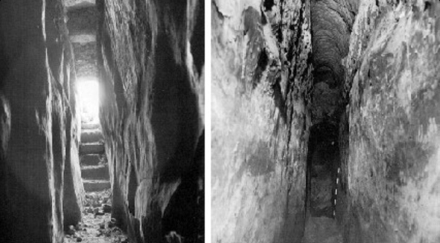
The tunnel of the low-level aqueduct in Jebel Mukaber (“Armon Hanatziv”) (East Talpiot) interior view near the South entrance (left) and further inside (right).

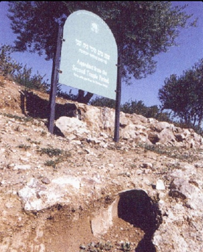
The channel emerges from the tunnel just east of and downslope from today’s Haas Promenade, continues below the Sherover Promenade and then across the slopes of Abu Tor, to here—the western slopes of the Hinnom Valley. (NOTE: Many of the aqueduct remains in the area of Armon ha-Natziv, the Tayelet, and the Peace Forest have been preserved and marked: At the beginning of the Goldman Promenade one of the tunnel shafts has been exposed, with an interpretive installation; in a park across the street to the south, centered on another shaft opening, is an interesting mosaic map of the whole system.)
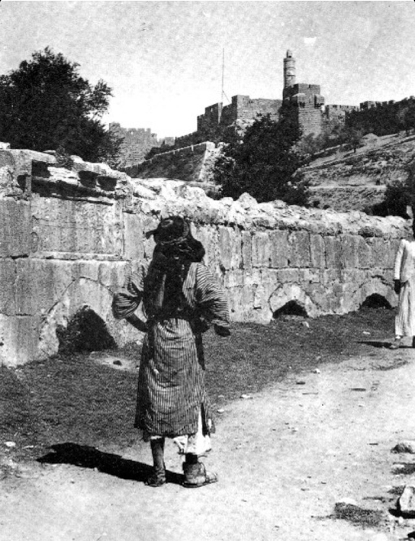
From here, Mishkanot Sha’ananim, the Lower Aqueduct continues northward past the Sultan’s Pool, and many remains of this section can still be traced with little effort. North of the Sultan’s Pool it then traverses through the Hinnom Valley on an arched stone bridge. This bridge (the Mamluk version, complete with a dedicatory inscription) was visible into the early 20th century, but was then totally obscured by modern grading and landscaping. (Note: As of 2010, two complete arches near the western end of the bridge were exposed once again in an infrastructure project; the announced plan is to uncover the entire bridge starting in 2011.)
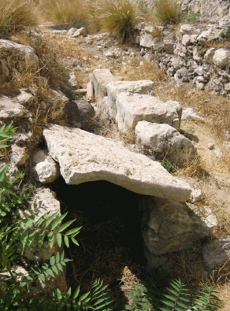
The aqueduct continues around the slopes of Mt. Zion and then beneath (outside) the present-day city walls.
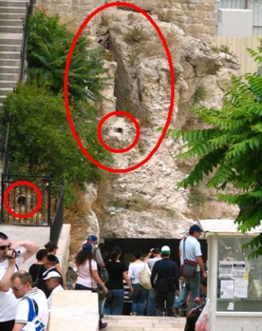
Entering the Old City west of Dung Gate, it proceeds through today’s Jewish Quarter, where portions are preserved along the scarp of the Western Hill (Josephus’ “Upper City”) opposite the southwestern corner of the Haram al-Sharif (Herodian Temple Mount) [note tall, rock-hewn channel and later ceramic pipe].
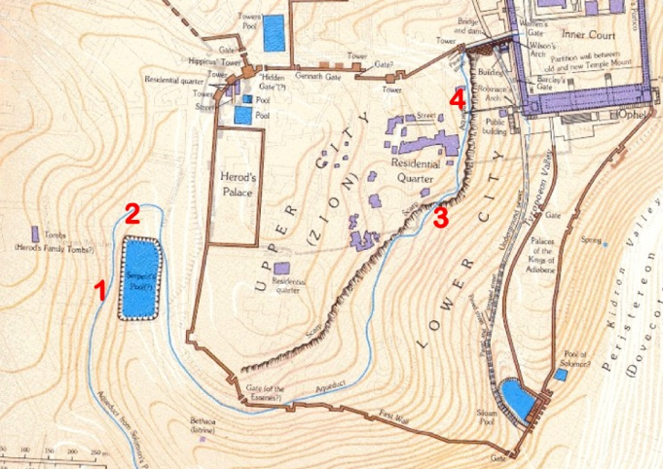

The map shows the Jerusalem’s Lower Aqueduct in its 1st century context, from the west bank of the Hinnom Valley (left), through the city (center), to its destination on the Temple Mount (upper right). Numbers indicate location of visible remains illustrated here: 1 – Reference segment at Mishkenot Sha’ananim; 2 – Mamluk Bridge across Hinnom Valley; 3 – sections outside the south wall of the Old City; 4 – Tall hewn channel opposite southwest corner of the Haram/Temple Mount.

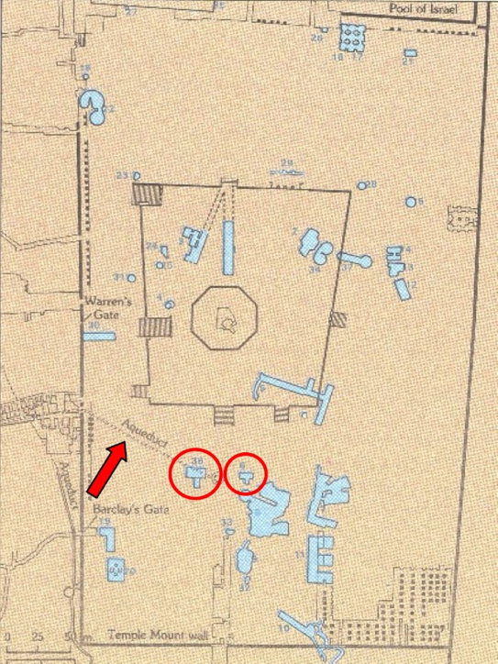
Via the Wilson’s Arch Bridge, the Lower Aqueduct led onto the Temple Mount to its ultimate (original) destination, the cisterns beneath the Haram platform. The 19th century explorers Conrad Schick and Charles Warren demonstrated that the Haram is pockmarked—akin to a Swiss cheese—with numerous water reservoirs and channels, and their mapping and numbering system still provide our only scientific knowledge of these spaces. They identified a water channel leading from Wilson’s Arch [ARROW] in the direction of two particular cisterns, numbers 6 and 36 [CIRCLED].
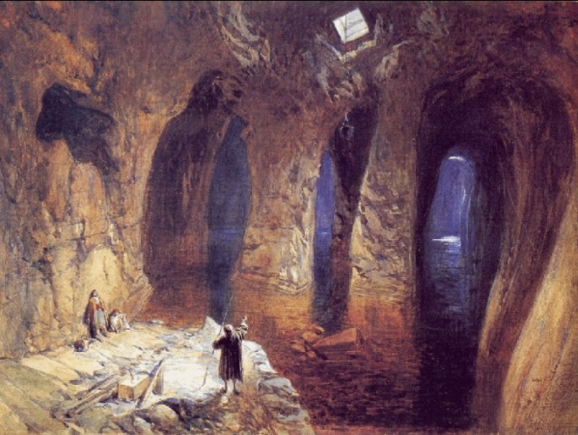

Very nearby is the largest of the Temple Mount cisterns, the one the explorers dubbed “The Great Sea.” Accompanying Warren in 1869, the English artist William “Crimea” Simpson sketched this cavernous reservoir by the light of a burning magnesium wire, and later produced this watercolor. It is still not known whether (or how) these various cisterns might be connected.

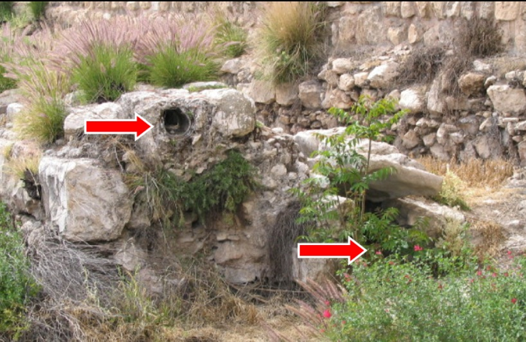

Alterations to the Lower Aqueduct:
Starting at Armon ha-Natziv and running all the way into today’s Jewish Quarter there is a second, parallel channel constructed at a slightly higher level. (This is not to be confused with the “Upper Aqueduct.”) In some places it is a separate, adjacent channel [PHOTO, outside Old City walls west of Dung Gate], and in others, like here in Mishkenot Sha’ananim, it exactly overrides and obscures the older Hasmonean channel. Thus, the original, lower channel was rendered forever useless. This shows clearly that the destination and uses of the water changed over time. A good guess for this rebuilding is the Byzantine period, when Jerusalem was burgeoning and the Temple Mount, by all accounts, lay unoccupied and largely forgotten. A drawing of Conrad Schick in fact shows this higher channel passing very near the top of the great vaulted cistern of the NEA Church, one possible destination for the water.

In the Early Islamic and Crusader periods, the water was probably once again directed to the Temple Mount via Wilson’s Arch. At the southwest corner of the Temple Mount, the large horizontal grooves cut into the Herodian masonry probably held pipes which, in the Omayyad period (660-750 CE), conducted at least some of the water to the large palaces or pilgrim hostels situated there.
The aqueduct was restored and rebuilt by the Mamluks; their arched bridge crossing the Hinnom Valley was visible into the 20th century (see photo above), was then buried, and now (as of 2010) is being exposed once again.
The Ottoman Turks reconstructed the Lower Aqueduct along its entire length, laying a closed ceramic pipe [PHOTO] into the existing channel in the 1500s. The pipe made the aqueduct more vulnerable to blockage, but it continued in use, off and on, into modern times.
In 1902, the Ottomans bypassed most of the ancient Lower Aqueduct (including the stretch seen here) by constructing a shunt of iron pipe on a more direct line from Bethlehem to the Old City. This pipeline never worked well, however, until the British installed pipe all the way from Solomon’s Pools and built a pumping station there in 1924, a system which continued to supply water to the Old City until 1967. The partially-ruined pumping station structures, with much of the original apparatus still in place, are still visible.

Mount Zion Fountain

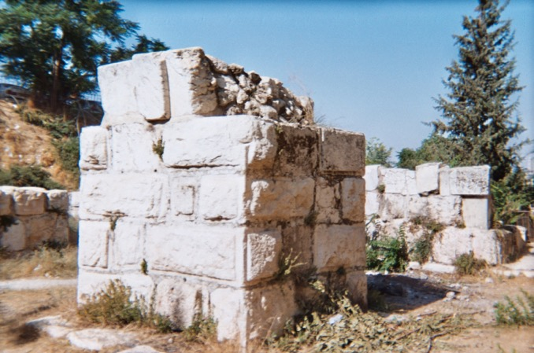
Announcing the discovery of the Mount Zion Fountain!

Isaiah 55:1
Invitation to the Thirsty
“Come, all you who are thirsty,
Come to the waters;
And you who have no money,
Come, buy and eat!
Come, buy wine and milk
Without money and without cost.

Jeremiah 2:13
“My people have committed two sins:
They have forsaken me,
The spring of living water,
And have dug their own cisterns,
Broken cisterns that cannot hold water.

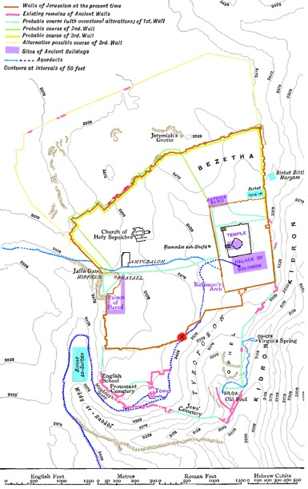
Mount Zion Fountain location marked with a red dot and X above the Jerusalem Lower Aqueduct at the highest elevation entering Old Jerusalem on Mount Zion!
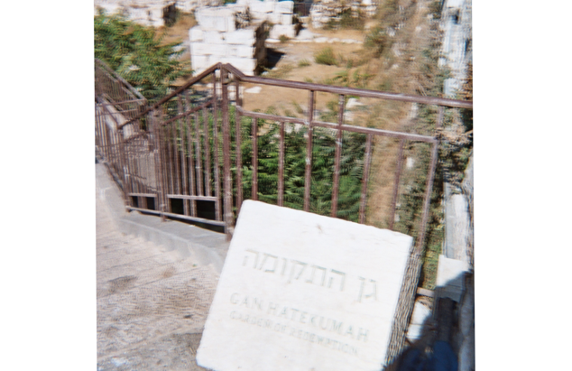
Entrance to Gan HaTekuma (Garden of Redemption) Archaeological Park with Mount Zion Fountain in the background. Excavations of this area were first made by Dr Nahman Avigad, 1970s/1980s.

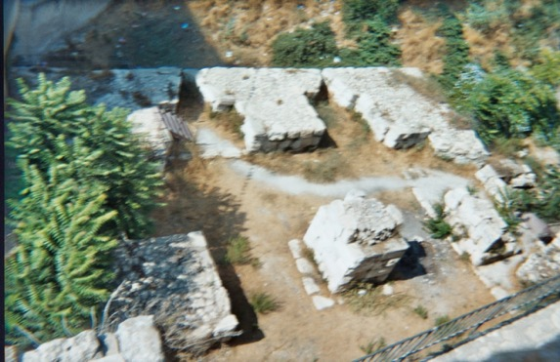
Mount Zion Fountain outlet central structure with defensive tower walls, dating from the Ayyubid period (ca.1171-1341) surrounding the fountain. Note the original construction of Jerusalem’s Lower Aqueduct has been dated back to at least the Hasmonean dynasty of classical antiquity, from 140 BCE to 37 BCE. Thus, predating the Ayyubid period fortress by over a millennium!
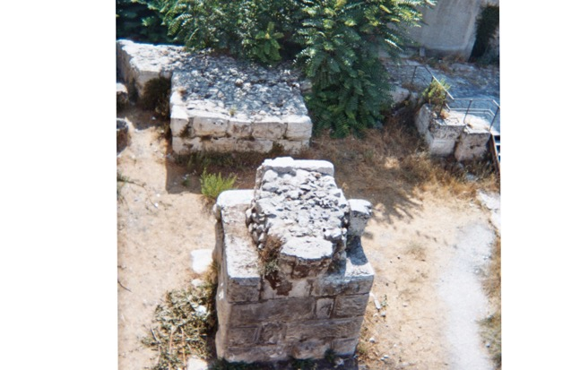
Mount Zion Fountain outlet viewed from atop Old Jerusalem Southern Wall. Notice the rocky cement sealing the central fountain outlet structure closed.

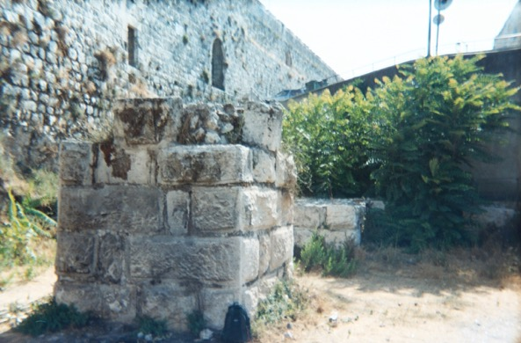
Mount Zion Fountain with Old Jerusalem Southern Wall in background.
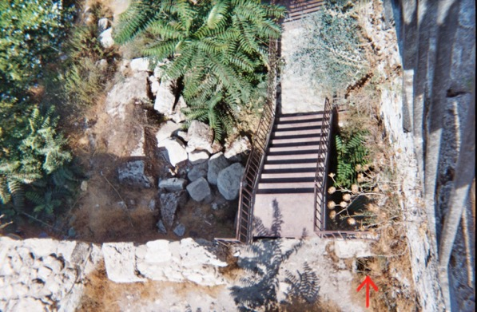
View from atop Old Jerusalem Southern Wall with Red arrow pointing to the Mount Zion Fountain water drainage outlet. The black hole would have been the headwater source to feed into descending groundwater engineering works from this highest elevated point on Mount Zion.

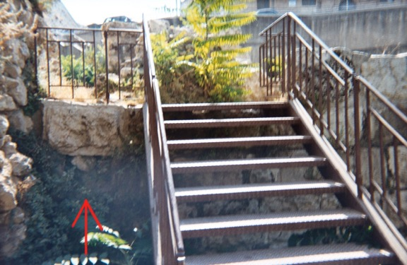
Red arrow pointing to the Mount Zion Fountain water drainage outlet from ground level on the Eastern side.
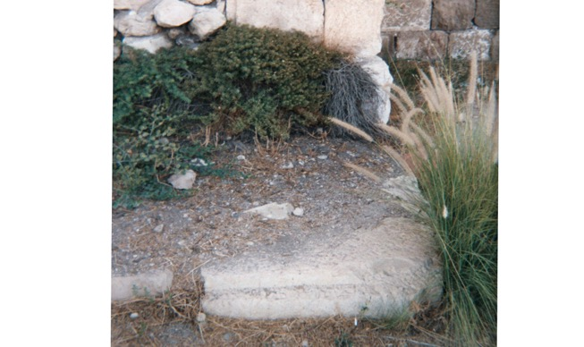
Top of the Corner Stone of the original Mount Zion Fountain complex at ground level just outside of the Southern Wall of Old Jerusalem. Notice the Corner Stone design has the chiseled edge with rough protruding face that matches the oldest stones used in Old Jerusalem and the matches the same stone design used on the central structure of the Mount Zion Fountain.
This giant Temple Corner Stone with its most top part only revealed at ground level is a perfect example of why the discovery of the Mount Zion Fountain has lain hidden, out of sight and out of mind throughout the ages. When Jerusalem was destroyed with “Not one stone on another” they were also buried by invading siege ramps used to level Jerusalem to ground level. These siege ramps have only been slowly unearthed to make room for development of the Modern State of Israel which has been uncovering new archeological discovers of Old Jerusalem’s true ancient past only to be rediscovered in modern times today.

Mark 13:1-2
The Destruction of the Temple and Signs of the End Times
¹As Jesus was leaving the temple, one of his disciples said to him, “Look, Teacher! What massive stones! What magnificent buildings!”
²“Do you see all these great buildings?” replied Jesus. “Not one stone here will be left on another; everyone will be thrown down.”

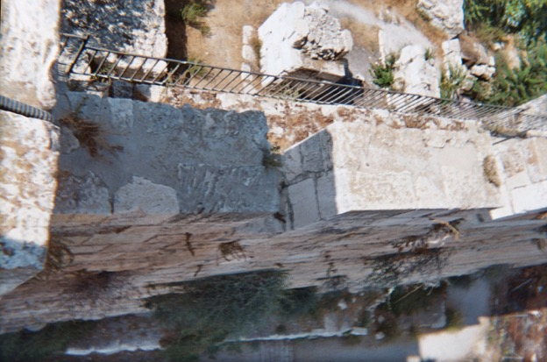
Current Southern Wall of Old Jerusalem covering the Mount Zion Fountain area complex.

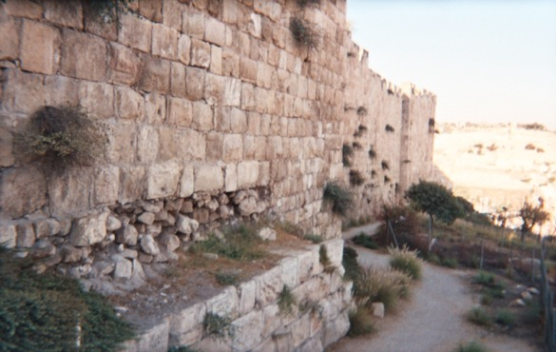
Current Southern Wall of Old Jerusalem above the Mount Zion Fountain and Ayyubid period structure. Additionally, the Southern Wall is also covering other archaeological locations in connection to the original function of Jerusalem’s Lower Aqueduct system in this area.
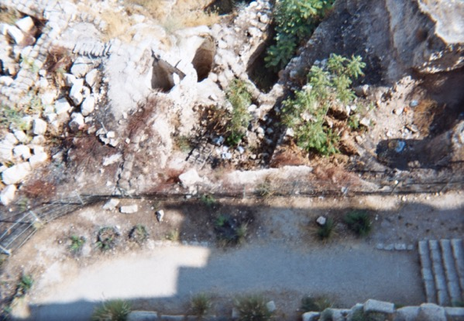
Mount Zion Archeological remains of 1st century Priestly Quarter of ancient Jerusalem as seen from outside the Southern City Wall of Old Jerusalem, Mount Zion Fountain on the inside.

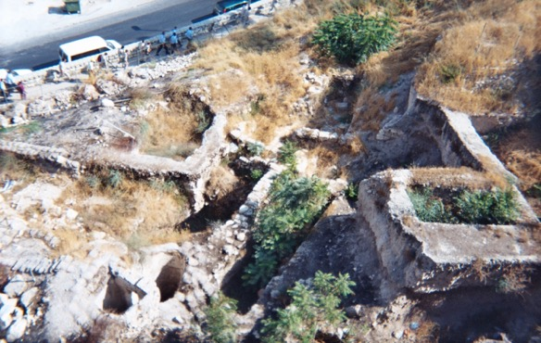
Archaeologist uncover luxuries of priestly ruling class for example one house with its own cistern, mikveh and another with a bathtub. Which all require clean water hence their relative proximity to the Living Waters flowing from the Jerusalem Lower Aqueduct and Mount Zion Fountain system once in existence in this area as the source of clean water on Mount Zion.
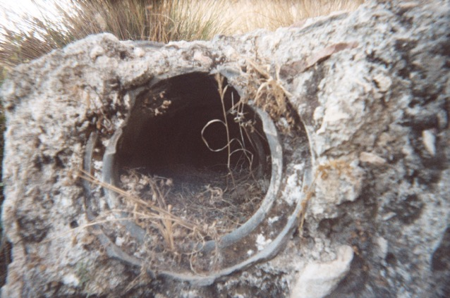
Opening to an aqueduct channel pipe outside the Southern Wall of Old Jerusalem.

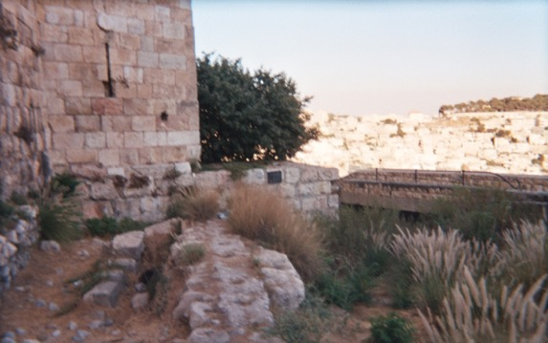
Jerusalem’s Lower Aqueduct channel with various outlets beneath and predating the current Southern Wall of Old Jerusalem.
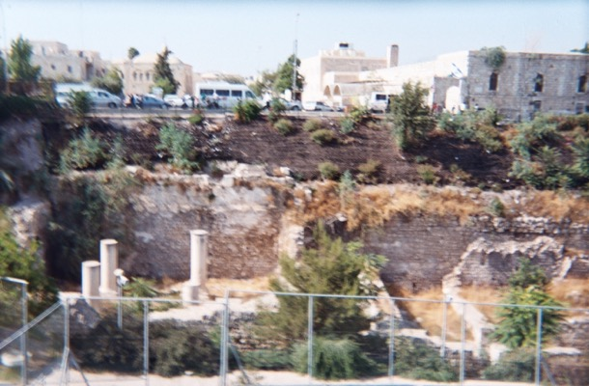
View of the Gan HaTekuma (Garden of Redemption) Archaeological Park, inside Old Jerusalem, seen from atop the Southern Wall of Old Jerusalem facing North.

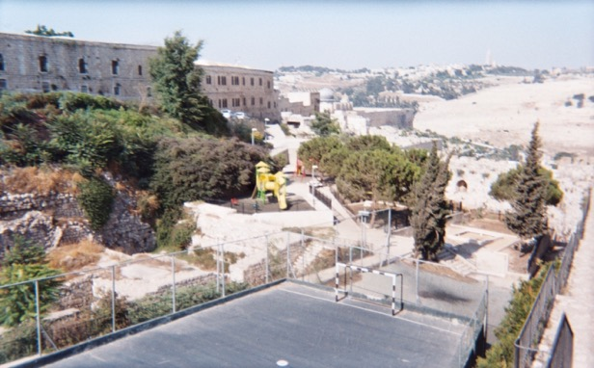
View inside from atop the Old Jerusalem Southern Wall facing North East down towards the entrance to the Great Vaulted Cistern of the NEA Church inside Gan HaTekuma (Garden of Redemption) Archaeological Park and further down the mountain is the Dome of the Rock area.
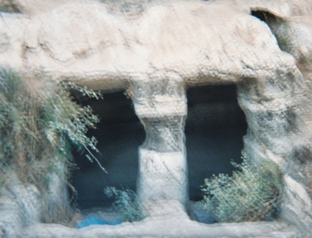
Original Mikveh carved in the solid stone bedrock just outside the Southern Wall of Old Jerusalem in an Eastern descending flow line from the Mount Zion Fountain area at an elevation well above the final destination of Jerusalem’s Lower Aqueduct to the Temple Mounts several water reservoirs, cisterns and the Al-Kas ablution fountain.

The Mount Zion Fountain and Jerusalem Lower Aqueduct system is set in stone and has been protected below ground level throughout antiquity to modern times. These living waters of purification have been a central source of renewal and promise of life to the Holy City of Jerusalem. Throughout the ages of devastation, destruction and complete decimation of
Jerusalem’s past, these aqueduct channels have lost their use in modern times. Thus, preventing the Orthodox practice of Spiritual Cleansing with Holy Water, a once central way of life in Jerusalem. According to several scriptures in the Bible, revelations alluding to water flowing from Mount Zion need to be fulfilled to restore the divine ordinances of the Holy Land creating a heavenly Jerusalem, for the Living God’s holy, eternal city on Earth for all Nations. After excavations are completed a restoration project can then take place restoring the living waters to Jerusalem through the original design and Jerusalem aqueduct system. Drought and low flowing spring water feeding Solomon’s Pools has also resulted with the heart of the pools and veins of the headwaters to the aqueduct channels being empty. However, with modern technology we can provide a new pump house in Bethlehem to once again refill and restore the Solomon’s Pools ensuring its continual use thus reviving the heart and veins of the system once again.
Psalm 46:4
4 There is a river whose streams make glad the city of God, the holy place where the Most High dwells.

Ezekiel 47:1-12
The River from the Temple
¹The man brought me back to the entrance to the temple, and I saw water coming out from under the threshold of the temple toward the east (for the temple faced east). The water was coming down from under the south side of the temple, south of the altar. ²He then brought me out through the north gate and led me around the outside to the outer gate facing east, and the water was trickling from the south side.
³As the man went eastward with a measuring line in his hand, he measured off a
thousand cubits and then led me through water that was ankle-deep. ⁴He measured off
another thousand cubits and led me through water that was knee-deep. He measured off another
thousand and led me through water that was up to the waist. ⁵He measured off another thousand,
but now it was a river that I could not cross, because the water had risen and was deep enough to swim in—a river that no one could cross. ⁶He asked me, “Son of man, do you see this?”
Then he led me back to the bank of the river. ⁷When I arrived there, I saw a great number of trees on each side of the river. ⁸He said to me, “This water flows toward the eastern region and goes down into the Arabah, where it enters the Dead Sea. When it empties into the sea, the salty water there becomes fresh. ⁹Swarms of living creatures will live wherever the river flows. There will be large numbers of fish, because this water flows there and makes the salt water fresh; so where the river flows everything will live. ¹⁰Fishermen will stand along the shore; from En Gedi to En Eglaim there will be places for spreading nets. The fish will be of many kinds—like the fish of the Mediterranean Sea. ¹¹But the swamps and marshes will not become fresh; they will be left for salt. ¹²Fruit trees of all kinds will grow on both banks of the river. Their leaves will not wither, nor will their fruit fail. Every month they will bear fruit, because the water from the sanctuary flows to them. Their fruit will serve for food and their leaves for healing.”

Revelation 22:1-2
Eden Restored
¹Then the angel showed me the river of the water of life, as clear as crystal, flowing from the throne of God and of the Lamb ²down the middle of the great street of the city. On each side of the river stood the tree of life, bearing twelve crops of fruit, yielding its fruit every month. And the leaves of the tree are for the healing of the nations.

Conclusion
The Temple Mount (Hebrew: הַר הַבַּיִת, Har HaBáyit, "Mount of the House [of God, i.e. the Temple in Jerusalem]"), known to Muslims as the Haram esh-Sharif (Arabic: الحرم الشريف‎, al-Ḥaram al-Šarīf, "the Noble Sanctuary", or الحرم القدسي الشريف, al-Ḥaram al-Qudsī al-Šarīf, "the Noble Sanctuary of Jerusalem") and the Al Aqsa Compound, is a hill located in the Old City of Jerusalem that for thousands of years has been venerated as a holy site in Judaism, Islam, and Christianity alike.
The present site is a flat plaza surrounded by retaining walls (including the Western Wall) which was built during the reign of Herod the Great for an expansion of the temple. The plaza is dominated by three monumental structures from the early Umayyad period: the al-Aqsa Mosque, the Dome of the Rock and the Dome of the Chain, as well as four minarets. Herodian walls and gates, with additions from the late Byzantine and early Islamic periods, cut through the flanks of the Mount. Currently it can be reached through eleven gates, ten reserved for Muslims and one for non-Muslims, with guard posts of Israeli police in the vicinity of each.
According to Jewish tradition and scripture, the First Temple was built by King Solomon the son of King David in 957 BCE and destroyed by the Neo-Babylonian Empire in 586 BCE – however no substantial archaeological evidence has verified this or the actual location of the First Temple. The Second Temple was constructed under the auspices of Zerubbabel in 516 BCE and destroyed by the Roman Empire in 70 CE. Jewish tradition maintains it is here that a third and final Temple will also be built. The location is the holiest site in Judaism and is the place Jews turn towards during prayer. Due to its extreme sanctity, many Jews will not walk on the Mount itself, to avoid unintentionally entering the area where the Holy of Holies stood, since according to Rabbinical law, some aspect of the divine presence is still present at the site.
Among Muslims, the Mount is the site of one of the three Sacred Mosques, the holiest sites in Islam. Amongst Sunni Muslims, it is considered the third holiest site in Islam. Revered as the Noble Sanctuary, the location of Muhammad’s journey to Jerusalem and ascent to heaven, the site is also associated with Jewish biblical prophets who are also venerated in Islam. Umayyad Caliphs commissioned the construction of the al-Aqsa Mosque and Dome of the Rock on the site. The Dome was completed in 692 CE, making it one of the oldest extant Islamic structures in the world. The Al Aqsa Mosque rests on the far southern side of the Mount, facing Mecca. The Dome of the Rock currently sits in the middle, occupying or close to the area where the Holy Temple previously stood.
In light of the dual claims of both Judaism and Islam, it is one of the most contested religious sites in the world. Since the Crusades, the Muslim community of Jerusalem has managed the site as a Waqf. The Temple Mount is within the Old City, which has been controlled by Israel since 1967. After the Six-Day War, Israel handed administration of the site back to the Waqf under Jordanian custodianship, while maintaining Israeli security control. It remains a major focal point of the Arab-Israeli conflict. In an attempt to keep the status quo, the Israeli government enforces a controversial ban on prayer by non-Muslims.
The Temple was of central importance in Jewish worship in the Tanakh (Old Testament). In the New Testament, Herod’s Temple was the site of several events in the life of Jesus, and Christian loyalty to the site as a focal point remained long after his death. After the destruction of the Temple in 70 CE, which came to be regarded by early Christians, as it was by Josephus and the sages of the Jerusalem Talmud, to be a divine act of punishment for the sins of the Jewish people, the Temple Mount lost its significance for Christian worship with the Christians considering it a fulfillment of Christ's prophecy, for example;

Matthew 24:1-2
¹Jesus left the temple and was walking away when his disciples came up to him to call his attention to its buildings. ²“Do you see all these things?” he asked. “Truly I tell you, not one stone here will be left on another; everyone will be thrown down.”

It was to this end, proof of a biblical prophecy fulfilled and of Christianity's victory over Judaism with the New Covenant, that early Christian pilgrims also visited the site. Byzantine Christians, despite some signs of constructive work on the esplanade, generally neglected the Temple Mount, especially when a Jewish attempt to rebuild the Temple was destroyed by the earthquake in 363, and as Christian worship in Jerusalem shifted to the Church of the Holy Sepulchre, and Jerusalem's centrality was replaced by Rome.
However, it is still important to understand how the fulfillment of this Biblical prophecy in the scripture of Matthew and Mark took place and its effect on the land, “Not one stone here will be left on another; everyone will be thrown down.” Evidence of this destruction can still be seen today by the remnants of giant siege ramp works surrounding Old Jerusalem, burying the
ground up to the Old City Walls from Mount Zion, surrounding the outside of the Temple Mount, down through the City of David and to the Gihon Spring and to the bottom of the Kidron Valley. The siege ramp built up to surrounding the Temple City Walls of Old Jerusalem, was similar in scope to the one built at Masada during the end of the Second Temple period, was used to “throw down every stone” and in turn encapsulated shards of the Biblical past. A past that Archeologist are still excavating today and learning more about with every layer.
None the less “tradition” teaches us to except the fact that we can’t know with any degree of certainty where any of these “great buildings” once stood because of this fulfillment of the Biblical destruction attributed to “Not one stone here will be left on another” and the general knowledge of Jerusalem’s continual destructive historical past through the millennia’s have left us with a perceived unsolvable depiction of Jerusalem’s authentic Biblical past.
Fortunately, finding evidence of our TRUE authentic Biblical past in Old Jerusalem, not in controversy with scripture or tradition, is still possible today, if you only know where to first start to look. Which is in the foundation of the bedrock from which every stone was cast down to and then below the ground level remains Jerusalem’s Aqueduct System from whence its original construction was created providing the life source and purification necessary for Temple Life during Biblical times. Specifically, Jerusalem’s Lower Aqueduct system once brought the Living Waters to Biblical Jerusalem that fed the city providing the purification rights necessary for Temple Life in the Upper City that the Gihon Spring headwaters could not provide. By restoring the Mount Zion Fountain and Jerusalem’s Lower Aqueducts system, we can in turn restore the Living Waters to Jerusalem creating purification and spiritual cleansing in the Holy Land once again authored about in our Biblical texts…

Zechariah 13:1
Cleansing From Sin
¹“On that day a fountain will be opened to the house of David and the inhabitants of Jerusalem, to cleanse them from sin and impurity.

Revelation 22:17
¹⁷The Spirit and the bride say, “Come!” And let the one who hears say, “Come!” Let the one who is thirsty come; and let the one who wishes take the free gift of the water of life.

Zechariah 14:8
The LORD Comes and Reigns
⁸On that day living water will flow out from Jerusalem, half of it to the Eastern Sea and half of it to the Western Sea, in summer and in winter.
Revelations of a flow of living water from Jerusalem have been interpreted as the Eastern Sea being the Dead Sea and the Western Sea being the Mediterranean Sea. However, an alternative view can be based on the antiquity of archeological remains of Jerusalem’s past and Judaic Law. The term “Sea” can also be interpreted as a large body of water, like in reference to the Molten Sea. The remnants of two existing examples of a large pool as a “Sea” in antiquity can both be found to the Eastern and Western sides of Old Jerusalem. The “Eastern Sea” of Old Jerusalem is the Pool of Siloam dating to the First Temple Period and its Lower Pool dating to the Second Temple Period. The “Western Sea” is the Sultan’s Pool fed by the spring waters channeled from the Lower Aqueduct of Jerusalem. These large pools or “Seas” once played a vital role supporting life and offering purification to the masses of people during pilgrimages to the Holy City of Jerusalem.

Joel 3:17-18
Blessings for God’s People
¹⁷“Then you will know that I, the Lord your God,
dwell in Zion, my holy hill.
Jerusalem will be holy;
never again will foreigners invade her.
¹⁸“In that day the mountains will drip new wine,
and the hills will flow with milk;
all the ravines of Judah will run with water.
A fountain will flow out of the Lord’s house
and will water the valley of acacias.

It is water that purifies and quenches the thirst of all nations. It is the Spring of Life harnessed from the Mount Zion Fountain that can unite the tribes of Israel and make the world whole again. The promise of a never-ending flow of water to freely give the blessing of life is what the world must seek as a God given right and promise with every life. Living in conjunction with a never-ending flow of living water of life is the divine plan that God has willed since the Garden of Eden, to create a better world in cadence with nature and all creation. The foundation has been set in stone by the Wisdom of Solomon through the Mount Zion Fountain and Jerusalem Aqueduct system that still exists today only waiting to be utilized again as in Biblical times. It is time for the trumpets to blow the sound of truth, resonating the promise of life through the Mount Zion Fountain, for the Golden Age will mark the beginning of the promise of Everlasting Life on God’s Earth for all Nations.
Mount Zion Fountain marks the location at the beginning of where the headwaters would have started at the highest elevated point in order to best maximize the utilization of Jerusalem’s Lower Aqueduct groundwater engineering plan after first reaching the Old City of Jerusalem on Mount Zion. Jerusalem’s low-level aqueduct goes around Mount Zion at approximately 738-737 meters above sea level at the highest elevation before descending to Mount Moriah and the Dome of the Rock, Temple Mount area at approximately 736 meters above sea level. The original objective of the low-level aqueduct was not to just get water to its final destination at the end of a pipe to a network of water installations on the Temple Mount but to first maximize its efficiency through an extensive master groundwater engineering plan starting first from its maximum highest elevation once reaching Old Jerusalem and then flowing naturally downhill from there to the rest of the city.
Therefore, true construction of an authentic House of Prayer for All Nations that ushers forth the Spring of Life from the Mount Zion Fountain can be resurrected in peace without affliction from surrounding areas. In Fact, the Great Vaulted Cistern of the NEA Church inside Gan HaTekuma (Garden of Redemption) Archaeological Park was connected to Jerusalem’s Lower Aqueduct and can be restored to work in conjunction as a “Molten Sea” which in turn would render the descending Mikveh’s purity all the way to the “Eastern and Western Seas” for spiritual baths and baptisms for all pilgrims visiting the Holy City. The NEA Church also known as the New Church of the Theotokos was a Byzantine church erected in Jerusalem by the Byzantine Emperor Justinian I (c. 527-565). The church was completed in 543 but was severely damaged or destroyed during the Persian conquest of the city in 614.
None the less, once again like the aqueduct system that still exists today underground still exists the remains of the Great Vaulted Cistern under the ground level. However, it may be incorrect to call it a “cistern” when it has more characteristics of a giant mass “Mikveh” or Baptismal Bath. The main difference between a cistern and mikveh is the openings, for example cisterns typically only require one access point to retrieve the water many of the openings are also smaller and can be closed to allow only a bucket to enter to retrieve water to prevent evaporation during dry seasons. Whereas traditional mikvehs will have an entrance for the impure to enter and separate exit to leave as spiritually cleansed and renewed in order to not become atomically defiled again by leaving through the same entrance. Not only does the NEA Church Great Vaulted Mass Mikveh Baptismal Bath system have both an entrance and exit; the exit was once a spiral stair case that symbolizes your ascension in life to a purer higher state of
being and never turning your back on the Lord as you re-enter life Spiritually Renewed and one
with the Lord. Spiritually, the spiral represents a connectivity with the Divine, spiraling from the
outer ego of the outside world, into the inner soul of cosmic awareness and enlightenment. The spiral stair case represents evolution and growth of the spirit, a symbol of change and development as one enters an everlasting life with the Lord.
Central to GOD’s Divine design for his Holy Mountain is the resurrection of the Mount Zion Fountain for the flow of living waters from Jerusalem’s Lower Aqueduct to spring forth in conjunction with the NEA Church Great Vaulted Mass Mikveh Baptismal bath system for Interfaith Spiritual Cleansing for Jerusalem, Israel and all pilgrims visiting the Holy Land.
Most depictions of the reconstruction of the First and Second Temple periods and the Jewish prophesied Third Temple, showcase a magnificent central Temple connected to the Holy of Holies, Inner and Outer Courts separated by walls, gates and all the details listed in the Bible. However, most of all these modern depictions lack a very key element to the central role and function of how the flow of living water actually existed, necessary for Temple life for the rights of purification for priests to enter the Temple and its surrounding City offering purification for the masses and its promise of life. The importance of this ever-lasting flow of water through the true Holy Temple and City of God is vital for its creation and promise of purification for the never-ending duration of divine life on Earth for all to take part. GOD is the creator of life, and water is the tool to sustain and renew the purification of life that GOD has created. The Life, Light and Energy that comes from our Lord God Almighty Creator is in the essence of every seed of life.

Genesis 1:27
²⁷So God created mankind in his own image, in the image of God he created them; male and female he created them.

The righteous must unite creating a Fountain of Life on Mount Zion giving glory to the Lord and all his creation through its promise of life, purification, and spiritual renewal for all eternity. As GOD is all-pure and Divine in all ways, it is our responsibility and purpose to spiritually cleanse our soul and live life with our truest Divine-self in the spirit of all things. Living with a spiritually clean soul and world is the central way to the straight and narrow path to living a life in Heaven on Earth. You cannot be pure of heart and expect to live in Sodom and Gomorrah. It is time for the New Jerusalem to come!

1 Peter 1:15-16
¹⁵But just as he who called you is holy, so be holy in all you do; ¹⁶for it is written: “Be holy, because I am holy.”

Leviticus 19:1-2
¹The LORD said to Moses, ²“Speak to the entire assembly of Israel and say to them: ‘Be holy because I, the LORD your God, am holy.’”

Isaiah 40:9
You who bring good news to Zion, go up on a high mountain. You who bring good news to Jerusalem, lift up your voice with a shout, lift it up, do not be afraid; say to the towns of Judah, “Here is your God!”

We, the one people of our Earth, created in the image of GOD in Heaven, may be united in the flow of the living springs of water of this world. As a drop of water is a part of the whole of the ocean, the same is true for a breath of air in all the wind between Heaven and Earth. Blessed be even the vapor of water in the mist of the wind to cleanse and baptize you with every breath to the center most part of your soul with Holy Water in the vapor of Air from its everlasting connection to the Holy Water that still flows from the Garden of Eden today! Water is the great purifier and Divine Union for all of God’s creation. May we walk with every step in the presence of our Living Lord GOD Almighty and breathe in his cleansing righteousness with every breath.
We should be inspired to build complete Holy Temple cities built around purification and spiritual rebirth from water that extends from the threshing floor of the most central part of the Holy of Holies of the Temple of the Lord’s House of Prayer of All Nations. The Temple would connect consecutive descending spiritual baths with aqueducts throughout the city that eventually flow into massive collection pools or seas of water for mass purification ceremonies, and conclude feeding into irrigation pasture land for the animals and crops to be connected and thrive from the same seed of purification and divine holiness for all. A self-sustaining ecological
economy will in turn be created by this cycle of living waters of purification and spiritual rebirth from the Holy of Holies. For the Day of the Lord is upon us, may we have a righteous and straight path for our Lord to walk among us! For our body’s temple is the greatest of all creations and it is our duty to our Lord God Almighty to continually cleanse away the sinful material world to awaken our truest transcendental consciousness of our being and become one with the Lord and live-in harmony with all creation as it was in the beginning.

