THE AFRO INSTITUTION

PRODUCTION INFO

FORMAT: INTERACTIVE STORY DRIVEN WEBSITE
GENRE: AFRO FUTURISM & POPULAR EDUCATION
VISUAL ARTIST: KIM DEMÅNE / DELICIOUS BRAINS
PROJECT MANAGEMENT: ISMAILA JALLOW
CONTACT: jallowism@gmail.com / 0735577480

What do we want to do?

The Afro Institution is an interactive text-based story about the excavation of a mysterious digital artefact, discovered by the data archaeologist Adama. The story takes place about 150 years after the AI-wars, won by the humans after they managed to shut down the internet and erase all AI integrated systems. The narrative depicts an era in which humankind is trying to bring large parts of their historical heritage to light.

The loss of history has made the data archaeologists indispensable. They belong to one of the few groups of people with permission to connect to the ancient Internet of the 20th century. The archaeologists are equipped with cryptographically validated keys to data bridges that enable secure transfers of digital artifacts to OriNet, an infrastructure that has replaced the Internet.

What happens in the story?
The story begins with Adama being sent on a mission to investigate a weak signal coming from a potential artifact. While Adama is waiting for the data bridge to set up a secure connection, they scroll through various AR-feeds that give us subtle glimpses of background to the events described above. These glimpses establish the conditions of the world we are finding ourselves in.

When the connection is secured, the artefact is loaded to Adama’s AR-glasses. We see it through their eyes. A large, majestic afro-futuristic building with a sign that says The Afro Institution. We walk through the entrance of the building and are met with walls covered by afro-futuristic murals:
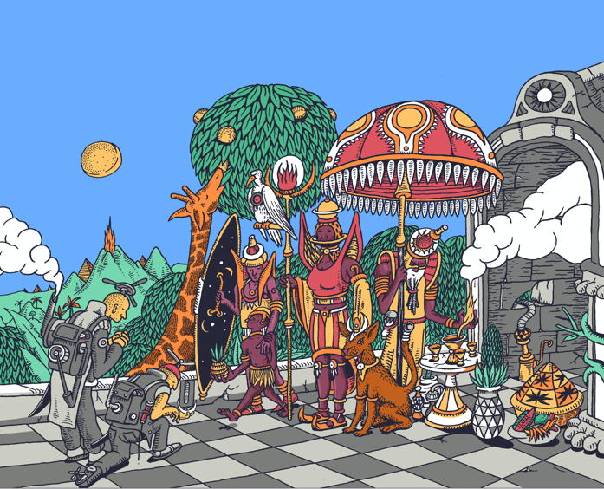
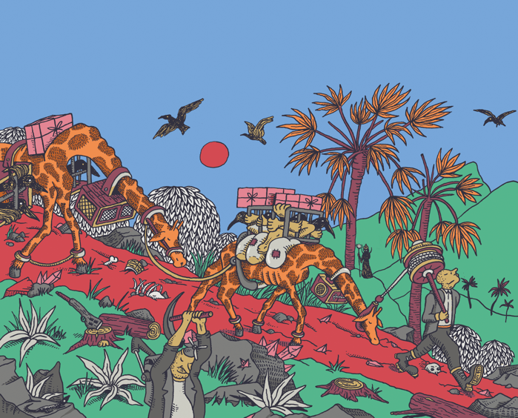
Paintings by Kim Demåne, project visual artist

There are eight different doors in different parts of the entrance. Each door is locked and has a different symbol on it. Adama concludes that the key must be hidden somewhere in the room. We start searching for the key by clicking on different objects. It turns out it has been hidden in one of the murals, in a necklace of one of the characters similar to the one painted by Kim below. The key has the same symbol as one of the eight locked doors. We use it to unlock and open the door.
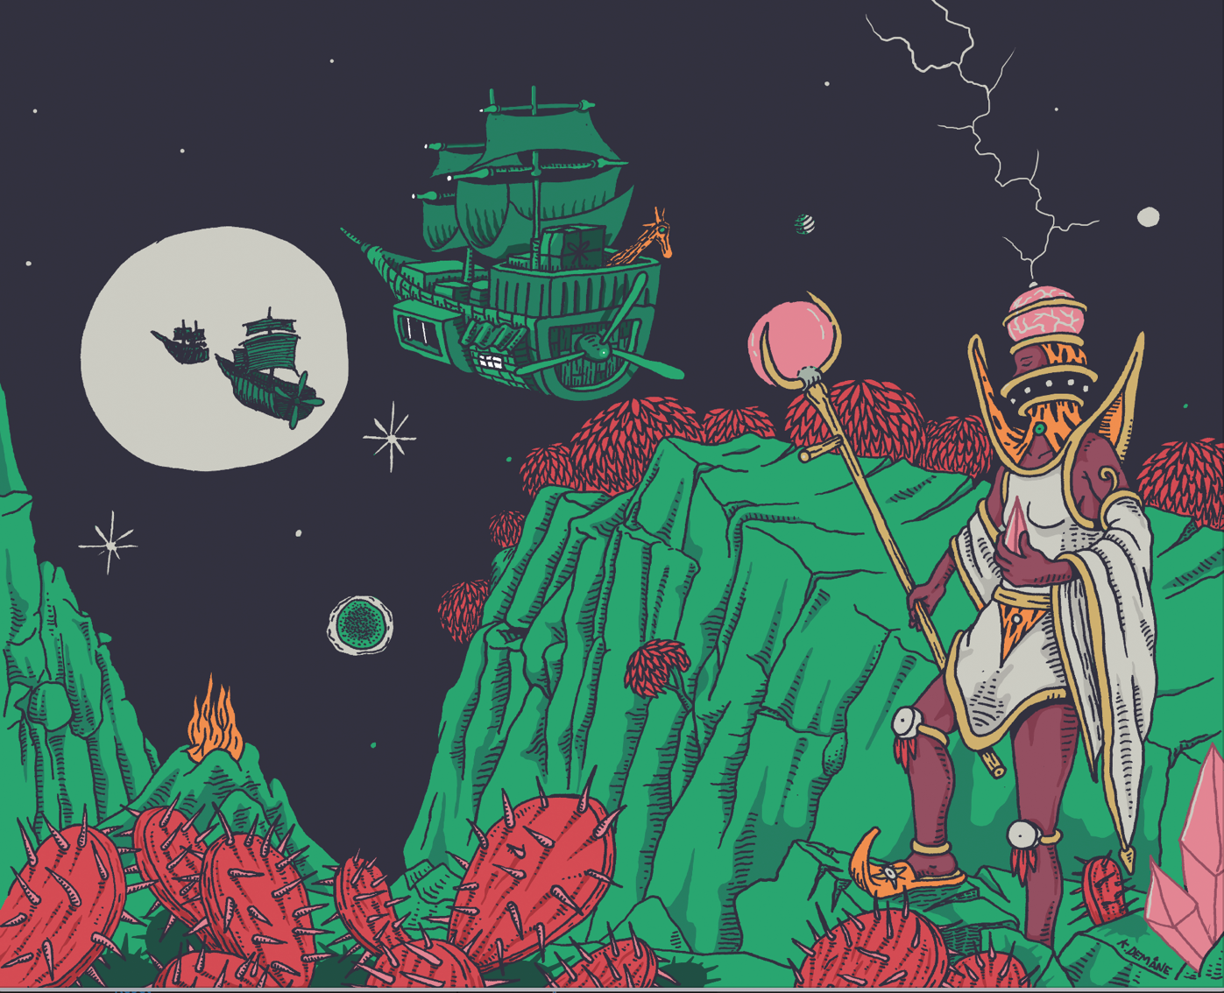

The door leads to a new room filled by framed paintings. The paintings are glitching in a way that makes it impossible to distinguish what they depict and Adama’s data tracker picks up very strong frequencies from the room. Adama concludes that we need to re-establish a secure connection before going any further. They launch another data bridge between the room and the OriNet, and while waiting for it to connect, Adama reports back to headquarters. The HQ conversation once again provides us with insights and additional information about the world in its current state. A lot has changed from the world we know.
When the data bridge is all set, one of the paintings stops glitching. It depicts Mansa Musa, the richest man to ever live, he who caused inflation in entire countries by giving away vast amounts of gold.
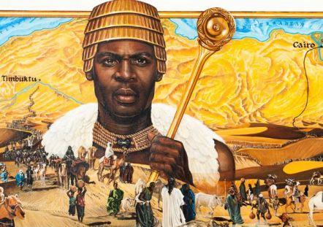
Below the painting, a lock appears with the same type of symbol as the key we found by the entrance of the Institution. When we open the lock with the key, the painting of Mansa Musa comes to life. We see a text and hear a voice telling us his story and who he was.

After the text has been played, Adama once again reports back to the headquarters to brief them about what they just witnessed inside the Afro Institution. The response Adama gets is that this might be larger than what the people at the headquarters had expected. Adama is ordered to immediately get out of the artifact and do a comprehensive scan of the data in order to get a better analysis of what they could be dealing with. Adama exits the building and sets up a deeper artefact scan. While waiting, they search for Mansa Musa in the archives, with no matching searches as a result. This is highly unusual and leads Adama to the understanding that the artefact is more valuable than they thought.

This story is a draft of how the world will take shape. The script will be further developed in the coming months until the spring of 2021.

Where will the story lead?

The world that the data archeologist Adama is living in, is a high technological, paranoid reality in which all communication and interaction has to be validated to keep the AI-systems under control. Race and racism does not exist in this new world (as the story proceeds, we will find out that all documentation of racism and other forms of oppression has been erased from the OriNet, with the hope of creating a new, equal society), but there are other inequalities. Validated data, i.e. data that has been confirmed to be true and secure is the new oil - and those sitting on the most validated data are those with the most resources. The people with less resources are forced to sell their data. This is because data-workers have more or less public data profiles, which makes the data workers easy targets for the sophisticated algorithms of the big corporations. The more personified data the algorithms have access to, the more extensive the corporation's knowledge becomes on how to sell their products. The more products being sold, the bigger the data pools, which in turn leads to all the more precise algorithms and consequently even more products being sold.

As a data archaeologist, Adama understands the injustices and inequalities caused by the data economy. Adama feels for the data workers, but sees nothing they can do to change the system since it is so deeply embedded in the current state of the world. All the data being secured really is vital after all, and nobody is forcing the data workers to sell their data...

The discovery of the Afro Institution awakens something within Adama. The stories from the institution raises questions that neither the headquarters nor Adama’s coworkers seem willing to answer. Adama then decides to create a clone of the digital artefact, which initiates a chain of events that will cause everything they believe in to
tumble.

Essentially, this is in many ways a story about redefining the narrative about brown and black bodies and their place in history. Data is used as a symbol of taking ownership of one’s own story, and the digital artefact, the Afro Institution, becomes an awakening for Adama in which they start to question who’s history they really belong to - and who’s narrative they’re living in. Through this project, we’re exploring the possibilities of combining popular education and storytelling, as well as an ambition of building a platform. More about this in the following section.

Why do we want to do this?

The story about the Afro Institution is based on a long term vision of building an institution as a resource-centre for Afroswedes. The goal is to establish this as a physical building that will grow and develop throughout the centuries to come.
But what does an institution even mean? And how do you ensure its longevity and its capability to outlive its founders?

We want to start by building a virtual institution. An Afrocentric palace full of rooms which in different ways can become a resource for Afro-Swedes. It could be the possibility to mirror oneself in different narratives and different worlds, it could be access to Black history and other popular education material, it could be instruments for community organizing and grassroot organizing, or the possibility to take part in digital art exhibitions by Black artists from around the world.

We do however believe that it needs to begin with this world and this story. There are plenty of great initiatives focusing on popular education and distribution of resources, but as a young person you might not always have the motivation or the prerequisites to do the research and take in the existing information. If we, on the other hand, focus on building the story and the characters we might be able to build a platform that people want to come back to. A magical world that engages people can plant seeds in a way that an uninspiring text reading cannot. Harry Potter is a living proof.

The project is based on the methods of Afrofuturism and reflections about breaking free from ascribed narratives by redefining existence through fictional futuristic worlds or parallel universes. It is a way of imagining what would happen if we were to put ourselves outside the eurocentric writing of history. It is a way of exploring what happens when building an institution based on those conditions.

Maybe the institution already exists. Maybe it exists within us all and it just needs to come out to take root. The story about the Afro institution is the first building block.

Who are the producers of the project?

The association The Afro Institution was born in connection to the
Black Lives Matter protests in Gothenburg the 7th of July, 2020, but most of our board members already started building the organization back in December of 2019.

The long term goal of the organization is to establish an institution for Afro-Swedes in the shape of a physical building with sustainable conditions for further development through the centuries to come. As mentioned earlier, the first step is to build a virtual institution.

The majority of the association consists of people with considerable experience of leading and developing projects, both in and out of the cultural sector. Ismaila Jallow is the project manager and Isatou Svenungsson is the coordinator and research manager. In addition to them, the association's other board members will take part in follow-ups and strategic development of the project to ensure that we help each other in achieving the goals set out for the project.

The association is rooted in the ambition to create better conditions for Afro-Swedes in Sweden through methods that will give more energy than they take. Collectively, we believe in the power of storytelling and we agree that the story must come first if we are to succeed in building a platform that young people want to return to and spread within their communities

HOW WILL THE PROJECT BE IMPLEMENTED?

The first part of the story of the Afro Institution, the parts that have been described in this project outline, will consist of three production parts.

1.) Development and preparations
Script development and world-building in dialog with the artist will be followed by: Translation of the script so that we can launch the story in both Swedish and English. Research focusing on Afrofuturism, history, architecture, and mythology. Storyboarding to prepare illustration and 3D-building. Webbdesign to test coding-mechanisms and to lay the ground for the interactivity that the platform will be based on. For the parts of the story containing speech, voice castings will be held. We will be looking for one voice in Swedish and one in English. Moreover, we will draw up agreements for all participants to ensure that the rights to the project are managed by the Afro Institution.

2.) Production and programming
While the story is being illustrated and colored, the website's infrastructure will be prepared simultaneously. We will work together with a 3D-artist to design the virtual rooms. The work of the artist will be coordinated with that of a programmer to build the interactivity and the code that binds together the elements of the story. The voice actors
will be recorded and tested with the coding mechanisms. When the foundations are in place, the interactive parts and objects in the virtual rooms will be animated.

3.) Post-production and distribution
The platform is debugged and the 3D artist and programmer adjust the platform to fix any bugs. Then it is time for sound editing and grading. The marketing strategy is developed during the course of the project by taking in feedback from our community and sibling organizations. Finally, we will launch the platform during a large event where people from our target audience will be invited to join.

Who is our target audience?
The project wants to create a virtual world that one wants to return to with curiosity and wonder. Our primary recipients for this are Afro-Swedish youths. The platform has elements of popular education that will be organically integrated into the stories; the stories are captivating, engaging ways of making knowledge more accessible. The platform aims to empower and support young people who all too often have had to experience afrophobia and lack of information about the African continent and its diaspora. The project's secondary target audience is the general public, where the platform has the potential to broaden perspectives and challenge traditionally Eurocentric depictions of history, through new, exciting narratives.

How will we follow up?
We will work consistently with follow-up throughout the course of the project and the project will then be evaluated upon its completion. Through careful documentation, both the project group and the organizational board will observe and evaluate the methods and effects as well as analyzing what lessons can be learned.

The Afro Institution has a board in which the majority of members have professional experience of project management. This expertise grants us access to a range of methods and resources that will help us ensure that we achieve the project's goals.

At the beginning of the project, a detailed project plan with specified goals and realistic schedules will be presented. We will, based on the project plan, develop a risk management plan to highlight potential risks and determine the adequate measures to prevent them. Within the Afro Institution, we work with effect logic where we create boundaries and measurement criteria that allows us to evaluate if the project has achieved its desired effects upon completion.

The effect logic is analyzed, among other things, through follow-up interviews with young participants in order to draw lessons about reception and impact.

TIME FRAME

The story of the Afro Institution is structured in a way that enables the story to continue to grow through several decades. The data bridges that establish secure connections to the ancient Internet have a dramaturgical function that allows you to use the connections to a data bridge as a way to create natural time delays. The story then allows it to take several weeks, months or even years before the data archaeologist succeeds in securing certain data from the Afro Institution. This is an important function for the institution to be able to take shape organically. The virtual rooms that the data archaeologist unlocks then become a kind of expanding archive of the Afro Institution's growth. A living organism.

Below is a schedule for the parts described in this project plan.

2020 Q4
Project development, financing, research
2021 Q1
World-building, financing, research
2021 Q2
Script, storyboard, research
2021 Q3
Storyboard, illustration, translation, web development, casting
2021 Q4
Illustration, 3D-production, programming, voice narration
2022 Q1
Programming, 3D-production, animation, sound, grading
2022 Q2
Marketing & launch

