Sixth Intercultural Morning Coffee
Wednesday 23rd of June, 09:30 am to 10:15 am CET Time

Attendees:

Participants: Kristof Tamas, Senior Adviser at the Ministry of Justice, inter alia in charge of the implementation of the Global Compact for Migration in Sweden (Sweden); Frankie Reid, Research and Production Assistant at Migration Matters, United Kingdom/Germany; Tereza Svášková, Director of Arabfest, Czech Republic; Younes El Yousfi, doctoral student at Mohammed V University of Rabat (Morocco) .

ALF Representatives
Chair of the meeting: Eleonora Insalaco - Head of Operations and Intercultural Research
Facilitator and rapporteur: Johannes Jauhiainen – Social Media Executive
Co-rapporteur: Racha Omeyri - Intercultural Research Officer
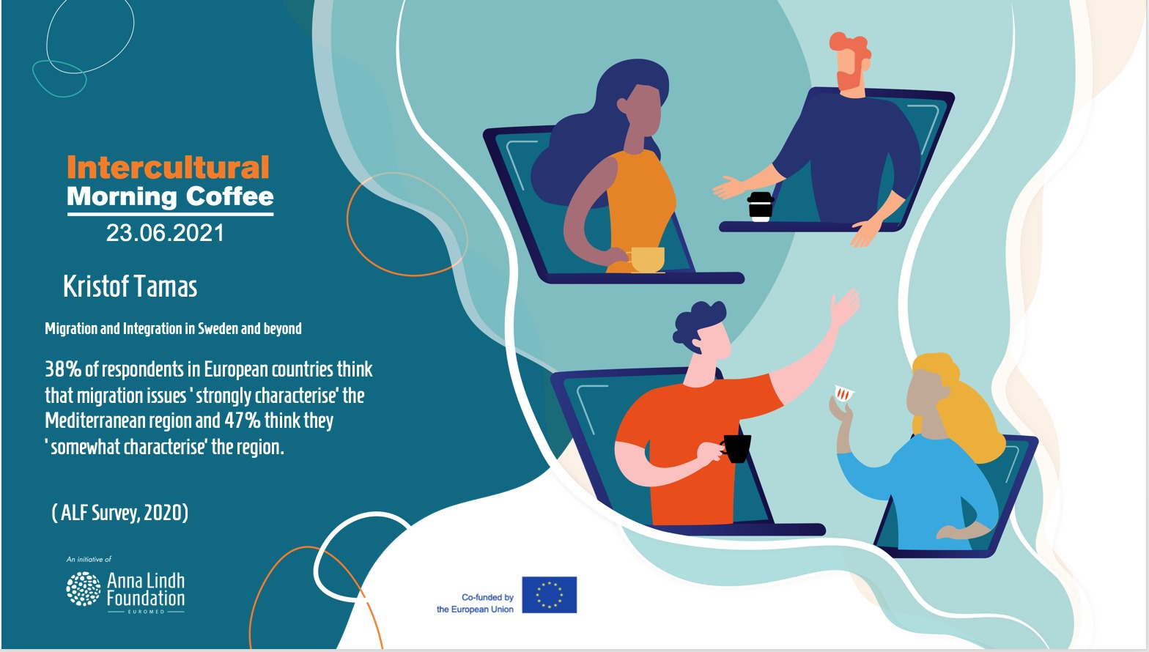

Background of the meeting

Sweden has welcomed a significant number of refugees and migrants over the last number of years. Furthermore, Sweden is also among the most tolerant countries according to the Anna Lindh Survey of 2020. However, trust is not guaranteed, and while social solidarity remains strong in Sweden, increased diversity since the mid-2010s seems to have decreased mutual trust and cohesion, according to Kristof Tamas, Senior Adviser at the Ministry of Justice, inter alia in charge of the implementation of the Global Compact for Migration in Sweden.

Considering these observations and the media coverage of Sweden one may ask what civil society in Sweden and other parts of the Euro-Mediterranean could do, in order to promote diversity, dialogue-driven media coverage, and a nuanced public debate on diversity and integration.

A brief presentation on data regarding these questions, was provided in the beginning of the Sixth Intercultural Morning Coffee by Kristof Tamas, author of the Fourth edition of the Anna Lindh Intercultural Trends Report.

Summary of key challenges and recommendation

The meeting started with a short introduction Kristof Tamas, Senior Adviser at the Ministry of Justice, inter alia in charge of the implementation of the Global Compact for Migration in Sweden & author of the Fourth edition of the Anna Lindh Intercultural Trends Report.

Mr Tamas underlined in his introduction that the ALF Survey data reflects the high level of attention given to migration among the Swedish public, with respondents in Sweden seven percentage points more likely than the EU average to think that migration issues ‘strongly characterise’ the Mediterranean region.

According to Mr Tamas, it is hence somewhat surprising that people living in Sweden remain among the most tolerant in Europe. To illustrate this, The ALF Survey data shows that 90% of respondents in Sweden would ‘not mind at all’ if their children were to go to school with children from a different cultural background (second only to Ireland with 92%); whilst 81% of Swedes -the joint highest across the study, alongside Ireland- would ‘not mind at all’ if one of their close relatives were to marry someone from a different cultural background.

Lastly, as a recommendation and as a conversation starter for the Morning Coffee, Mr Tamas highlighted the need to explore how trust can be maintained across various social strata in societies as cultural diversity increases. Both economic and social integration of immigrants appear key to counteracting tendencies of distrust. This is of particular significance in relation to the Mediterranean region, from where many immigrants to Sweden originate.
Following the presentation by Mr Tamas, the reflections developed around how mutual understanding and dialogue can be promoted via multimedia work and cultural festivities. Interestingly enough, as migration and diversity are very charged emotionally, it was concluded that facts, figures and countering fake news via myth-busting is not always the most efficient way to promote a better understanding of one another.
The power of sharing food culture and enjoying cultural events to promote better living together in multicultural societies was also discussed and best practices were exchanged among the participants.
It was also acknowledged that civil society working to promote intercultural dialogue needs to do more in terms of communication and visibility - especially to shed light on all of the inspiring and innovative initiatives that promote sustainability and social cohesion in the Euro-Mediterranean.

Recommendations

- Formal and non-formal education initiatives are essential measures to promote a better understanding of one another and to tackle polarization. In order to achieve this, cultural events are essential and bear much potential.
- In order to promote trust and tolerance, education is key and more active participation among peers as well.
- More cooperation is needed not only among civil society actors across the Euro-Mediterranean but also between civil society groups and local authorities.
- To promote trust and a better understanding of one another, cross-cultural encounters are of the highest essence.

Annex II Post-event press release

The Morning Coffee meetings are conceived as space for alumni of the Intercultural Trends and Media Platform to discuss informally up-to-date affairs with regards to dialogue and cross-cultural reporting in the media in the Euro-Mediterranean region.

The Morning Coffee on the 23rd of June, was arranged to shed light on an upcoming article on intercultural dialogue and relations in Ireland, in the fourth edition of the Anna Lindh Intercultural Trends Report, written by Kristof Tamas, Senior Adviser at the Ministry of Justice, inter alia in charge of the implementation of the Global Compact for Migration in Sweden (Sweden).

“With these Morning Coffees, we want to make it easy for academics, journalists and civil society members, North and South of the Mediterranean, to call each other, or send an email, for any pending questions they might have in relation to their work. We need more cooperation and discussions”, underlined Eleonora Insalaco, Head of Operations and Intercultural Research at the Anna Lindh Foundation, during the meeting on the 21st of April”.

Main recommendations from the discussion include:
- Formal and non-formal education initiatives are essential measures to promote a better understanding of one another and to tackle polarization. In order to achieve this, cultural events are essential and bear much potential.
- In order to promote trust and tolerance, education is key and more active participation among peers as well.
- More cooperation is needed not only among civil society actors across the Euro-Mediterranean but also between civil society groups and local authorities.
- To promote trust and a better understanding of one another, cross-cultural encounters are of the highest essence.

Lastly, Insalaco also noted based on the recommendations presented during the morning coffee that the Foundation and other relevant actors working to promote intercultural dialogue in the region, need to invest in education on the formal and informal level and to facilitate cross-cultural encounters, be it within the parameters of cultural events or otherwise.

About the Intercultural Trends and Media Platform & The Intercultural Morning Coffee
The Intercultural Trends and Media Platform & the Intercultural Morning coffees are organised by the Anna Lindh Foundation and the Mediterranean Universities Union (UNIMED) bringing together media, academia and civil society to create a network and to discuss how perceptions between Europeans and Southern and Eastern Mediterranean people have evolved in recent years as a result of the growing migratory and refugee movements, the rise of populist’s discourses and phenomena of violent extremism.
If you are a journalist, member of civil society or academic who would like to participate in a future edition of the Intercultural Trends and Media Platform, please do not hesitate to contact us (Johannes.Jauhiainen@annalindhfoundation.org - Intercultural Research Social Media Executive).
For more information on the Intercultural Trends and Media work at the Anna Lindh Foundation you can contact: Eleonora.Insalaco@annalindhfoundation.org - Head of Operations and Intercultural Research.

