24th of June
11:00-12:30 CET
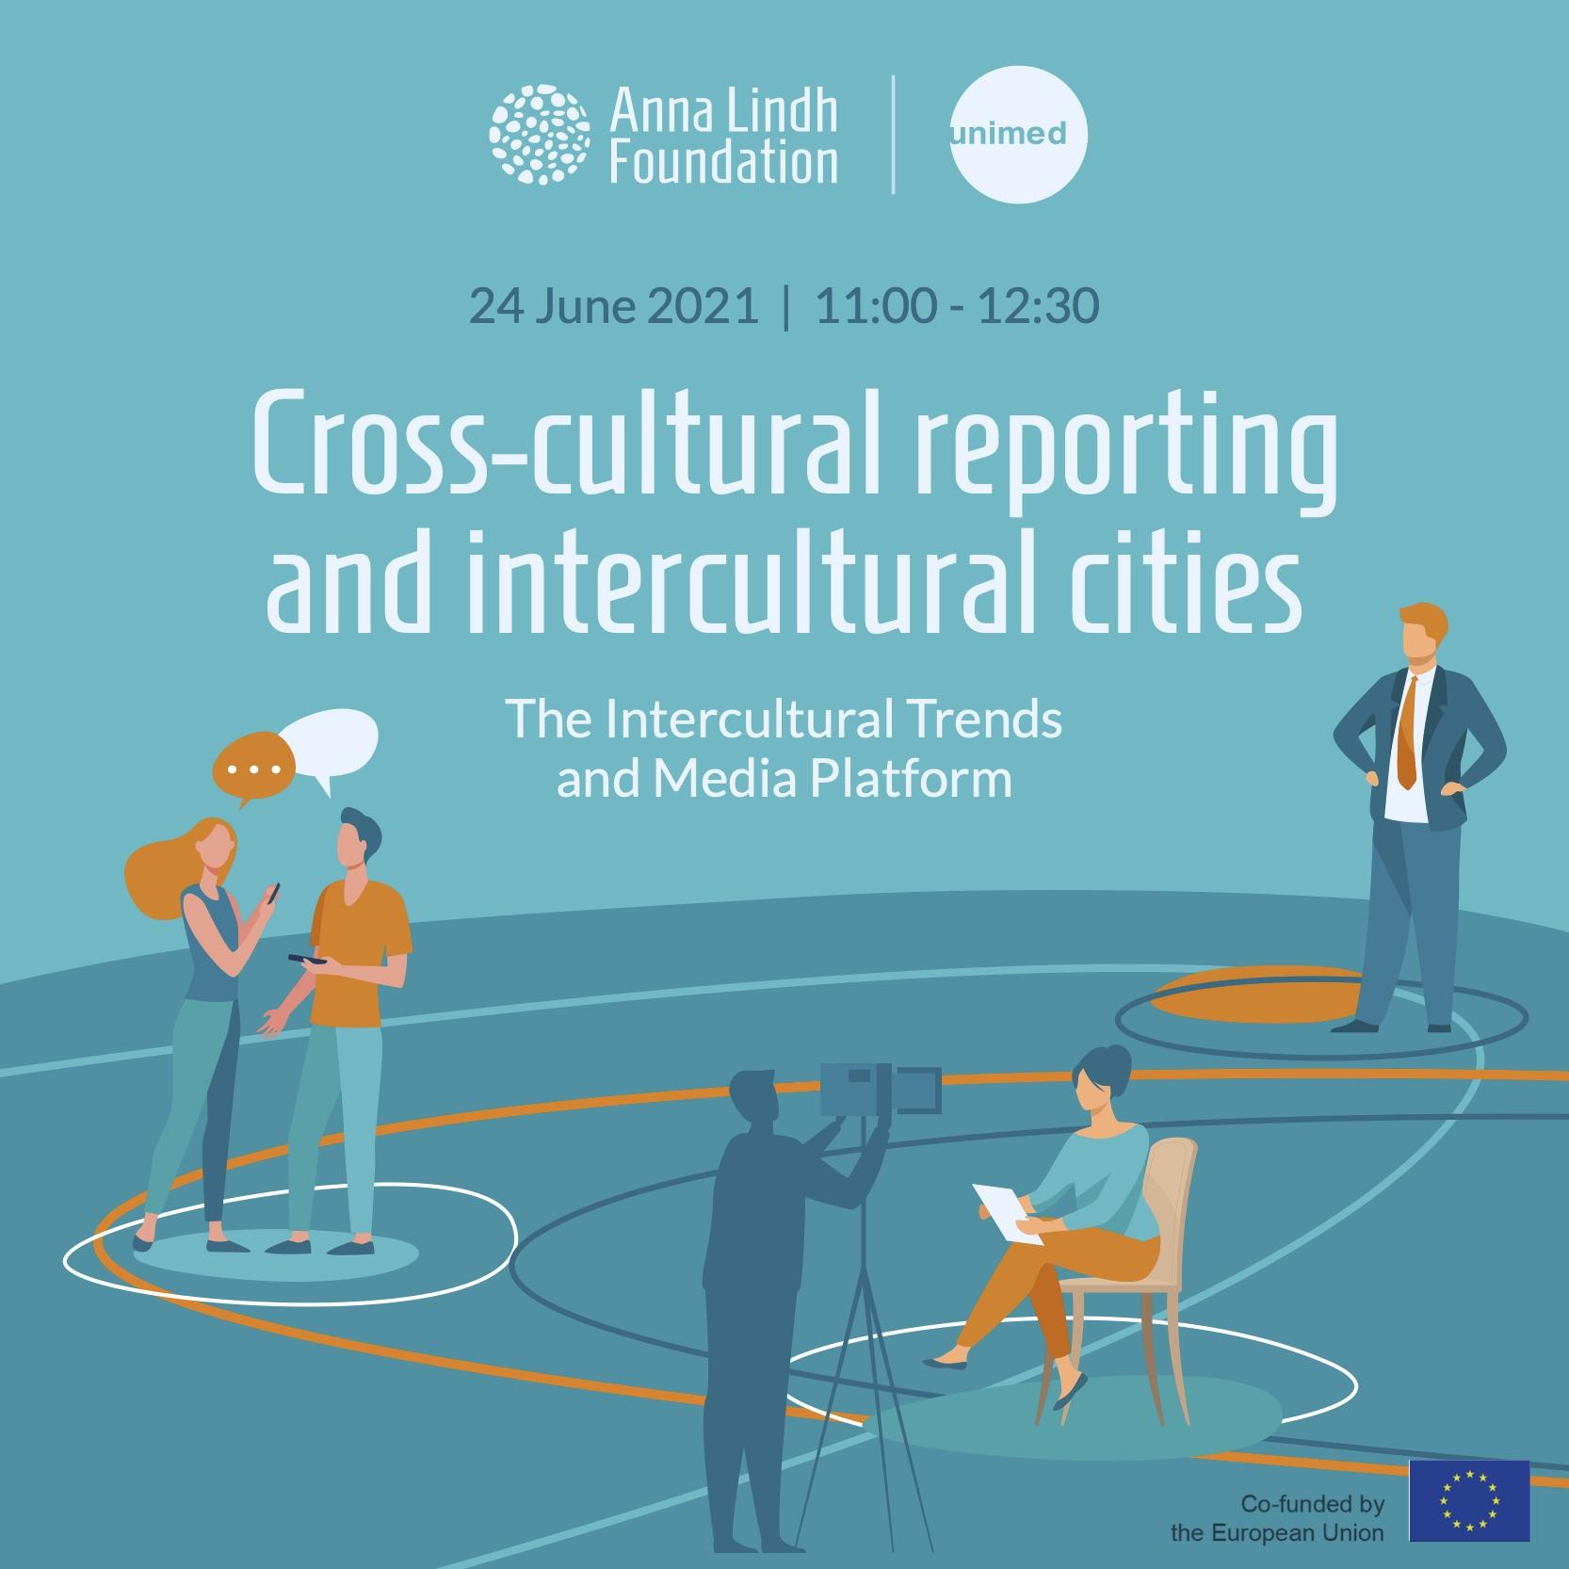

List of participants:

Participants from civil society, academia and the press in the Euro-Mediterranean region

Jelnar Ahmad, Germany-based Syrian consultant, Research and M&E Manager at IMPACT-Civil Society Research and Development, Germany; Suleiman Othman, Founder and Editor of Caravel Magazine, The United Kingdom, Nicole Hamouche, Freelance Journalist for L’orient Le Jour, Lebanon; Benoit Martin, Strategic Partnerships Coordinator at PAX, the Netherlands; Filipe Thermudo Barata, Professor at the University of Evora, Mario Schejtman, Executive Director of the Center for Advancement in Peace Initiatives, Israel.

Anna Lindh Foundation:

Eleonora Insalaco, Head of Operations and Intercultural Research; Racha Omeyri, Intercultural Research Officer - Co-rapporteur of the meeting; Johannes Jauhiainen, Intercultural Research Social Media Executive- Co-rapporteur and technical moderator of the meeting; Thomas Lund, coordinator for the Anna Lindh Intercultural Cities and Learning Program, Observer of the meeting.

The Mediterranean Universities Union:

Marcello Scalisi, Director; Nathalie Clauter, Project Manager; Camille Limon, Communications Officer.

The Meeting

The discussion and debate focused on media coverage of diversity and dialogue at the local level and issues relating to coexistence within multicultural societies in the Euro-Mediterranean region.
- The following questions were used to stimulate the debate: Since the outburst of the pandemic in which way has the media covered issues relating to culturally diverse communities, migration and social inclusion within your country?
- Which good and bad practices could you share in relation to social cohesion and measures to enhance respect for cultural diversity and intercultural interaction within the current context?
- The findings of the ALF Intercultural Trends Survey 2020 reveal a good level of openness to cultural diversity and rights of minorities within society by people in the EuroMed region. Which media formats could reflect this attitude?
- What role could the media play to promote migrant integration and inclusion in host communities? Which actions can stimulate collaborations at the city level for the promotion of intercultural relations?

Polling data from the Intercultural Trends Survey 2020 gathering the views of over 13.000 people from the region was shared among the participants whilst the outcomes of the Platform will be used to feed into the broader process around the New Agenda for the Mediterranean.

Summary of key challenges and recommendations

The meeting started with welcoming words from Marcello Scalisi, director of the Mediterranean Universities Union (UNIMED), who highlighted that the importance of intercultural cities and the work that UNIMED is doing in this regard, thanks to the students and mobility of academic staff across all four corners of the Euro-Mediterranean region.

Eleonora Insalaco, Head of Operations and Intercultural Research at the Anna Lindh Foundation, then proceeded to present a selection of findings from the Anna Lindh Intercultural Trends Survey of 2020. Insalaco noted amongst other, with regards to diversity in cities as an essential phenomena in the Euro-Mediterranean, that that migration issues are considered to strongly characterise the Mediterranean region by 38% of respondents in Europe and 60% of survey respondents in countries in the southern and eastern shores of the Mediterranean (SEM).

With regards to intercultural dialogue being promoted specifically in cities, Insalaco also underlined that the vast majority of respondents (89% in European countries and 90% in SEM countries) considered local authorities and civil society initiatives that promote intercultural dialogue to be either ‘somewhat effective’ or ‘very effective’ actions. This in turn suggests a high level of confidence in local authorities and civil society.

On a positive note, Insalaco also shed light on the fact that according to the Anna Lindh Survey of 2020, residents see the Mediterranean region as characterised by its common cultural heritage and history, with 89% of respondents in European countries and 85% in SEM countries considering it as somewhat or strongly characteristic of the region. This in turn gives a positive tone for all initiatives promoting cohesion in the region.

Lastly, and as a tip to journalists and media professionals working with cross-cultural reporting, Insalaco underlined that there are high levels of interest in the culture and lifestyle of the ‘other’ respective country group (84% in European countries and 70% in SEM countries are ‘very interested’ or ‘somewhat interested’ in hearing about the cultural life and lifestyle of neighbouring countries).

During the roundtable of the discussion, migration and integration in the Iberian peninsula was discussed as well as the lack of knowledge in Europe about the situation that especially youth face in countries such as Iraq and Syria, which have been countries of origin, for some asylum-seekers who have come to Europe, during the last years.

Reflections also developed around intercultural relations in different parts of Israel and the Palestinian territories. It was acknowledged among other that there are increased tensions between the Israeli Jews and the Palestinian citizens of Israel and between Israeli ultra-orthodox Jews and secular Jews.

Light was also shed on the particular challenges that Lebanon faces including the lack of basic infrastructure such as food, electricity, access to internet and even money.

Lastly, intercultural relations in cities was also reflected upon from the viewpoint of interreligious relations which is a media narrative that has surfaced especially in Sweden - for better and for worse.

Recommendations:

- All actors working or aspiring to promote intercultural dialogue in the region, need to do more to highlight the positive stories of solidarity and peaceful coexistence that exist on the grass-roots level in the four corners of the Euro-Mediterranean region. This concerns particularly journalists, who too often report merely on politics, misery or poverty.
- There is a high need for more collaboration and more strategic partnerships among all actors seeking to promote mutual understanding and a more nuanced public debate about intercultural dialogue in the Euro-Mediterranean region.
- Language diversity in the Euro-Mediterranean should also be noticed - more needs to be done in French and Arabic as well, instead of only English.
- While online media might be an efficient tool to reach some people in the Euro-Mediterranean, billboards might be more effective in other parts. Hence the local contexts should always be taken into consideration for campaigns raising awareness.

Annex 1: Press Release

Promoting intercultural dialogue in cities is crucial to ensure the success and sustainability of increasingly diverse societies around the Mediterranean. On the 24th of June the Anna Lindh Foundation & the Mediterranean Universities Union (UNIMED) organized the seventh edition of the Intercultural Trends and Media Platform focusing on intercultural dialogue in cities.
According to the Intercultural Trends Survey of 2020, 89% of respondents in Europe and 90% of those in the Southern and Eastern Mediterranean considered local authorities and civil society initiatives that promote intercultural dialogue to be either ‘somewhat effective’ or ‘very effective’ actions, which suggests a high level of confidence in local authorities and civil society working namely in cities.
Yet, media narratives in the Euro-Mediterranean have to a large extent quite a neutral effect on mutual perceptions with only 8% of respondents in Europe and 17 % in the Southern and Eastern Mediterranean reporting that the media had influenced their views in a positive way about the other shore of the Mediterranean. This in turn begs questions on how coverage of practices promoting intercultural dialogue and intercultural encounters in cities, could contribute to a more nuanced public debate and a better understanding of one another in the Euro-Mediterranean.
With these observations in mind, the Anna Lindh Foundation was thrilled to bring together academics, civil society and journalists to discuss the promotion of intercultural dialogue at the city level and the prevalent public and media discourses on that topic.
“Cities are on the forefront when it comes to promoting intercultural dialogue and the seventh Intercultural Trends and Media Platform will be a great stepping stone in the Foundation’s Intercultural Cities and Learning program that will soon see the launch of the EuroMed Capital for Dialogue Award”, highlights Eleonora Insalaco, Head of Operations and Intercultural Research.

About the Intercultural Trends and Media Platform
The Intercultural Trends and Media Platform is organised by the Anna Lindh Foundation and the Mediterranean Universities Union (UNIMED) bringing together media, academia, and civil society to create a network and to discuss how perceptions between Europeans and Southern and Eastern Mediterranean people have evolved in recent years as a result of the growing migratory and refugee movements, the rise of populist’s discourses and phenomena of violent extremism.
If you are a journalist, member of civil society or academic who would like to participate in a future edition of the Intercultural Trends and Media Platform, please do not hesitate to contact us (Johannes.Jauhiainen@annalindhfoundation.org - Intercultural Research Social Media Executive).
For more information on the Intercultural Trends and Media work at the Anna Lindh Foundation you can contact: Eleonora.Insalaco@annalindhfoundation.org - Head of Operations and Intercultural Research.

Annex 2 Post-event Press Release

Intercultural dialogue in cities on the agenda of the sixth Intercultural Trends and Media Platform
According to the Intercultural Trends Survey of 2020, 89% of respondents in Europe and 90% of those in the Southern and Eastern Mediterranean considered local authorities and civil society initiatives that promote intercultural dialogue to be either ‘somewhat effective’ or ‘very effective’ actions, which suggests a high level of confidence in local authorities and civil society working namely in cities. This in turn reaffirms the need for an even closer cooperation between local authorities and civil society actors.
Yet, journalists often do not give visibility to stories highlighting solidarity and peaceful coexistence that exist on the grass-roots level in the four corners of the Euro-Mediterranean region.
With this in mind the Anna Lindh Foundation and the Mediterranean Universities Union were eager to once again dedicate a virtual exchange among journalists, academics and civil society to this timely topic of high interest

Main recommendations emerging from the roundtable include the following:

- All actors working or aspiring to promote intercultural dialogue in the region, need to do more to highlight the positive stories of solidarity and peaceful coexistence that exist on the grass-roots level in the four corners of the Euro-Mediterranean region. This concerns particularly journalists, who too often report merely on politics, misery or poverty.
- There is a high need for more collaboration and more strategic partnerships among all actors seeking to promote mutual understanding and a more nuanced public debate about intercultural dialogue in the Euro-Mediterranean region.
- Language diversity in the Euro-Mediterranean should also be noticed - more needs to be done in French and Arabic as well, instead of only English.
- While online media might be an efficient tool to reach some people in the Euro-Mediterranean, billboards might be more effective in other parts. Hence the local contexts should always be taken into consideration for campaigns raising awareness.

“The recommendations and assessments, presented during the seventh Intercultural Trends and Media Platform, once again underlines the need for a variety of actors in the Euro-Mediterranean to highlight in their activities and their communication, positive and inspiring examples, of peaceful and prosperous coexistence in cities across the Euro-Mediterranean”, said Eleonora Insalaco, Head of Operations and Intercultural Research, at the Anna Lindh Foundation .

About the Intercultural Trends and Media Platform
The Intercultural Trends and Media Platform is organised by the Anna Lindh Foundation and the Mediterranean Universities Union (UNIMED) bringing together media, academia, and civil society to create a network and to discuss how perceptions between Europeans and Southern and Eastern Mediterranean people have evolved in recent years as a result of the growing migratory and refugee movements, the rise of populist’s discourses and phenomena of violent extremism.
If you are a journalist, member of civil society or academic who would like to participate in a future edition of the Intercultural Trends and Media Platform, please do not hesitate to contact us (Johannes.Jauhiainen@annalindhfoundation.org - Intercultural Research Social Media Executive).
For more information on the Intercultural Trends and Media work at the Anna Lindh Foundation you can contact: Eleonora.Insalaco@annalindhfoundation.org - Head of Operations and Intercultural Research.

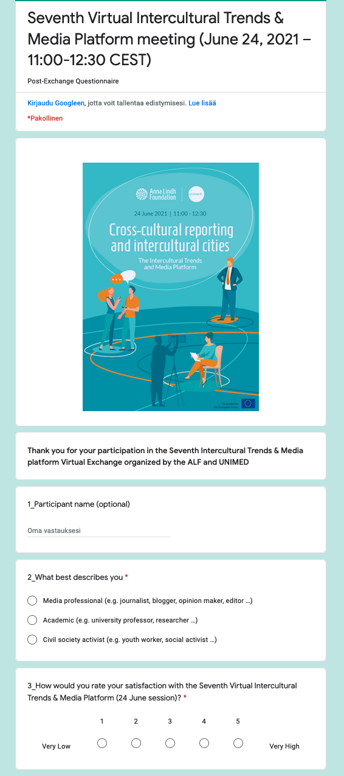
AnnexIV Post-Exchange Questionnaire
