Fourth Intercultural Morning Coffee
Wednesday, 12, May, 2021 09:30 am to 10:15 am CET Time

Attendees:

Participants: Riham Bahi (Egypt), Associate Professor of international relations at the Faculty of Economics and Political Science, Cairo University and contributor to the Fourth Anna Lindh Intercultural Trends Report, Sara Ahmed, Editor in Chief of Egyptian Streets (Egypt), Ahmed el Jechtimi (Morocco)), Journalist for Thomson Reuters.

ALF Representatives
Chair of the meeting: Eleonora Insalaco - Head of Operations and Intercultural Research
Facilitator and rapporteur: Johannes Jauhiainen – Social Media Executive
Co-rapporteur: Racha Omeyri - Intercultural Research Officer

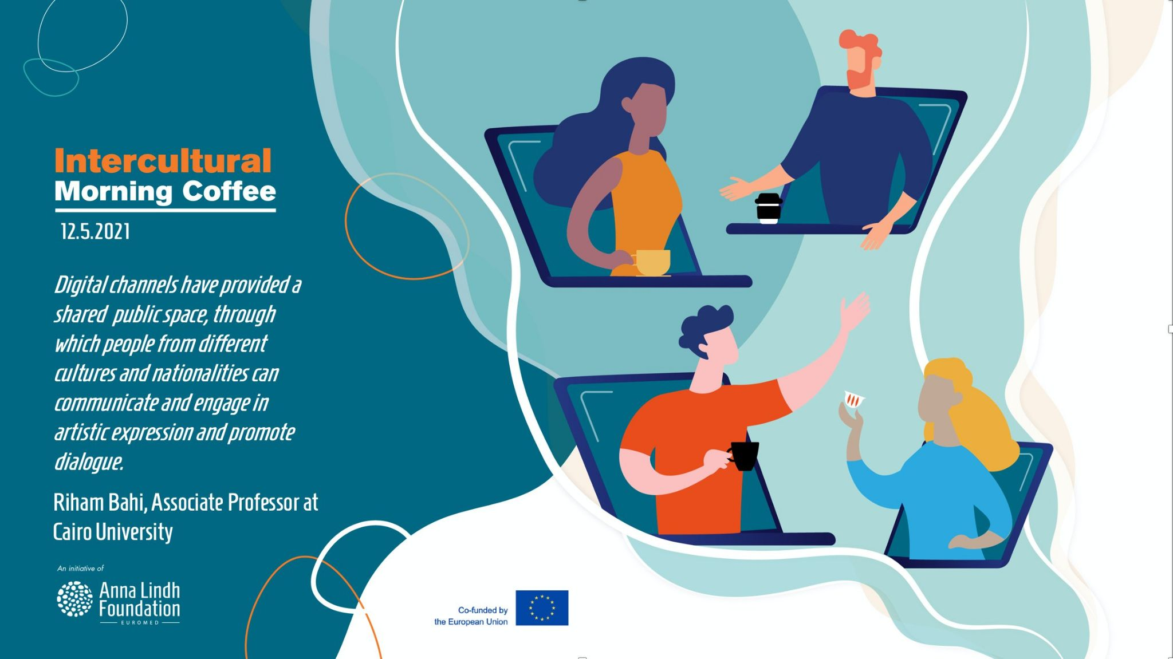

Background of the meeting 2
Summary of key challenges and recommendations 2
Annex II Post-event Press Release 3

Background of the meeting

The Anna Lindh Foundation is organizing a series of meetings called the Intercultural Morning Coffee which brings together researchers, journalists, and civil society to discuss up-to-date issues over a cup of coffee in the morning. The get-together is set out to be casual with fewer people than for example the Intercultural Trends & Media Platform Virtual Exchanges.

The Fourth morning coffee was organized on the 12th of May, from 09:30 CET to 10:00 CET and focused on how culture and art can promote living together in diverse societies, which is a particularly timely topic since a growing number of countries in the Euro-Mediterranean are easing restrictions, which means that people will soon be able to attend public events and cultural festivities.

The session started with a brief presentation by Riham Bahi, Associate Professor of international relations at the Faculty of Economics and Political Science, Cairo University. Bahi is a contributor to the fourth edition of the Anna Lindh Intercultural Trends Report 2021 in which she has explored the relevance of art and intercultural dialogue to post-pandemic recovery.

Summary of key challenges and recommendations

Riham Bahi started her presentation by arguing that culture and artistic initiatives can bring people together and encourage greater participation in cultural and social life. For these reasons, they will be crucial in developing a vision for real inclusion during and post-Covid-19. For example, a recent report by the EU discussed the integration of migrants and refugees in societies through artistic initiatives and culture. The report confirms that participatory arts practices are particularly conducive to integrating refugees and migrants.

Bahi also noted that, on both shores of the Mediterranean, respondents of the ALF Intercultural Trends Survey agreed overall that exposing people to cultural diversity through civil society initiatives and multi-cultural events are effective ways of promoting cohesion. Indeed, respondents in both country groups (83% in Europe and 88% in SEM countries) think that cultural and artistic initiatives are either a ‘very effective’ or “somewhat effective” measure to prevent and deal with the challenges of hate speech and opposing cultural views.

On that note, Bahi also underlined that respondents were also asked about which actions would be effective in helping people live better together in multicultural environments. ‘Encouraging local authority and civil society initiatives that promote intercultural dialogue’ was perceived to be effective action in both regions, with 89% of respondents in European countries and 90% in SEM countries considering this action as either ‘somewhat effective’ or ‘very effective’ in helping people live better together in multicultural environment.

Lastly, Bahi concluded that art and intercultural dialogue can be used as ways to ‘build back better’, enforcing social solidarity and creating a sense of belonging among the most vulnerable groups in society, improving resilience.

During the roundtable of the meeting it was noted that it can at times be challenging for journalists to cover events promoting intercultural dialogue because the scope and aim of these events are not clear. Furthermore, it was noted that while events claim to promote dialogue they can still sometimes be exclusive to certain groups in society, with the type of language and/or the de facto language they use, such as English in an Arabic speaking environment.

Light was also shed on the logic of the media which by definition does not tend to cover stories on intercultural dialogue but instead covers conflicts extensively. It was also noted that Meanwhile, intercultural dialogue, art or conflict sensitivity are not taught as subjects at journalism schools whilst there are numerous courses available on other topics that are considered as priorities such as economics or international relations.

It was also acknowledged that the pandemic has taken a severe toll on the cultural sector as many venues in the Euro-Mediterranean have had to close.

Recommendations:

- Civil society and cultural operators need to do more to put intercultural dialogue on the agenda of the public debates. To do so, civil society may need to be clearer about the aim of the intercultural and artistic events if they wish to receive coverage of them by the media.
- Intercultural events should be designed to be as inclusive as possible - by appealing to people of different classes and backgrounds.
- Civil society and academics need to do more in reaching out to the media, journalists and associations such as foundations of media outlets to get their message heard and across.
- Universities and other educational and academic institutions were called on to include courses and modules on how to cover issues relating to intercultural dialogue.
- Financial help is needed to support artistic initiatives promoting intercultural dialogue.

Annex II Post-event Press Release

The Anna Lindh Foundation is organizing a series of meetings called the Intercultural Morning Coffee which brings together researchers, journalists, and civil society to discuss up-to-date issues over a cup of coffee in the morning. These get-togethers are set out to be casual with fewer people than for example the Intercultural Trends & Media Platform Virtual Exchanges.

“With these Intercultural Morning Coffees, we want to bring journalists, academics and civil society together, in an informal way, to discuss current affairs and their implications on dialogue in the Euro-Mediterranean. We hope that with these meetings, it will be easier for participants to get in touch with one another and that we, as a Foundation could contribute to a more fact-based and nuanced public debate about issues affecting mutual perceptions and cohesion in our region”, underlined Eleonora Insalaco, Head of Operations and Intercultural Research at the Anna Lindh Foundation.

About the Intercultural Trends and Media Platform & the Intercultural Morning Coffees
The Intercultural Trends and Media Platform and the Intercultural Morning Coffees are organised by the Anna Lindh Foundation and the Mediterranean Universities Union (UNIMED) bringing together media, academia and civil society to create a network and to discuss how perceptions between Europeans and Southern and Eastern Mediterranean people have evolved in recent years as a result of the growing migratory and refugee movements, the rise of populist’s discourses and phenomena of violent extremism.
If you are a journalist, member of civil society or academic who would like to participate in a future edition of the Intercultural Trends and Media Platform, please do not hesitate to contact us (Johannes.Jauhiainen@annalindhfoundation.org - Intercultural Research Social Media Executive).
For more information on the Intercultural Trends and Media work at the Anna Lindh Foundation you can contact: Eleonora.Insalaco@annalindhfoundation.org - Head of Operations and Intercultural Research.

