15th of December
11:00-12:30 CET

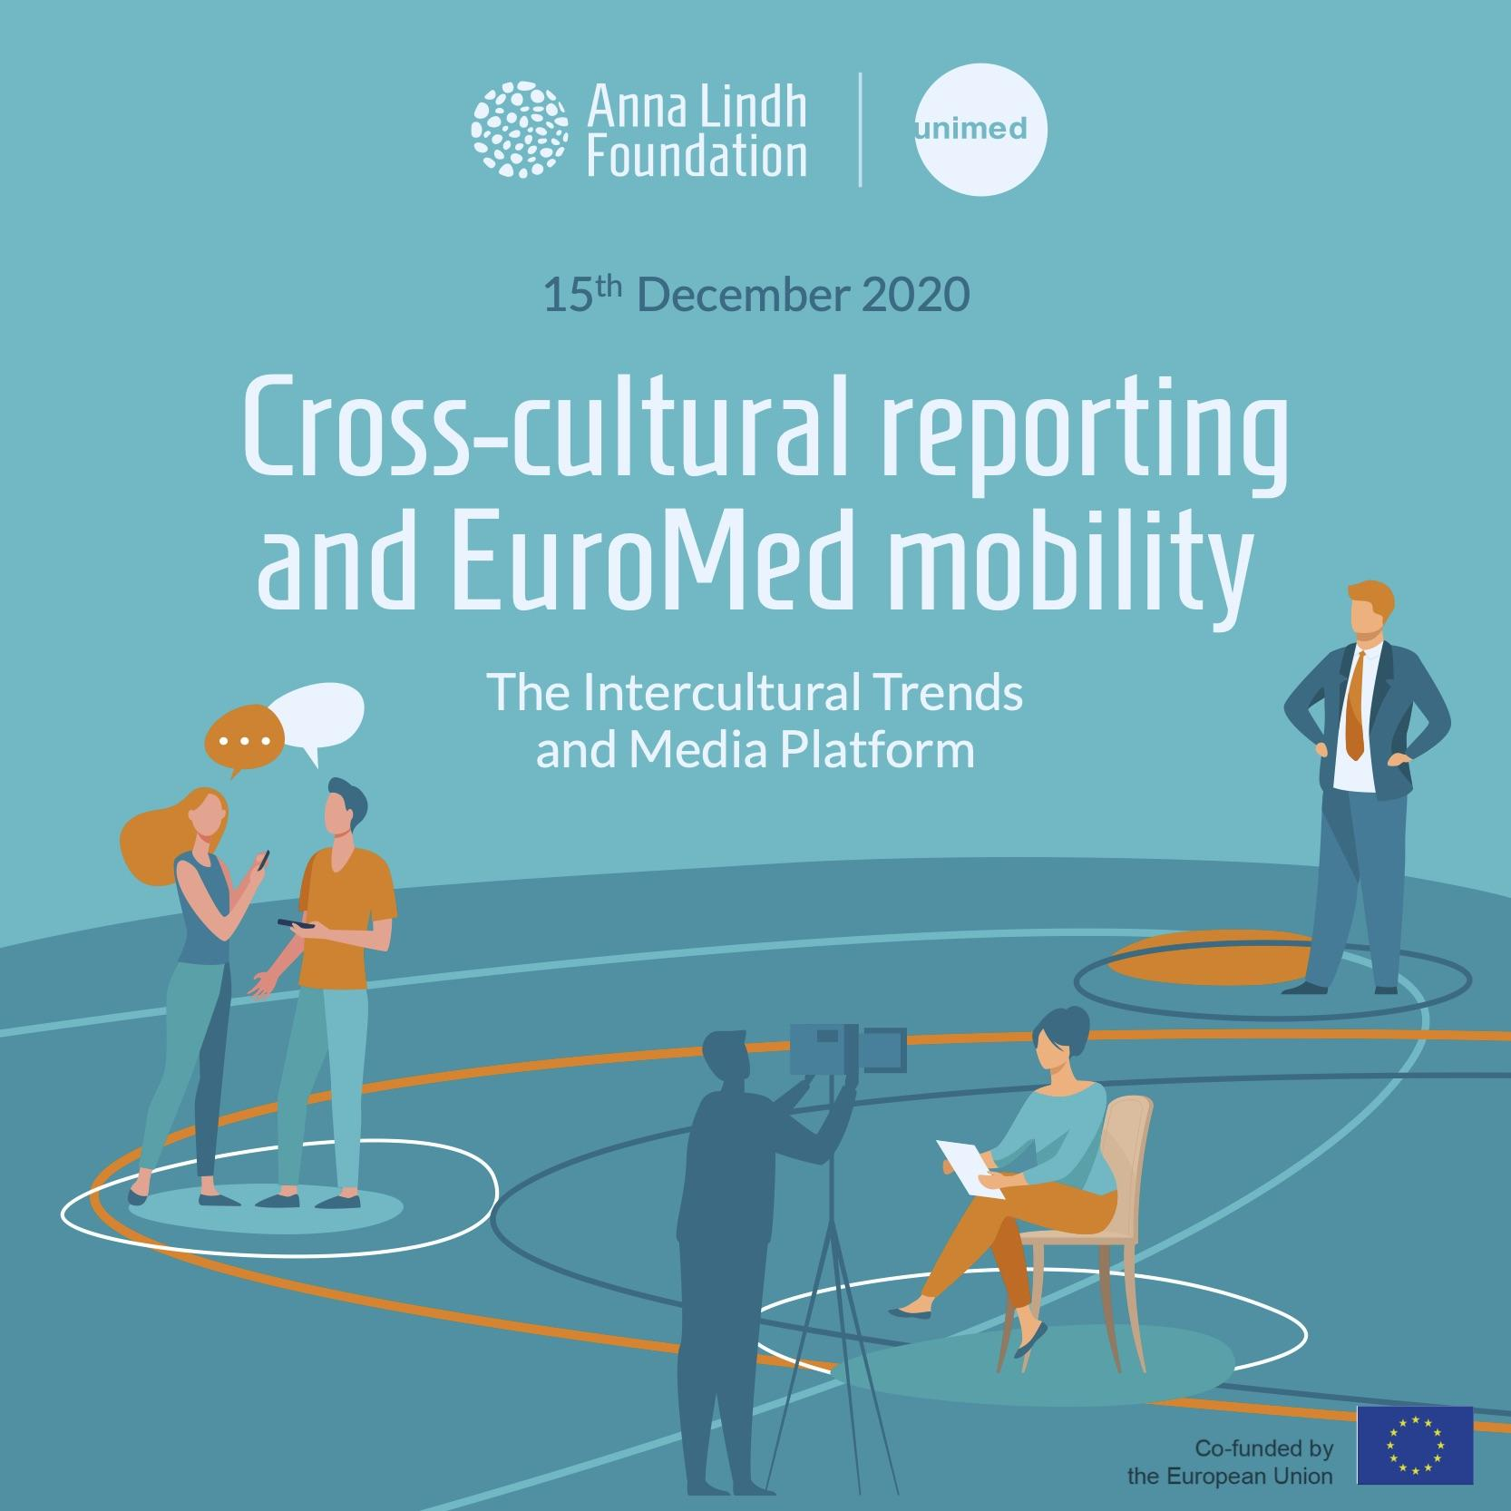

List of participants:

Participants from civil society, academia and the press in the Euro-Mediterranean region

Dr. Shadeen Khallaf, Senior Policy Advisor, UNHCR MENA, Jordan; Yamina EL Kirat El Allame, Coordinator of the Research Laboratory “Culture, Language, Education, Migration & Society” (CLEMS) and Vice Dean for Research and Cooperation at FLHSR, Mohammed V University, Morocco; Serena Marcenò, Associate professor in the field of culture and societies and lead partner of the Erasmus+ CBHE project MIGRANTS, University of Palermo, Italy; Frankie Reid, Research & Production Assistant Migration Matters, Germany; Samira Mechri, Professor of Migration Studies, Partner of MIGRANTS, Université Tunis El Manar, Tunisia; Shahd Anani, Head of Public Relations division at the Jordan Hashemite Charity organization (JHCO), Jordan. Tereza Svášková, Head of ARABFEST, Czech Republic; Renee Hattar, Head of International Studies, Programs & Projects. The Royal Institute for Inter-Faith Studies (RIIFS), Jordan; Daham Alsaad, Danemark, Freelance journalist and filmmaker, regular contributor to Der Spiegel Magazine, L'express, Le Point, Dagbladet Information in Denmark, Danish Tv, France 24, and M6 TV in France, Danemark.

Anna Lindh Foundation:

Eleonora Insalaco, Head of Operations and Intercultural Research; Racha Omeyri, Intercultural Research Officer -Rapporteur of the meeting; Johannes Jauhiainen, Intercultural Research Social Media Executive- Co-rapporteur and technical moderator of the meeting; Giulia Latronico - Co-rapporteur.

The Mediterranean Universities Union:

Marcello Scalisi, Director and Nathalie Clauter, Project Manager, Camille Limon, Communications Officer.

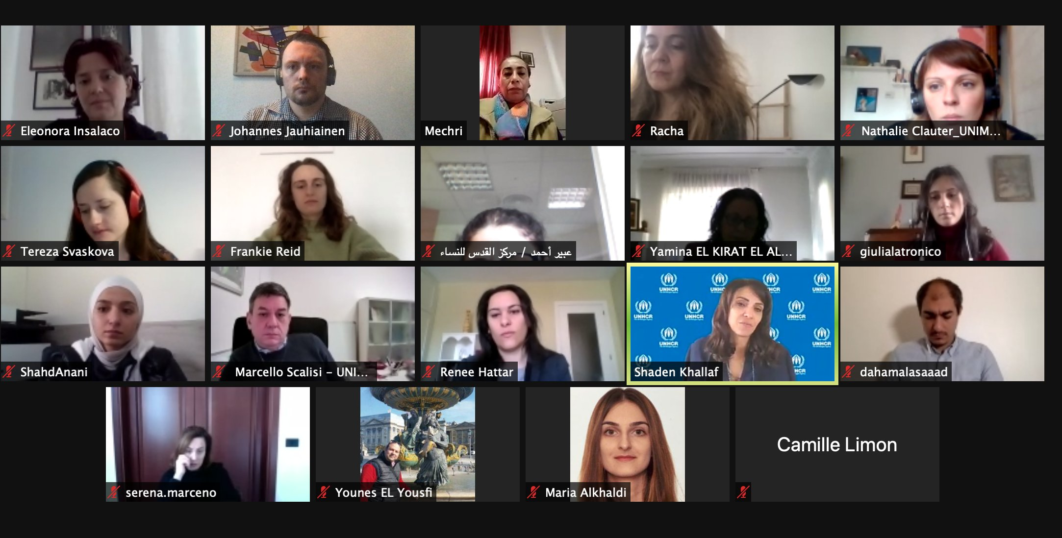

Background of the meeting 4
The meeting 5
Summary of key challenges and recommendations 6
Annex I: Press Release 10
Annex II: Post-event Press Release 12
Annex IV Post-Exchange Questionnaire 13

Background of the meeting

The Intercultural Trends and Media Platform brings together media, academia and civil society to debate on media narratives in relation to diversity and intercultural relations in the Euro-Mediterranean region.

A focus of the fourth Intercultural Trends and Media Platform was the media coverage of migration-related issues and coexistence within multicultural societies in the Euro-Mediterranean region.

The ALF shared results from the latest ALF-Ipsos Intercultural Trends Survey 2020 which gathered the views of over 13.000 people from the region.

The online discussion was, as previous platforms, conceived as a space for a facilitated discussion to exchange reflections on the topic and to share some initial ideas on what can be done by journalists, academia, and civil society together to support intercultural relations and cooperation in the EuroMed region.

The outcomes of the Intercultural Trends and Media Platform(s) feed into the broader process of reflection carried out in 2020 on the occasion of the 25th Anniversary of the Barcelona Process/EuroMed Partnership (launched in 1995) and in view of further strengthening cooperation in the Euro-Mediterranean region.

The meeting

The fourth Intercultural Trends and Media Platform began with introductory remarks by Marcello Scalisi, Director of UNIMED, Shaden Khallaf, Senior Policy Advisor at UNHCR MENA, and Eleonora Insalaco, Head of Operations and Intercultural Research at the ALF. In particular, Insalaco presented a brief overview of the ALF-Ipsos Intercultural Trends Survey 2020, especially focusing on the data being relevant for the topic of discussion. Following the introduction, participants were invited to share their first reactions during the plenary session. Participants were then divided into three parallel breakout rooms, each with a rapporteur. In the virtual breakout rooms, the discussion among the participants was initiated with the following guiding questions:

- Since the outburst of the pandemic, in which way the media has covered migration issues and cultural diverse communities within your country?

- Which good and bad practices could you share in relation to the portrayal of migrants and refugees within the current context?

- What measures to promote diversity and dialogue via the media? What role could migrants and refugees and the media play for intercultural dialogue in the EuroMed region?

The fourth virtual Intercultural Trends and Media Platform Exchange included a post-evaluation questionnaire.

Summary of key challenges and recommendations

In his opening remarks, Marcello Scalisi, Director of UNIMED - the Mediterranean Universities Union, underlined the importance of creating safe spaces where academics and scholars can network and reflect together with members of the media and representatives of civil society in order to promote dialogue in the Euro-Mediterranean region. Scalisi also underlined that the Intercultural Trends and Media platform is, indeed, a tool that aims to promote a positive storytelling about Mediterranean societies, and contributes to create a Mediterranean generation based on values of dialogue and mutual understanding.

Eleonora Insalaco, Head of Operations and Intercultural Research at the Anna Lindh Foundation, noted in her opening remarks that a key challenge for promoting dialogue is that the media too often frames “otherness” in the Mediterranean based on stereotypes. With this in mind and in order to provide fact-based insights on mutual perceptions and inclinations, the ALF has been conducting scientific research by carrying out opinion polls on a variety of topics of interest since 2010. The data collected on migration and cross-cultural reporting is particularly interesting and highlights the inclination towards migration throughout the whole Mediterranean region and over time.

Giving an overview of the ALF-Ipsos Intercultural Trends Survey 2020, Insalaco underlined that respondents in both Europe and the Southern and Eastern Mediterranean (SEM) generally hold a positive perception of the Mediterranean region, which is perceived to be mainly characterised by hospitality, a common cultural heritage and a common history. In terms of migration, both country groups associate the Mediterranean with migration issues.

Continuing on the results of the 2020 Intercultural Trends Survey, Insalaco noted that regarding the attractiveness of Europe and the SEM countries as places to live, only half (51%) of SEM respondents said they would prefer to start a new life somewhere else, conversely 60% of European respondents said they would choose to move abroad. Among the European respondents who would choose to leave, other European countries remain the preferred destinations. Only 20% of SEM identified Europe as their destination to start a new life. The survey revealed that young people (15-29) would also prefer to start a new life in another country; whilst a difference in responses between men and women was also evident, with men preferring to start a new life in their country of origin while women in another country.

On the impact of the media in shaping public perception, overall, more respondents said that media stories had a negative, rather than positive, impact on their views and perceptions of other cultures. TV remains the most trusted media source for cross-cultural reporting across the Euro-Mediterranean, though online and social media are also trusted sources for large sections of the population, particularly young people and people in SEM countries. In European countries, only 24% of young people trust social media, but a big importance is recognised to online media as well as to traditional means of information - books, newspapers, magazines.

Finally, it was highlighted how most respondents think that digital technology is likely to have a positive rather than negative impact on intercultural dialogue, with cultural barriers seen as less of an obstacle to dialogue during digital communication compared to face-to-face interaction.

The roundtable of the meeting began with a presentation from Shaden Khallaf, Senior Policy Advisor to the United Nations High Commissioner for Refugees-MENA. In her opening remarks, Ms Khallaf underlined that there has always been diversity in how Mediterranean countries receive and treat refugees. In particular, she highlighted that the MENA region hosts more than 40% of refugees, who are generally perceived as a burden and as a responsibility, especially considering that countries within the region do not have well established frameworks for the reception of refugees, but also since they experienced massive displacement flows, coupled with economic crises, shift in political alliances, and global financial flows. All this considered, Khallaf also noted that refugees can also contribute to their host societies and communities, and this is being progressively recognised. Indeed, over the past ten years there has been a significant evolution in terms of policies addressing refugees and displaced persons. The pressures on the host communities remain very high, but refugees are starting to be recognised as active and positive members for the community, when given the space to do so.

Khallaf further stressed how UNHCR continues to work to open up the policy space for refugees to be included and have access to education and to basic health care in their host countries, but also to allow access to livelihoods for them to preserve their dignity and sustain themselves and their families. With the implementation of many initiatives, positive results are being achieved such as the inclusion of refugees in the medical response to Covid-19. However, more should be done on the political side to avoid that countries with limited resources bear alone the responsibility of refugee hosting. There is the need for a stronger solidarity with countries that host refugees, a stronger support to the host communities, a stronger emphasis on innovative solutions and on self-reliance.

Finally, Khallaf stressed that the role of civil society, academia, interfaith organisations and artists is key to ensure action is taken at the local and national level for the elevation of the refugees’ situation - and their core and valuable role is currently being emphasised at the international level. Indeed, in the last couple of years, the role of the civil society in the MENA-region has taken a key role in the refugee crisis, beyond the implementation of assistance programs. The international community is thus trying to make sure that these actors become more involved in the design of the response and in the analysis of what the needs of refugees are, rather than being left alone at the implementation phase of projects.

Reflections in the plenary then developed around the challenges that the pandemic poses on journalists covering issues relating to refugees, migration and mobility. For example, travel bans have made it more difficult to report on the refugees’ situation on the ground. Furthermore, there is a gap between NGOs, human rights organisations and journalists, who are sometimes seen as outliers. With that in mind the plenary also recognised that since the outburst of the pandemic, migration has been overtaken by other topics in the news cycle.

The plenary was also briefed on some cases where the media has been used to spread disinformation since the outbreak of the pandemic. An example of such a case occurred in the Czech Republic, where a news broadcast of a speech by a politician contained false accusations towards Muslims. It was also noted that in some cases the media had been used as a vehicle to put additional pressure on the public around the refugees’ status in Denmark as a host country. Some examples of positive media coverage were also shared, particularly in relation to stories of migrants volunteering in the health care sector.

It was also recognised that coverage of migration, mobility and the situation of refugees and the lack of diversity in media agencies is key, since the presence of staff coming from different backgrounds, including refugees, is essential to represent and make refugees’ voice heard.

On how to raise awareness on the refugee crisis and on the real needs of migrants and displaced persons within the EuroMed region, participants reflected upon the need for access to news translated in several languages, including those spoken by refugees, especially in countries where the media coverage is only available in the country’s first language. Further, participants reflected upon the knowledge gap in relation to migration, with lack of data and/or difficulties in accessing material for scientific research; in addition to the need of addressing social responsibility in the higher academic institutions in the EuroMed region.

Recommendations

With regards to the recommendations, the plenary agreed that:

- Civil society actors need to be included in the design and analysis of projects targeting refugees, rather than in the implementation phase only, since they can make a difference at the local and national level.

- The plenary highlighted the importance of including refugees in the academic and cultural life of the host society. Through an interdisciplinary approach, universities can work with refugees on inclusion, diversity, human rights, human dignity and solidarity and develop seminars, trainings, workshops, artistic productions open to refugees, recognising them as active members of the society; while also opening up spaces for refugees to teach and train when otherwise impossible.

- The plenary called for more financial support that should also be provided to artists working for the promotion of dialogue, as art is a key tool to transform the narratives and perception of refugees and to encourage social cohesion and inclusion. One good practice of such an initiative supported by the Anna Lindh Foundation is Artists and Residents which brought together artists from Jordan, Lebanon and Cyprus to exchange experiences and work collaboratively.

- Addressing the knowledge gap on the migration phenomena, participants called to encourage scientific research in the academic environment and dig into unexplored areas around migration in order to acquire further data on the real needs of migrants throughout the Euro-Mediterranean region. This in turn will help develop expertise that can create links between the needs of refugees and migrants with policy-makers and practitioners.

- The plenary also recognised the significance of local charity organisations in providing humanitarian assistance to refugees within and outside refugee camps. One valuable form of such assistance includes vocational training for women who are responsible for their houses and their families, as well as community centres can be key to improve refugees’ skills and knowledge of their rights, as well as safe spaces for dialogue between the host community and refugees.

- It was also stressed that there is a need to advocate for: a) more solidarity to the host countries for financial support in order to develop innovative solutions to the refugee crisis; b) and for policies enabling the real inclusion of refugees in the host societies, considering that refugees can bring a wealth of contribution to their communities.

- Lastly, participants reflected upon the importance of developing partnerships with international organisations to further collaborate on common initiatives around the migration agenda (art, academia, education).

Annex I: Press Release
The Intercultural Trends and Media Platform brings together media, academia, and civil society to debate on media narratives in relation to diversity and intercultural relations in the Euro-Mediterranean region.
A focus of the discussion will be on the media coverage of migration-related issues and coexistence within multicultural societies in the Euro-Mediterranean region.
The ALF will share results from the latest ALF-Ipsos Intercultural Trends Survey 2020 which gathered the views of over 13.000 people from the region.
The meeting is conceived as a space for a facilitated discussion to exchange reflections on the topic and to share some initial ideas on what can be done by journalists, academia, and civil society together to support intercultural relations and cooperation in the EuroMed region.
The outcomes of the Intercultural Trends and Media Platform will feed into the broader process of reflection carried out in 2020 on the occasion of the 25th Anniversary of the Barcelona Process/EuroMed Partnership (launched in 1995) and in view of further strengthening cooperation in the Euro-Mediterranean region.
The following questions will be used to stimulate the discussion among participants:
- Since the outburst of the pandemic in which way the media has covered migration issues and cultural diverse communities within your country?
- Which good and bad practices could you share in relation to the portrayal of migrants and refugees within the current context?
- What measures to promote diversity and dialogue via the media? What role could migrants and refugees and the media play for intercultural dialogue in the EuroMed region?
About the Anna Lindh Foundation Intercultural Trends and Media Platform
The Intercultural Trends and Media Platform brings together media, academia and civil society to create a network and to discuss how perceptions between Europeans and Southern and Eastern Mediterranean people have evolved in recent years as a result of the growing migratory and refugee movements, the rise of populist’s discourses and phenomena of violent extremism.
If you are a journalist, member of civil society or academic who would like to participate in a future edition of the Intercultural Trends and Media Platform, please do not hesitate to contact us (Johannes.Jauhiainen@annalindhfoundation.org - Intercultural Research Social Media Executive)
For more information on the Intercultural Trends and Media work at the Anna Lindh Foundation you can contact: Eleonora.Insalaco@annalindhfoundation.org - Head of Operations and Intercultural Research

Annex II: Post-event Press Release

On the 15th of December from 11:00-12:30 CET, the Anna Lindh Foundation organised together with the Mediterranean Universities Union (UNIMED) the Fourth Virtual Intercultural Trends and Media Platform titled Cross-cultural reporting and Euro-Mediterranean mobility, within the framework of the Anna Lindh Foundation Virtual Marathon celebrating the 25th Anniversary of the Barcelona Process.

The meeting was organised as a space for a facilitated debate between journalists, academia and civil society to exchange reflections on the way media productions, cross-cultural reporting and mutual perceptions are changing as a result of the current crisis in the Euro-Mediterranean region and to share ideas on what could be done to minimise the negative consequences of the current crisis on intercultural exchanges and dialogue.

In his opening remarks Marcello Scalisi, Director of UNIMED, underlined the importance of creating safe spaces where researchers can network and reflect together with members of the press and representatives of civil society in order to promote dialogue in the Euro-Mediterranean region.

Giving an overview of the ALF-Ipsos Intercultural Trends Survey 2020, Eleonora Insalaco, Head of Operations and Intercultural Research at the Anna Lindh Foundation underlined that respondents in both Europe and the Southern Mediterranean generally hold a positive perception of the Mediterranean region, which is seen as mainly characterised by hospitality, a common cultural heritage and a common history. In terms of migration, both Europeans and the Southern and Easter Mediterraneans associate the Mediterranean with migration issues.. Also highlighted that the survey revealed that digital technology was considered to have a positive rather than negative impact on intercultural dialogue, with cultural barriers seen as less of an obstacle to dialogue during digital communication compared to face-to-face interaction.

Shadeen Khallaf, Senior Policy Advisor at UNHCR MENA, noted that over the past ten years there has been a significant evolution in terms of policies addressing refugees and displaced persons. The pressures on the host communities remain very high, but refugees are starting to be recognised as active and positive members for the community.

The participants to the meeting recommended, among others, that: a) civil society actors need to be included in the design and analysis of projects targeting refugees; b) including refugees in the academic and cultural life of the host society; c) more financial support should also be provided working for the promotion of dialogue; d) to encourage scientific research in the academic environment and dig into unexplored areas around migration in order to acquire further data on the real needs of migrants throughout the Euro-Mediterranean region; e) improve refugees’ skills and knowledge of their rights, as well as safe spaces for dialogue between the host community and refugees through vocational training.

Annex III: Agenda of the meeting
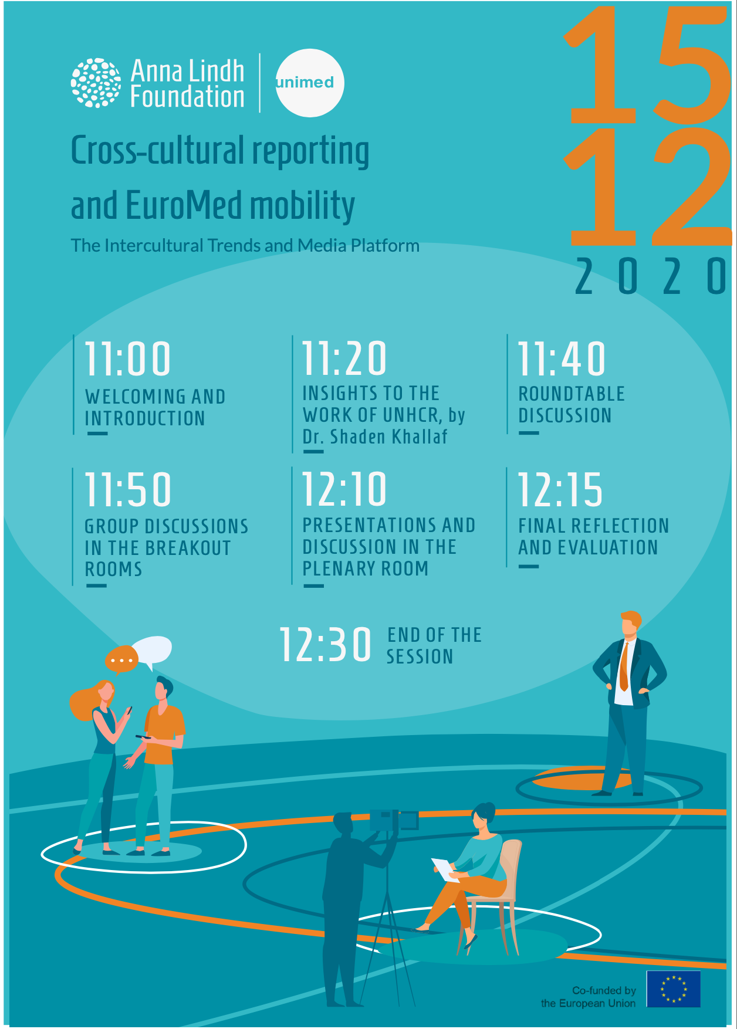

Annex IV Post-Exchange Questionnaire

Fourth Virtual Intercultural Trends & Media Platform meeting (December 15, 2020 – 11:00-12:30 CET)
Post-Exchange Questionnaire
*Required

Thank you for your participation in the Fourth Intercultural Trends & Media platform Virtual Exchange organised by the ALF and UNIMED

1_Participant name (optional)

2_What best describes you *

Media professional (e.g. journalist, blogger, opinion maker, editor …)

Academic (e.g. university professor, researcher …)

Civil society activist (e.g. youth worker, social activist …)

3_How would you rate your satisfaction with the Fourth Virtual Intercultural Trends & Media Platform (15 December session)? *

Very Low
1.
2
3
4
5
Very High

4_How would you rate the following statements? *

Strongly disagree
Disagree
Undecided
Agree
Strongly agree

The online event met my expectations

The addressed topic is relevant to my work/professional life

This virtual exchange encouraged meaningful discussion amongst the participants

This virtual exchange facilitates building positive relationships with participants from different sectors

The online event met my expectations

The addressed topic is relevant to my work/professional life

This virtual exchange encouraged meaningful discussion amongst the participants

This virtual exchange facilitates building positive relationships with participants from different sectors

5_How can Virtual Exchange help sustaining the work of intercultural trends & media platforms across the region? *

6_Since the outburst of the pandemic, in which way the media have covered migration issues and cultural diverse communities within your country? *

7_Which good and bad practices could you share in relation to the portrayal of migrants and refugees within the current context? *

8_What measures to promote diversity and dialogue via the media? *

9_What role could migrants and refugees and the media play for intercultural dialogue in the EuroMed region? *

10_What suggestions do you have to the ALF to support intercultural dialogue and cross-cultural reporting during the current situation? *

11_What aspects did you appreciate about this Virtual Exchange?

12_What aspects would you improve for a potential future Virtual Exchange?

13_In what ways (if any) was this Virtual Exchange different from other communications you have online or offline?

14_ you interested in having further Virtual Exchange sessions? *
Yes
No

15_Which topics would you like to be discussed in potential future Virtual Exchanges? *

