Testimonies of young people regarding the Launch of the Anna Lindh Intercultural Trends Survey and the Public Policy Forum on Youth and Civil Society in the Euro-Mediterranean on the second of December.

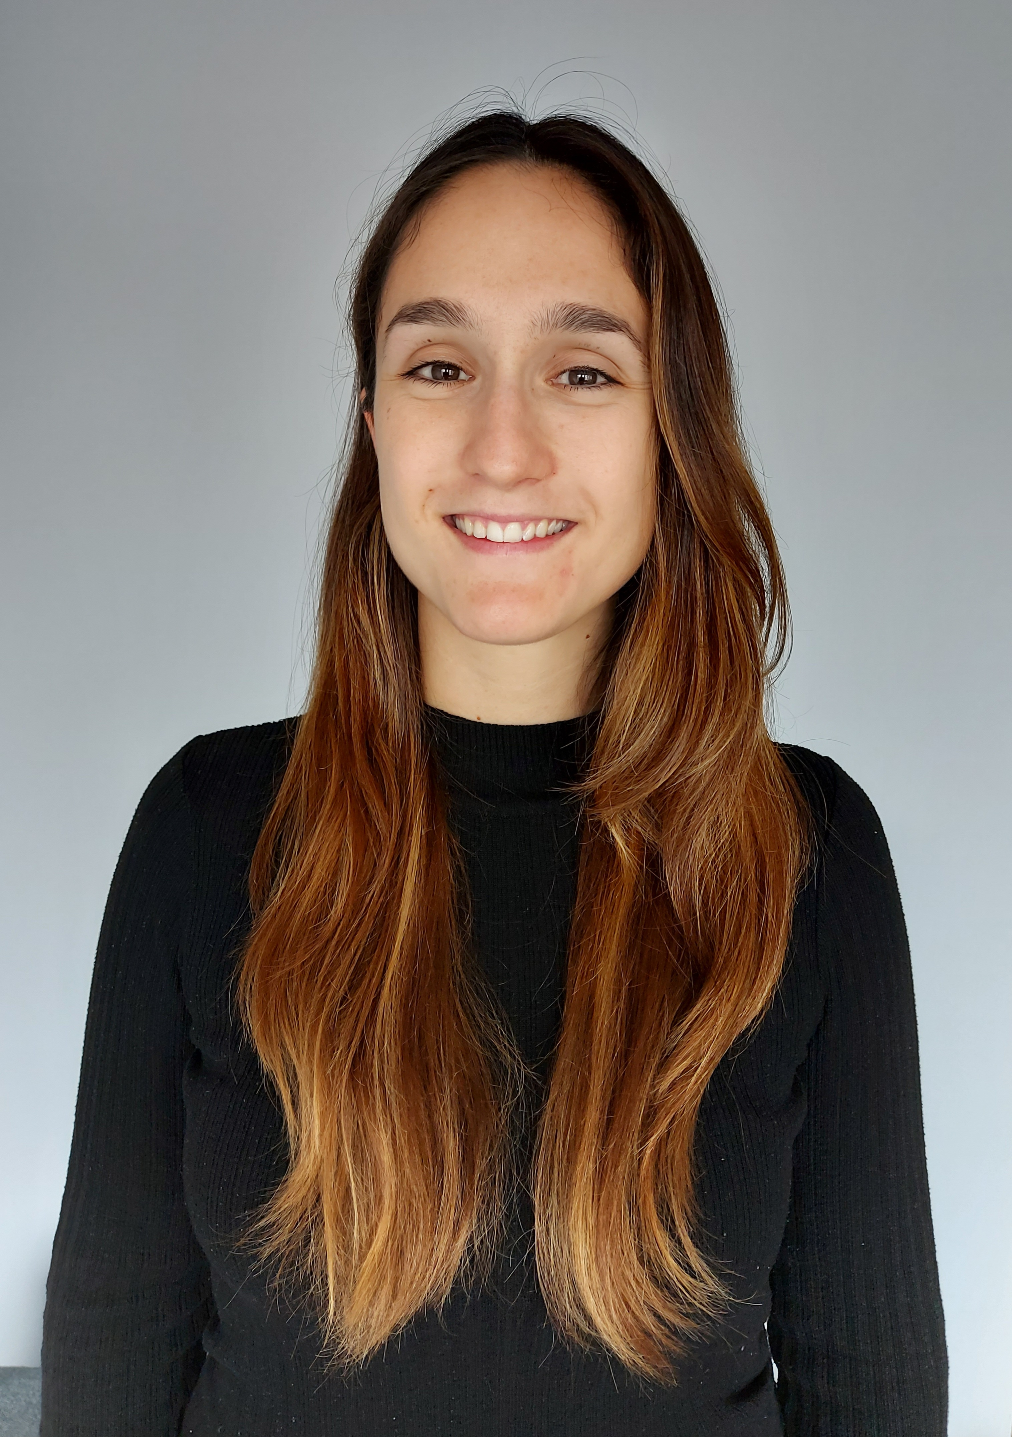
Carmen Cuenca comes from Spain. She is pursuing a career in science, having been awarded a fellowship from the Spanish Ministry of Education to develop her PhD thesis related to poverty, health and politics at the University of Alicante.

She has been a member of the Young Mediterranean Voices-program since 2018. She has been trained in facilitation dialogue by Soliya. Carmen was a trainer and adjudicator for the Third Euromed Debate Competition. She also coordinates the social area of a local NGO called GEA, which organizes intercultural exchanges and debates at local sphere.

Cuenca is proud of her contribution to creating an intergenerational and multicultural space accessible, especially for people from disadvantaged neighborhoods. Carmen recommends creating spaces in which art, music, painting are involved to address the issue of social inclusion in the North Mediterranean cities with the support of youth councils, youth organizations and municipalities.

Carmen Cuenca will participate in the Public Policy Forum on Youth and Civil Society on the second of December.

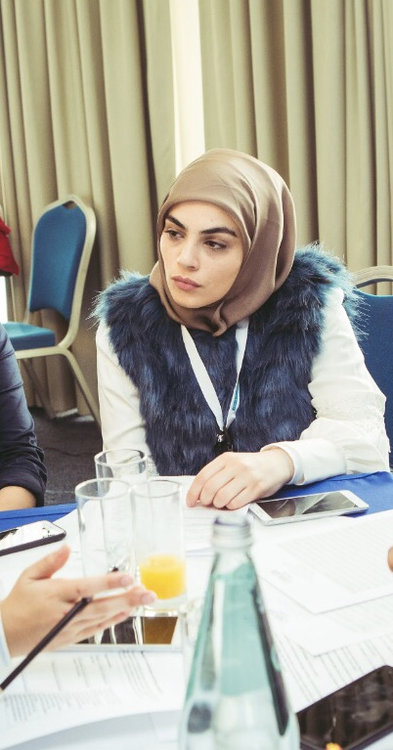
I am Nahia Kanj, a Lebanese citizen. I am studying civil and environmental engineering at the American university of Beirut. I am currently president at AUB discuss, debate and discourse club. I am also the opinion editor at the independent student newspaper, AUB outlook. Additionally, I am a debate trainer and adjudicator with Erasmus plus virtual exchange program.

One of the main issues I am concerned about as a young person from a developing Mediterranean country is “creating & finding job opportunities within a very challenging work environment”. The current political instability due to external and internal factors as well as the outdated educational systems which are moving very slowly with relative to the job market are hindering youth from investing in their own countries and directing their decisions towards immigration.

A lot of individual initiatives are taking place to mitigate these challenges; however, in the absence of serious governmental policies, the issue is still unsolvable. I believe that governments in our place of the world has first to have a free political will. Second, it has to incentive youth to work in under-developed sectors in their country such as the agriculture and sustainable energy sector like the case of Lebanon. Also, there should be investment in the data and research field for a better definition of the needs and design of policies.

To watch Nahia’s video testimony, click here.

Nahia Kanj will participate to the Launch of the Intercultural Trends Survey on the Second of December.

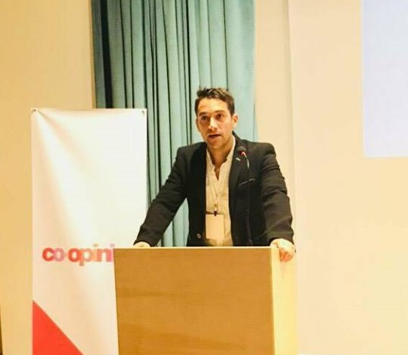
Jacopo Cimmino (32) grew up and studied in Italy where he He graduated cum laude at the University of Urbino "Carlo Bo" in July 2013, he holds a Master degree in Social Sciences and Management of Social policies.

From 2014 to 2016 he worked as a Social worker in orphanages and in therapeutic communities for the rehabilitation of people suffering from alcoholism and drug addiction.

Cimmino is an expert in conflict management and constructive resolution of conflicts. He is interested in international politics and an expert in gender studies and youth policies to promote gender equality.

He is currently in Ankara working with youth and as a backstopping person for the Anna Lindh Foundation’s Head of Network in Turkey.

With the Anna Lindh Foundation Jacopo has taken part, since the first pilot events, in the Online Debate Programme "Erasmus+ Virtual Exchange", actively contributing to its development, and covering different roles as debater, team leader, trainer, adjudicator, moderator and master trainer within the sessions and competitions implemented since June 2018.

Cimmino considers finding a spiritual path, through Buddism, as one of his main achievements in life. It has enriched his life and it has encouraged him to dedicate part of his energy and efforts to the wellbeing of others over himself. He would recommend creating a set of coordinated policies in the EuroMed region aimed at encouraging social entrepreneurship for the empowerment of young disadvantaged women, providing them with more leadership roles, and thus fostering their inclusion in the labor market to dismantle social, economic, political barriers that still block women from having the same level of participation of men in the civil society.

Click here to watch Jacopo’s video testimony

Jacopo will participate to the Public Policy Forum on Youth and Civil society in the Euro-Mediterranean on the second of December.

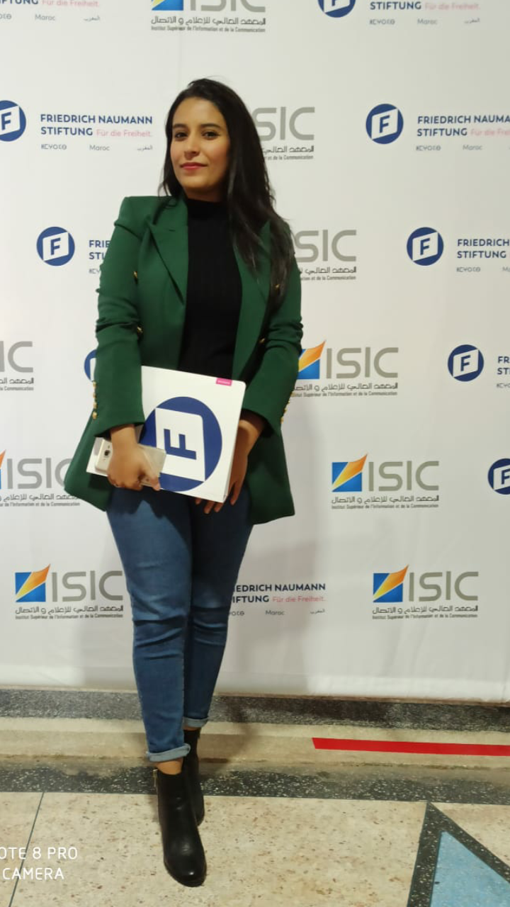
Sara Ahmarelainine is a Moroccan activist in the field of education and youth development. She obtained her bachelor degree in English language and literature in which she conducted her research on religion, diaspora, and feminist identity.

She is self-motivated and progress-driven towards making change in her community. Thus, she has significant experience in volunteering and social work, whether it is helping underserved students learn English or raising awareness about gender equality and climate change.

Ahmarelainine is particularly interested in issues surrounding gender inequality and stereotypes. She sees that in a contemporary Moroccan society, it’s unfortunate that women are still a minority whose major role is still tied to labels such as “the housewife” or the “re-producer” while the workplace and public sphere in general are still majorly male-dominated. She had the opportunity to take part in a Moroccan- German cooperation concerning gender inequality and stereotypes. The experience was eye opening for her since she got the chance to comparatively analyze real-life issues in two relatively different contexts and the efforts done in both countries towards solving it. On a practical level, Sara took up the task of implementing the manual that was the fruit of the previously mentioned collaboration to raise awareness and orient women and girls on their important role in society and the roles they can take in leading a positive change.

Ahmarelainine believes that gender inequalities transcend countries as they exist everywhere but take different manifestations. Several factors such economy, culture, and social convention play a role in this. That’s why she insists on the need for more realistic and concrete policies that enhance the presence of women in power such as implementing awareness-raising programs in secondary education on the importance of gender equality and gender roles. Additionally, she believes that the creation and effective implementation of strict measures against domestic violence and sexual harassment are a necessity. Furthermore, to address all-male succession into supposedly male jobs, companies need to ungender career paths, so women don’t get stuck in positions that are conventionally female like communications, HR and support roles. By being an active woman in society herself as part of a broader community of gender-equality advocates who seek to spread awareness, Sara aims to double her contributions in this field and take up more challenging roles as she gains more expertise.

Regarding the main challenges youth in the Euro-mediterranean face, Ahmarelainine believes that nowadays young people have different concerns and face divergent challenges. On an economical level, satisfactory employment, job security and financial instability constitute some of the top concerns that young people have to worry about and that significantly increased due to the Covid-19 outbreak. On a societal level, gender and cultural identity issues are on the rise and must be dealt with. The major problem here is the result of exclusion of certain minorities on the basis of gender and culture. Such minorities face consistent discrimination and marginalization due to the wide spread of false stereotypes and assumptions that are often the result of misunderstanding, mis-representation, and lack of inter-cultural knowledge of the other. Having more opportunities to open up to the world and engage with difference to foster understanding and engagement with difference could be a major step toward creating a more accepting and harmonious world with less religious conflicts, gender inequality or racism.

The above-mentioned challenges, can according to Ahmarelainine be addressed through intercultural dialogue, which she considers to bring youth together to voice their opinions and perspective in a mutual attempt to understand each other’s values and background and bridge the gap in understanding. Such dialogue helps equip young people with necessary skills such as active listening and critical thinking. It is also important to note that it's not only about exchanging but also activating the youth to take part in finding concrete and realistic solutions and policies to global and social challenges. I think that today’s challenges can’t be addressed on a country by country basis that is why Euro-Mediterranean cooperation is needed to aid and reach international agreements and achieve cooperative solutions that can contribute to the previous mentioned challenges by implementing strategies and programs that will bring people from different countries to work on programs like Anna Lindh Foundation.

Sara Ahmarelainine will participate Public Policy Forum on Youth and Civil society in the Euro-Mediterranean on the second of December.

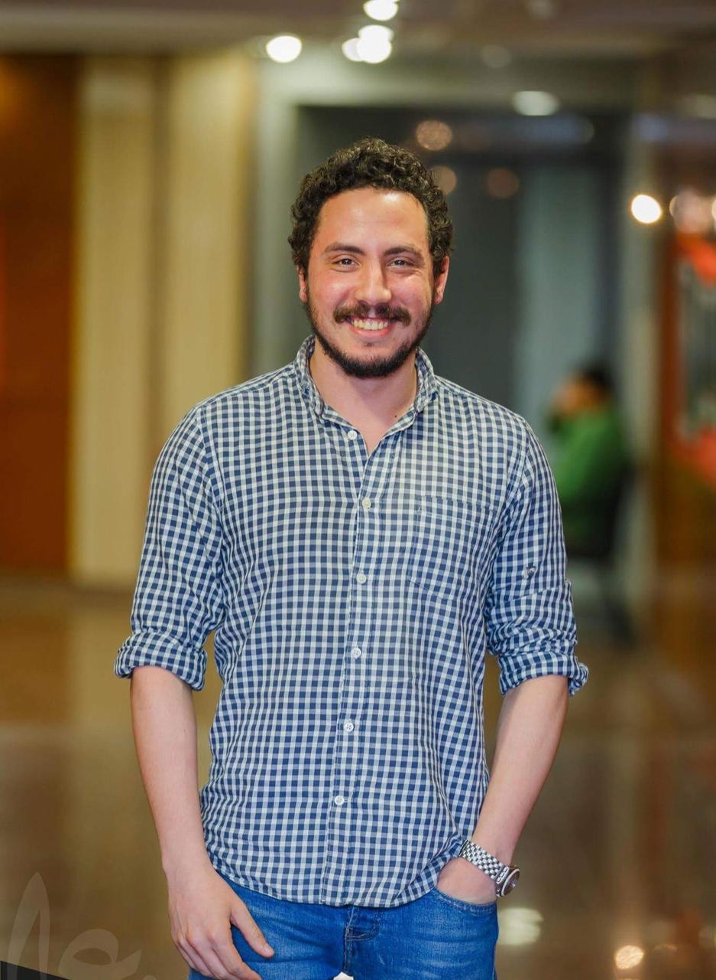
Ahmed Yassin is the cofounder and Marketing strategist of Banlastic Egypt. He finished his B.sc of Electromechanical Engineering, Alexandria University and he is now working as a solar ambassador for Solar city co. He does believe that climate change isn’t a myth or a luxury that is allegedly promoted for, it's a fact that needs extensive work to make his generation have a say in Climate crisis. He established a new platform called SOLAREGY to network all factories in Alexandria on a special basis to use clean energy as an alternative to fossil fuels. Ahmed is working extensively at the development field through various programmes that promote better community values and SDGs. Ahmed was awarded the fellowship of the U.S. Department of State International visitor leadership Programme & The European Union Visitor Programme in 2020 for his leadership and influence in civil society tackling both environmental and socioeconomic issues in his country Egypt.

Ahmed is a "Young Mediterranean Voices ambassador since 2019, he founded the first English debating Club in Egypt and introduced climate change as a prioritised topic. Also, Ahmed proudly started the plastic pollution movement initiative creating a plastic free-zone for Mediterranean basin countries. In late 2019 he Founded the 1st Med. Green transportation & E-Mobility Conference. Ahmed is also the current chief strategy councillor, trainer, moderator at MAC Club for training for social development. He is utterly proud to inspire and advocate for the climate crisis to the decision-makers of his country and was engaged in many talks around the legislation of Environmental laws, being one of the cofounders of “Egypt Ban Plastic" Coalition, he succeeded in imposing laws to ban single-use plastic in 4 cities.

Click here to watch Ahmed’s video testimony.

Ahmed will participate to the Public Policy Forum on Youth and Civil society in the Euro-Mediterranean on the second of December.

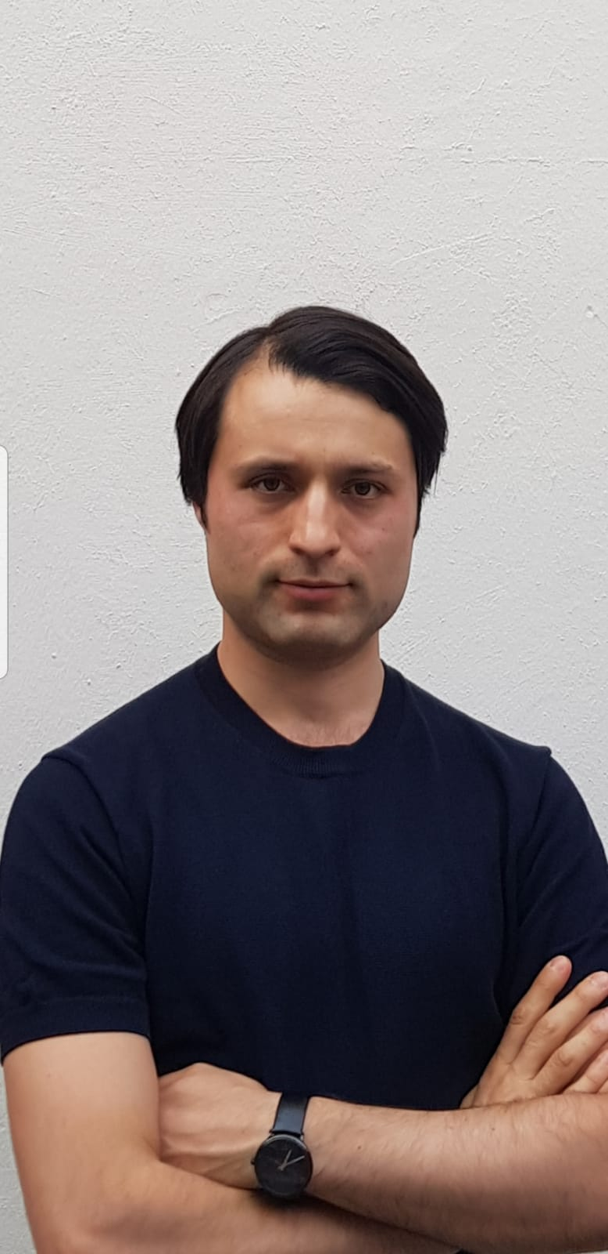
Burak Yusmak is youth activist from Germany. He

obtained his Masters in International Studies and Diplomacy from SOAS, University of London. He worked as a consultant in Brussels and then as a policy advisor at the European Parliament for a British MEP assisting the work at the Foreign Affairs Committee and the Sub-committee on Human Rights. He has experience in dealing with multiple actors such NGO's, Diplomats, Politicians and the Media and advocated for Human Rights globally. He is a certified Ambassador and Online Debate Trainer of the Erasmus+ Virtual Exchange (EVE) program and an alumnus of the first Young Mediterranean Voices Malta Leadership Seminar.

He delivered more than 20+ virtual exchange sessions across the euro-med region and is the winning team leader of the 2nd Erasmus+ Virtual Exchange Online Euromed Debate Competition with his team Brussels-Tripoli-Napoli. He co-founded the Youth Dialogue Platform together with Libyan activists, which promotes the dialogue between youth from Benghazi and Tripoli, and advocates for the implementation of the UN/SCR 2250.
Burak recommends the creation of an EU Special Envoy for Youth and the creation of a special advisor or special Envoy for Youth, Peace and Security at the German Foreign Office to address the need of the full implementation of the UN/SCR 2250 on youth, peace and security.

He believes that today's youth are the biggest benefiters of digital tools which makes them the most connected. They are leading social movements and protests driving to change in the social-political environment globally and they are the first feeling the impact of war, radicalization and poverty etc. International Diplomacy needs to engage constructively with future generations in order to solve the problems from the bottom for a sustainable development and a rules-based International Order.

Click here, to watch Burak’s video testimony.

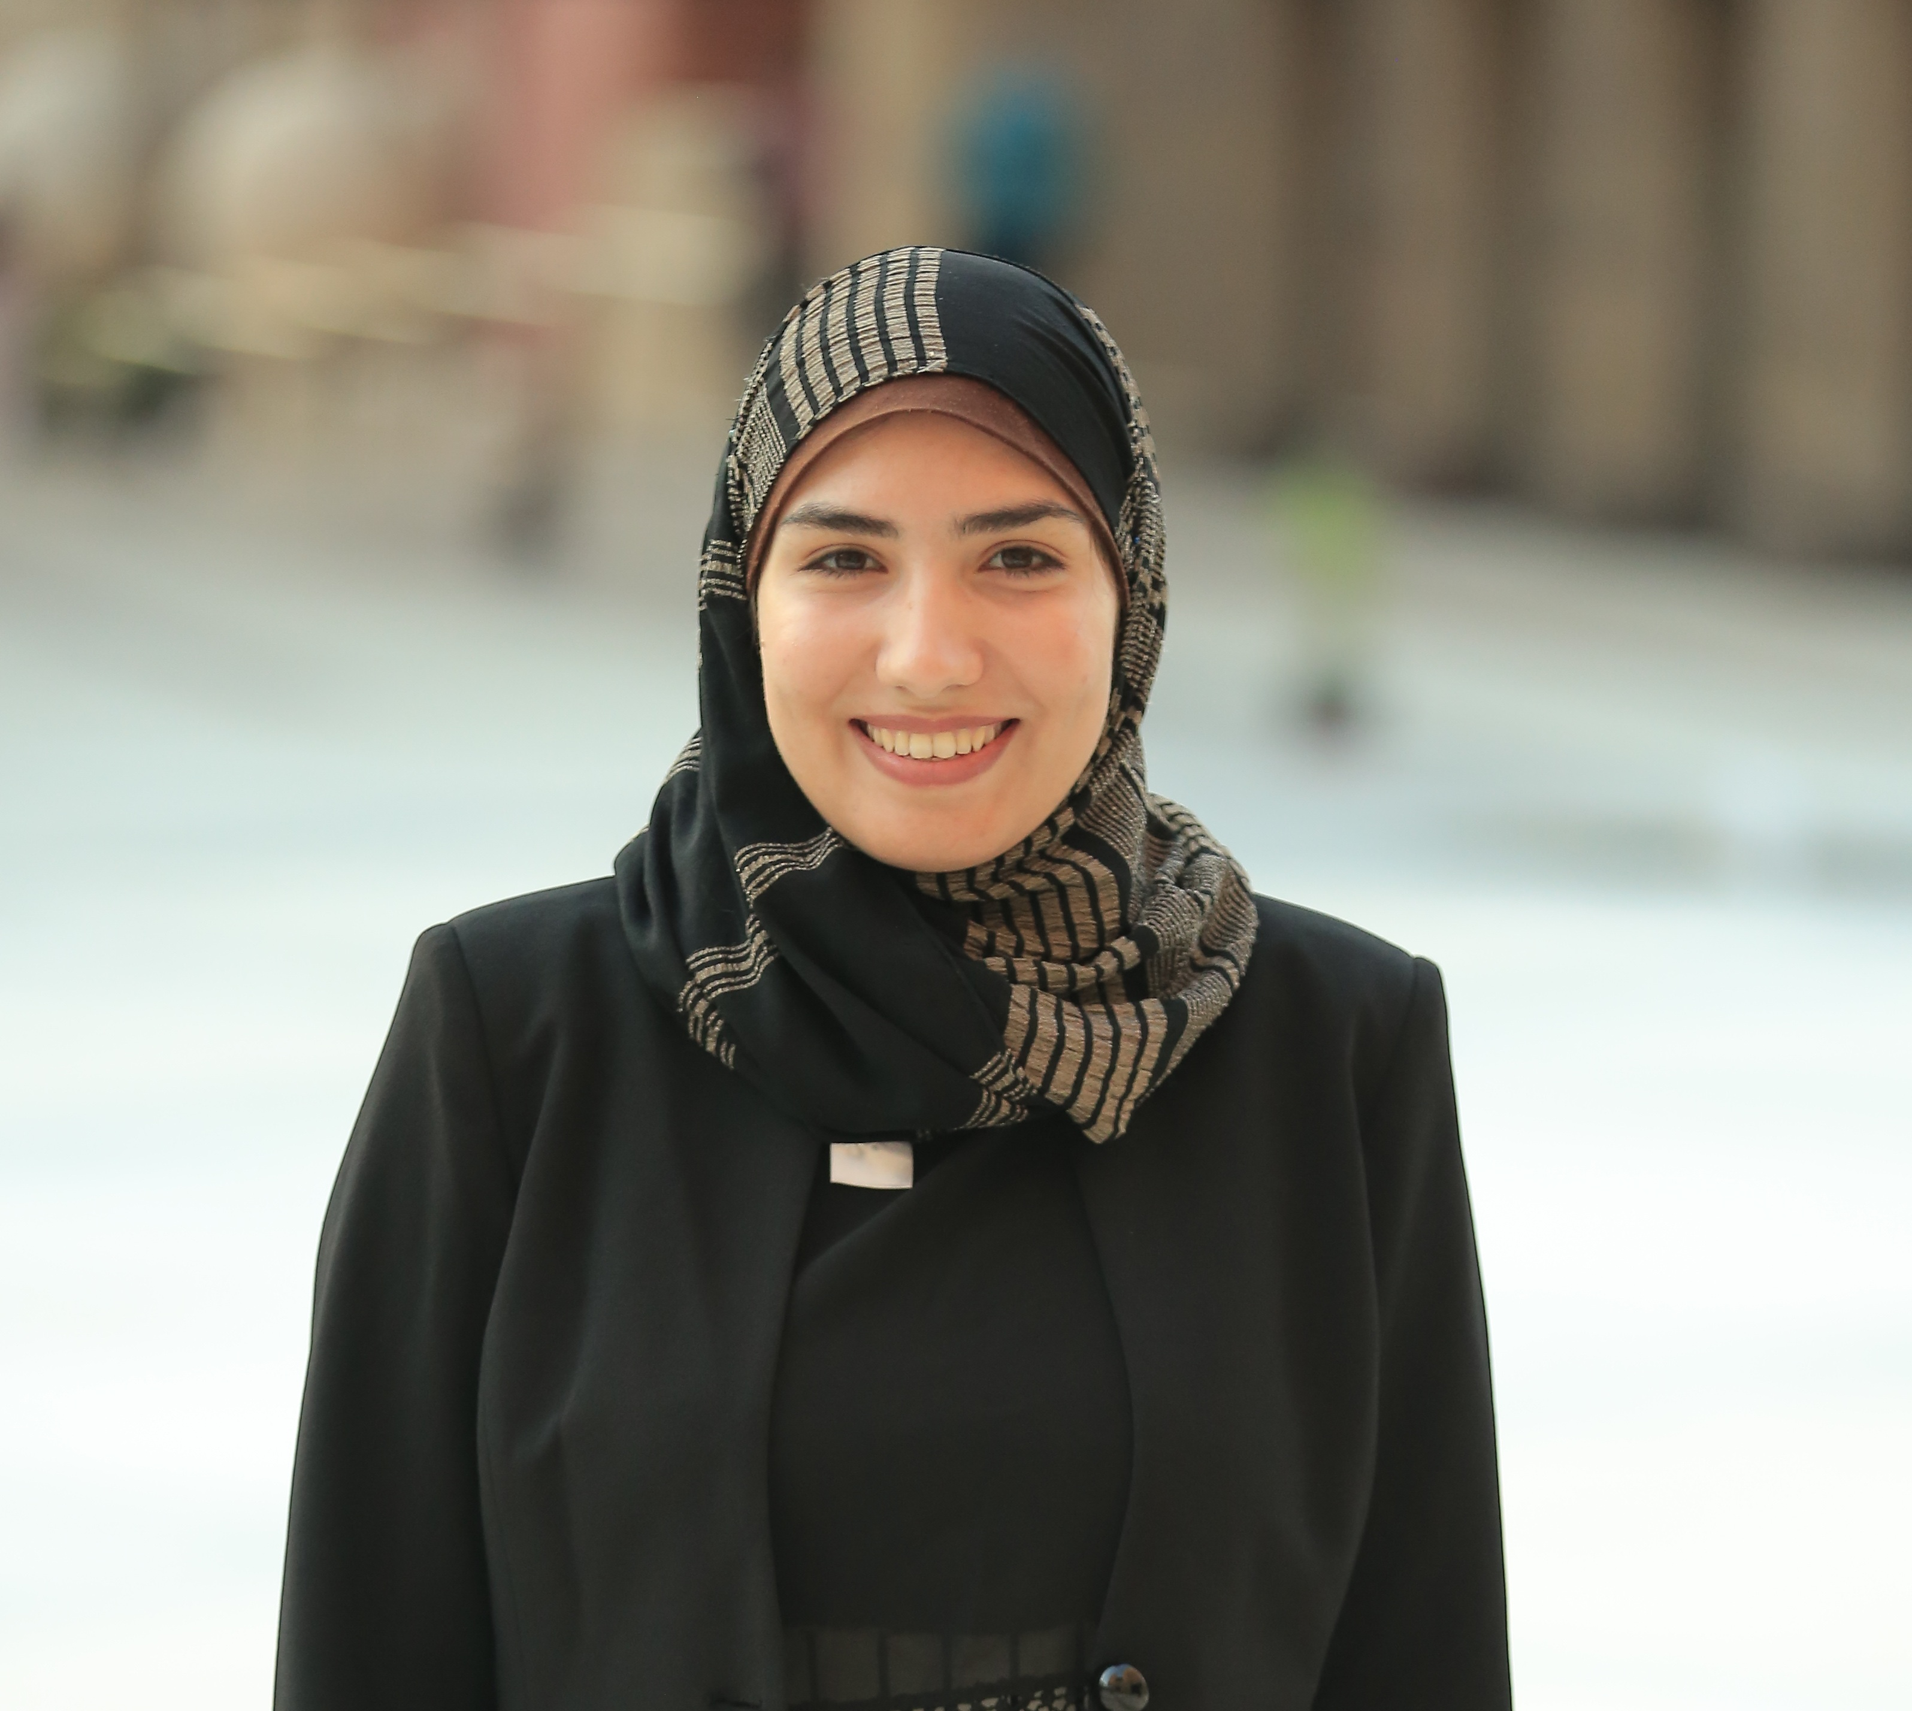
I am Zinab Abdelfatah Zidan; from Egypt. I am an English literature teaching assistant and UN interpreter with a broad experience in civic engagement and leadership. I am also a trainer, adjudicator and facilitator at two projects powered by Anna Lindh Foundation; YMV and E+VE.
My greatest achievement in 2020 is becoming an E+VE ambassador whereby I worked on collaborating with many universities and local organizations in Egypt to disseminate the culture of virtual exchange as an effective method in promoting intercultural education and engaging young people from hard-to-reach communities to amplify their voices and to participate in the democratic process. It was a journey that started in 2018 when I won the YMV National Debate Competition in Egypt; a life-changing experience that has escalated my potentials to higher levels of action by participating in many national and regional forums and conferences, both online and offline, as a representative of both EVE and YMV, presenting my ideas and policy proposals to actual policy-
makers and global leaders including heads of states, diplomats, academics, media professionals and social activists.
This has deepened my interest in the field of marginalized and subaltern groups including refugees, migrants and women, and the Israeli/Palestinian conflict being the most common challenges facing the Euro-Med and the MENA regions due to political misrepresentation and media propaganda.
Therefore, change in policies begins with bridging the gap between formal and non-formal education that fosters intercultural dialogue to promote media literacy, train young people how to spot false narratives of officials and politicians who tend to fabricate statistics to increase discrimination and xenophobia. I have been playing an integral role in enacting that through my engagement in two youth-led dialogue programs, EVE and YMV, especially in trying to integrate foreign language students of my university in utilizing policy dialogue to address the role of literature and critical theory in bridging divisions between different cultures, and in not only mitigating the impact of fake news on shaping youth's awareness but also in deconstructing the hegemonic narrative and counter extremist rhetoric. As EVE ambassador, during Covid-19 lockdown, I was able engage a number of my students in different E+VE activities including debates to learn how to connect what they learn in campus with real life advocacy through cross-cultural communication and to shape their cultural narrative against media stereotypes in the region particularly the crisis of Egyptian expats in the Gulf States in May 2020.
Click here, to watch Zinab Zidan’s video testimony.

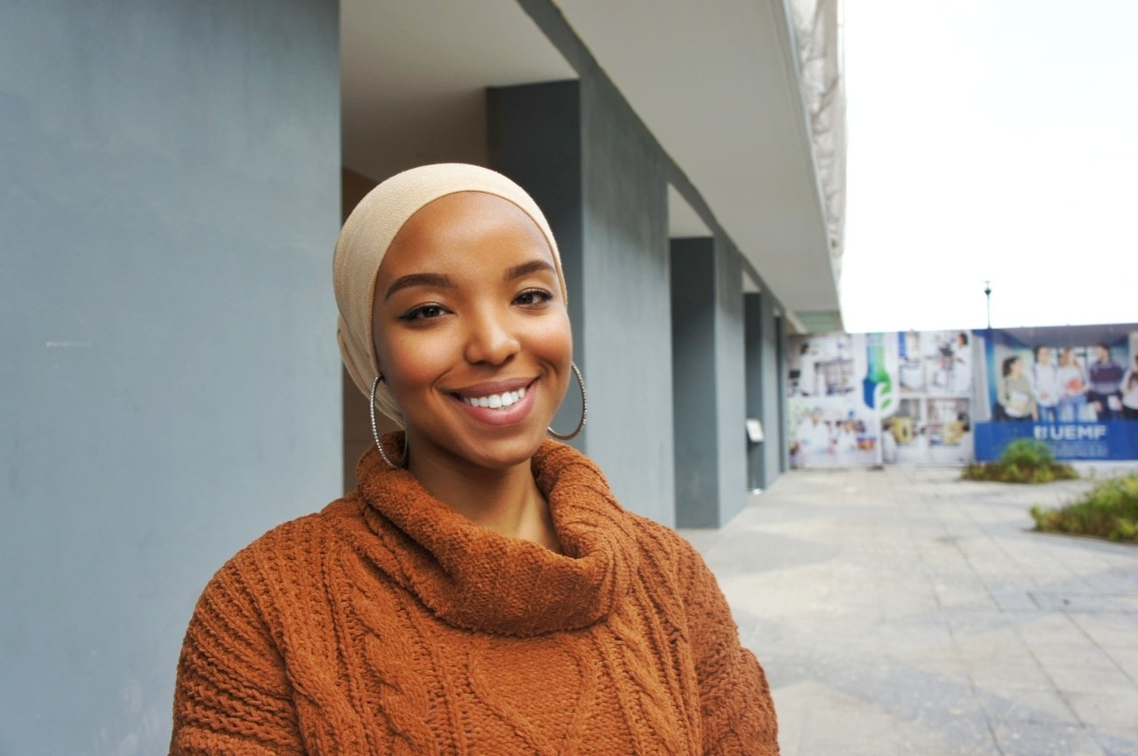
I am Fatima Zahra Outaiss, a 25-year-old Moroccan actor of change & youth empowerment advocate. I joined the Young Mediterranean Voices (YMV) program in 2017, and that was a turning point in my life.
I have always been passionate about debating but I never believed that my words have power, simply because I never thought I was powerful enough to lead a change anywhere.
YMV provided me not only with a platform to express myself but also with the guidance as to how to improve on many levels. It allowed me to grow, one debate at a time, and it taught me that the world can be seen through different lenses. One particularity of YMV is that it celebrates the individual and emphasizes on the importance of the group. That is why the program focuses on amplifying the voices of young people through dialogue.
The objectives of YMV align perfectly with my own objectives. I aim to inspire young people to actively participate in the processes of policy-making and I practice this within Young Med Voices through its approach: “from debate to action “. Thanks to YMV opportunities, I was able to interact with world leaders and share my policy recommendations on different issues. My most memorable experience is speaking to the President of Malta on fostering youth opportunities in the Euro-Med region.
I believe that youth appreciate initiatives such as YMV because they provide unconventional alternatives to practice advocacy, they bridge the gap between decision-makers and youth who is eager to enable change and they empower young people to influence policy-making.
Click here, to watch Fatima’s video testimony.

This document will be regularly updated

